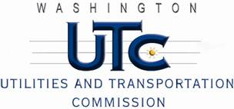

Memorandum
November 15, 2010

To: TR-091886 - File

From: Kathy Hunter, Deputy Assistant Director Transportation Safety

Subject: TR-091886 City of Ellensburg
Grade Crossing Protective Fund (GCPF) Project at the Intersection of
Mountain View Avenue and BNSF Railway Co.’s Tracks in the City of Ellensburg, Washington

On December 10, 2009, the Washington Utilities and Transportation Commission (Commission) awarded a GCPF grant totaling $10,000 to replace obsolete incandescent lights with LED type lights at the Mountain View Avenue crossing in the City of Ellensburg. The USDOT number assigned to this crossing is 085185U.

On October 25, 2010, the applicant, the City of Ellensburg submitted a request for reimbursement pursuant to Commission order. On November 15, 2010, Commission staff conducted a site visit and verified that the project is completed according to the specifications outlined in the order approving the grant.

Please close this docket.

