Steven King
Executive Director and Secretary
Washington Utilities and Transportation Commission
1300 S. Evergreen Park Dr. S.W.
Olympia WA 98504-7250

June 29th, 2015

RE: Eligible Telecommunications Carrier’s annual filling to the Federal Communications Commission pursuant to 47 C.F.R. § 54.313. and 47 C.F.R. 54.422 (Form 481)
Docket UT-150063

Dear Mr. King;

Enclosed please find additional Form 481 support as requested by staff.

Should you have any questions or require additional information please contact me directly.

Best regards,

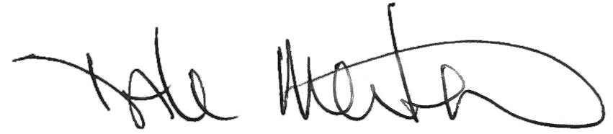

Dale Merten
C.O.O.
ToledoTel
306-864-2044
dale@toledotel.com

Enclosures

