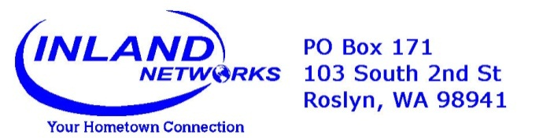

April 1, 2017

IMPORTANT NOTICE

Inland Telephone Company (“Company”) will be filing with the Washington Utilities and Transportation Commission ("Commission") to increase its Residential Individual Line Service for the Uniontown, Prescott and Roslyn Exchanges from $18.00 to $20.00, a change of $2.00 per month. The filing is proposed to take effect June 1, 2017.

The Federal Communications Commission has issued an Order (FCC Order No. 11-161) that requires the Company to increase its rates to the levels set forth in this Notice or face a corresponding reduction in its universal service support. Universal service support enables the Company to provide high quality service to you.

There is a chance that the FCC will reverse its position. Company representatives are asking the FCC to do that. If it happens, the rate will revert to $18.00 as quickly as possible.

This is not something that the Company is taking lightly. However, in considering the options available to it, the Company believes it has no choice but to follow the FCC's requirement in order to continue to receive universal service support at approximately the same level it has in the past, if the FCC does not reverse its position.

The commission has the authority to set final rates that may be lower or higher than the company’s request, depending on the outcome of its investigation. You can submit comments by going to www.utc.wa.gov and clicking “Submit a Comment,” or by one of the following options:

Washington Utilities and Transportation Commission
1300 S. Evergreen Park Drive SW
P.O. Box 47250, Olympia, WA 98504-7250
E-mail: comments@utc.wa.gov
Telephone: 1-888-333-WUTC (9882)

Commission staff will make a recommendation to the commissioners at an open meeting in Olympia, which is scheduled for 9:30 a.m. on May 17, 2017, and you will have an opportunity to comment in person at this meeting. If you are unable to attend the open meeting, you can participate by telephone by calling 360-664-1234 the day before the open meeting for instructions and to sign in.

A memo containing the staff recommendation will be available on the commission website about three days prior to the open meeting. To view the memo, go to www.utc.wa.gov. Click on the link near the bottom that says "Documents." Under "Open Meetings," click on "Agendas, meeting minutes, orders." When the open meeting date (see above) appears, click on the memo for this filing. This will take you to a page with the memo and any associated attachments.

The commission is committed to providing reasonable accommodation to participants with disabilities. If you need reasonable accommodation, please contact the commission at (360) 664-1132 or human_resources@utc.wa.gov.

If you have any questions about the proposed filing and how it will affect you, please call the Company at 509-649-2211.

Sincerely,

Inland Telephone Company

