July 8, 2014

Steven V. King, Executive Director and Secretary
Utilities and Transportation Commission
1300 S. Evergreen Park Dr. SW
P.O. Box 47250
Olympia, WA 98504-7250

RE: Washington Utilities and Transportation Commission v. Team Forks, LLC

Commission Staff’s Response to Application for Mitigation of Penalties TE-141082

Dear Mr. King:

On May 28, 2014, the Utilities and Transportation Commission issued a $1,000 Penalty Assessment in Docket TE-141082 against Team Forks, LLC for 10 violations of Washington Administrative Code (WAC) 480-30-071, which requires charter and excursion carriers to furnish annual reports to the commission no later than May 1 each year.¹

On June 23, 2014, Team Forks, LLC wrote the commission requesting mitigation of penalties (Mitigation Request).² In its Mitigation Request, Team Forks, LLC does not dispute that the violation occurred. The company states, “Team Forks LLC did not file the annual report for 2013 because it was mailed out on February 28, 2014 and the address of record was P.O. Box 995, Forks, WA 98331 so it did not reach us. The transfer of ownership was finally completed by the commission on March 6, 2014 at which time our address was stated as P.O. Box 1488, Forks, Wa 98331.”

It is the company’s responsibility to ensure that the regulatory fee is paid and the annual report is filed by the May 1 deadline. On February 28, 2014, Annual Report packets were mailed to all regulated charter and excursion companies. The instructions for annual report completion page of the annual report informed the regulated company that it must complete the annual report form, pay the regulatory fees, and return the materials by May 1, 2014, to avoid enforcement action.

UTC Annual Reports
July 8, 2014
Page 2

On June 23, 2014, Team Forks, LLC filed the 2013 annual report and timely paid the required regulatory fees on December 26, 2013. The company permit was issued on March 1, 2010 with the transfer of ownership effective March 6, 2014 per Docket TE-140288. The company was delinquent in filing the 2012 annual report under prior ownership. Commission staff supports the company’s request for mitigation due to the ownership change. Staff recommends the penalty be reduced to $25 per day for a total penalty assessment of $250.

If you have any questions regarding this recommendation, please contact Amy Andrews, Regulatory Analyst, at (360) 664-1157, or aandrews@utc.wa.gov.

Sincerely,

Sondra Walsh, Director
Administrative Services

ATTACHMENT A
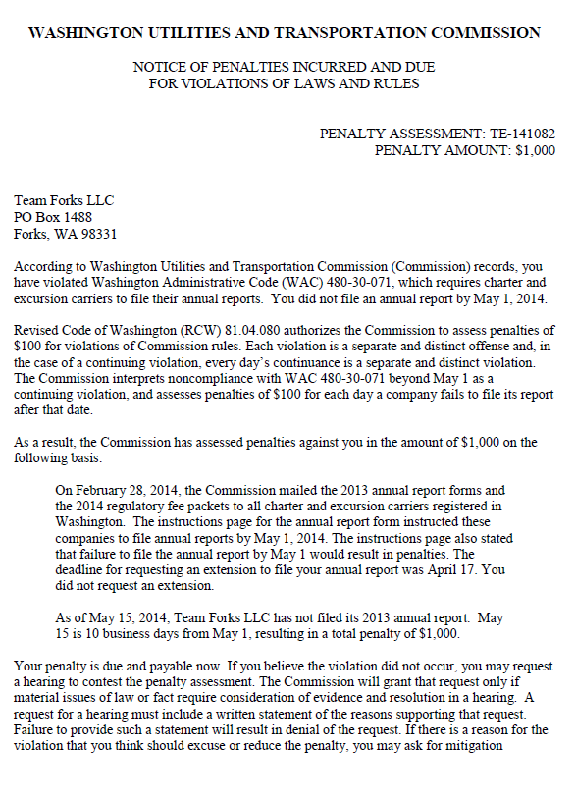

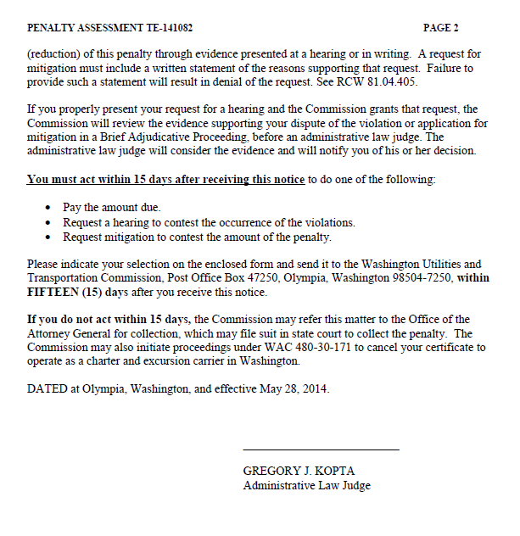

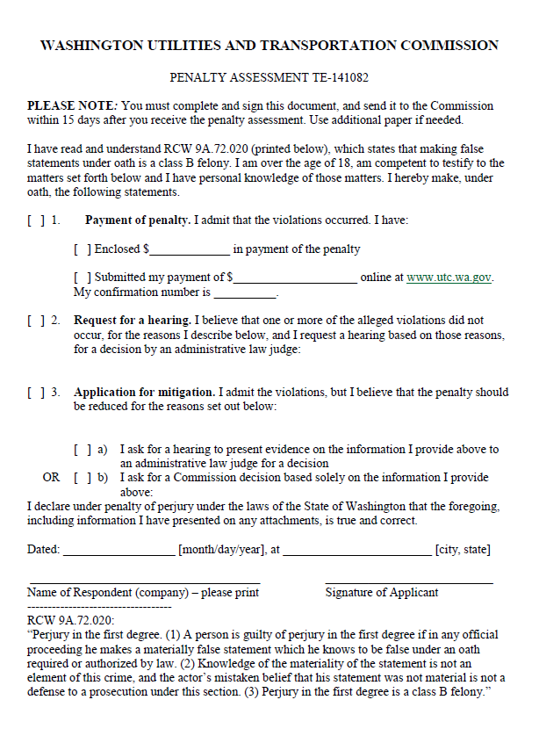

ATTACHMENT B
