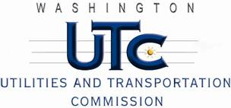

Memorandum
June 24, 2011

To: TR-110681 - File

From: Kathy Hunter, Deputy Assistant Director Transportation Safety

Subject: TR-110681 Eastern Washington Gateway Railroad
Grade Crossing Protective Fund (GCPF) Project at the Intersection of
Brace Street and Eastern Washington Gateway Railroad’s Tracks in
the City of Wilbur, Washington

On April 29, 2011, the Washington Utilities and Transportation Commission (Commission) awarded a GCPF grant totaling $9,505.60 to install LED lights, replace the battery charger, replace the batteries, install a LED power off light, and replace the cross-bucks at the Brace Street crossing in the City of Wilbur. The USDOT number assigned to this crossing is 066072M.

On June 15, 2011, the applicant, Eastern Washington Gateway Railroad submitted a request for reimbursement pursuant to Commission order. On June 10, 2011, Commission staff conducted a site visit and verified that the project is completed according to the specifications outlined in the order approving the grant.

Please close this docket.

