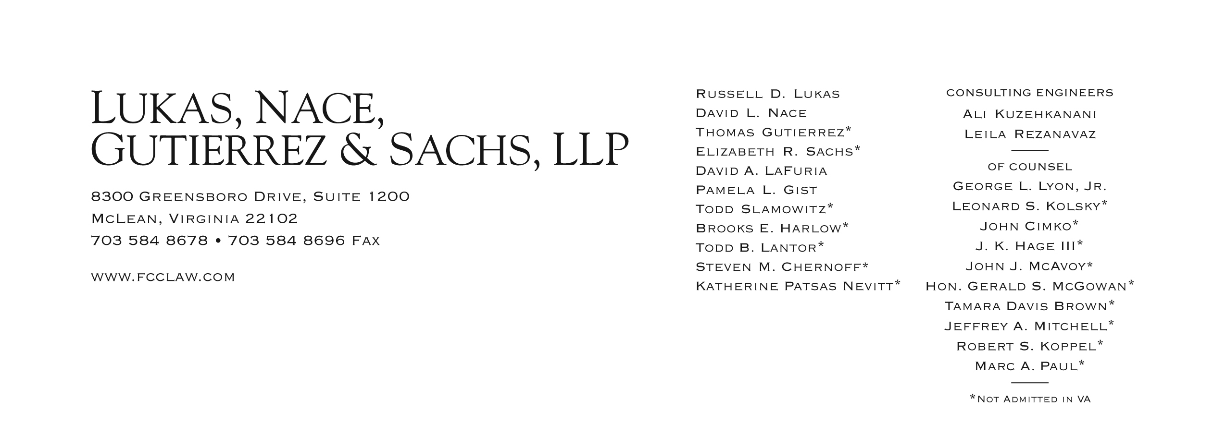

Brooks E. Harlow
(703) 584-8680
bharlow@fcclaw.com

March 13, 2012

BY Web Portal & OVERNIGHT FEDEX
David W. Danner
Executive Director and Secretary
Washington Utilities and Transportation Commission
1300 S. Evergreen Park Drive S.W.
Post Office Box 47250
Olympia, Washington 98504-7250

In re: Application of Shuttle Express, Inc.; Excalibur Limousine LLC d/b/a Seattle Green Limo; and Pacific Northwest Transportation Services, Inc. d/b/a Capital Aeroporter/Airport Shuttle,
Consolidated
For Permanent Auto Transportation Authority
Docket No. TC-111446; TC-111643; TC-111619

Dear Mr. Danner:
Enclosed, for filing, is the original and twelve copies of the Joint Stipulation Waiving Petitions to Review.

If you have any questions, please do not hesitate to contact the undersigned.

Very truly yours,
Brooks E. Harlow, P.C.

cc via email and U.S. Mail
Administrative Law Judge Martin Lovinger
Assistant Attorney General Rulkowski
Pacific Northwest Transportation Services
Excalibur Limousine

