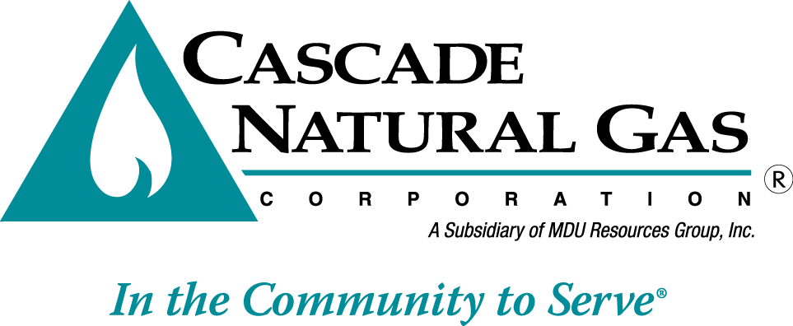 | 8113 W. GRANDRIDGE BLVD., KENNEWICK, WASHINGTON 99336-7166  TELEPHONE 509-734-4500 FACSIMILE 509-737-7166  www.cngc.com

September 28, 2016

Mr. Steven V. King
Executive Director and Secretary
Washington Utilities & Transportation Commission
P.O. Box 47250
Olympia, WA 98504-7250

RE: UG-161060, Supplemental Filing
Advice No. CNG/W16-09-01

Dear Mr. King:

On September 9, 2016, Cascade Natural Gas Corporation’s (Cascade or Company) submitted Advice No.W16-09-01. The Company now supplements this filing with the following sheets which are stated to become effective with service on and after October 10, 2016:

Seventh Revision Sheet No. 300
Fourth Revision Sheet No. 300-A
Third Revision Sheet No. 302-A.

This replaces all the sheets in the initial September 9, 2016 filing.

The changes made herein correct margin codes.

Any questions regarding this filing may be directed to me at (509) 734-4593.

Sincerely,

Michael Parvinen
Director, Regulatory Affairs

Attachment

