March 10, 2016

Mr. Steven King
Executive Director and Secretary
Washington Utilities and Transportation Commission
1300 South Evergreen Park Drive SW
Olympia WA 98504-7250

RE: Tariff Revision – WN U-5 for YCOM Networks, Inc. d/b/a FairPoint Communications

Dear Mr. King:

Pursuant to WAC 480-80-123, please find enclosed the following revised tariff pages for YCOM Networks, Inc. d/b/a FairPoint Communications. We are respectfully requesting an effective date of May 15, 2016.

Section IV, Third Revised Sheet No. 3
Section IV, Second Revised Sheet No. 3A

The purpose of this filing is establish rates for basic calling services which are in compliance with the Federal Communications urban rate floor requirement which states that residential local service rates must be at $18.00 by June 1, 2016.

With this rate increase, FairPoint is upgrading Local Measured Service (Basic Calling Service) to the Unlimited Flat Rate Service which will provide more local calling benefits. The Unlimited Flat Rate service provides unlimited local calling with the Yelm exchange as well as unlimited calling to Tacoma, Roy, Graham, and Olympia at no additional charge. Customers were previously charged per minute for all calls made to these areas once the $3 monthly usage allowance was exhausted.

Please contact Beth Westman at 207.535.4249 or bwestman@fairpoint.com with any questions or concerns regarding this filing.

Sincerely,
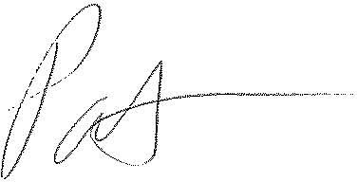
Patrick L. Morse
Senior VP Governmental Affairs
FairPoint Communications
P: 620-227-4409
F: 620-227-8576

