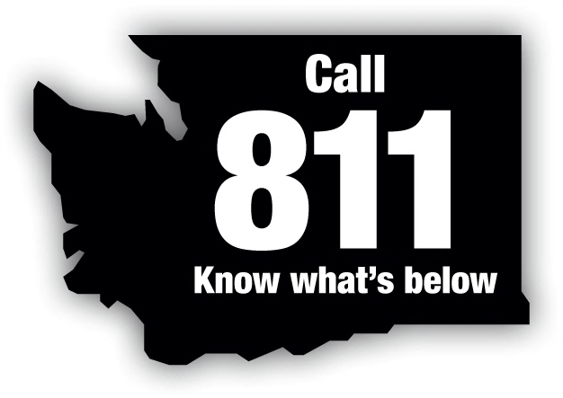
Washington State Dig Law Safety Committee
P.O. Box 734 • Poulsbo, WA 98370

Committee Members Represent:
Local Government
Natural Gas Utility
Contractors
Excavators
Electric Utility
Consumer – Owned Utility
Pipeline Utility
Insurance Industry
Utilities and Transportation Commission
Telecommunications Company
Three At – Large Positions

June 28, 2017

Steve King, Executive Director and Secretary
Members of the Commission
Utilities and Transportation Commission
1300 Evergreen Park Drive SW
Olympia, WA 98504-7250

Re: Review Committee Decision - Case Numbers 17-018 and 17-019 Jan Billings & Eric Westman vs William James Bryant

Dear Mr. King:

The Washington State Dig Law Safety Committee received two complaints regarding potential violations of the Washington State Dig Law RCW 19.122.030 for work performed on April 14, 2017.

On June 21, 2017, the Washington State Dig Law Safety Committee Review Board heard complaint Cases 17-018,019 filed by Jan Billings and Eric Westman; complainants, against William James Bryant; respondent.

The Review Committee determined that the respondent, Williams James Bryant did violate RCW 19.122.030(1)(a) for failing to provide notice to a one-number locating service before excavating in Case 17-018. For Case 17-019 the Review Committee determined that William James Bryant did not violate Washington State Dig Law as the work was performed by an excavator hired by Mr. Bryant.

The Review Committee recommends the following penalty be assessed to the respondent:
- $500.00 for violating 19.122.030(1)(a) Case 17-018

Please let me know if you have any questions regarding this case. I can be contacted at 425.430.7212.

Sincerely,

Dave Christensen, Chair
Cc: Lynda Holloway, UTC
Jan Billings
Eric Westman
William James Bryant

