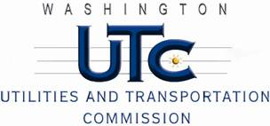

Memorandum
February 3, 2011

To: TR-100689 - File

From: Kathy Hunter, Deputy Assistant Director Transportation Safety

Subject: TR-100689 Cascade and Columbia River Railroad
Grade Crossing Protective Fund (GCPF) Project at the Intersection of
B & O Road and Cascade and Columbia River Railroad’s Tracks in the City of Malott, Washington

On May 25, 2010, the Washington Utilities and Transportation Commission (Commission) awarded a GCPF grant totaling $9,319 to replace obsolete incandescent lights with LED type lights and cross-bucks at the B & O Road crossing in the City of Malott. The USDOT number assigned to this crossing is 096275Y.

On February 3, 2011, the applicant, Cascade and Columbia River Railroad submitted a request for reimbursement pursuant to Commission order. On January 26, 2011, Commission staff conducted a site visit and verified that the project is completed according to the specifications outlined in the order approving the grant.

Please close this docket.

