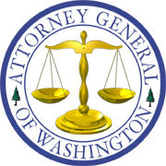
Bob Ferguson
ATTORNEY GENERAL OF WASHINGTON
Utilities and Transportation Division
PO Box 40128 • Olympia WA 98504-0128 • (360) 664-1183

November 16, 2017

Steven V. King, Executive Director and Secretary
Washington Utilities and Transportation Commission
1300 S. Evergreen Park Dr. SW
P. O. Box 47250
Olympia, Washington 98504-7250

RE: In the Matter of the Joint Application of Hydro One Limited and Avista Corporation for an Order Authorizing Proposed Transaction
Docket U-170970

Dear Mr. King:

Enclosed for filing in the above-referenced docket are the original and five copies of Commission Staff’s Response to Petition for Interlocutory Review, and Certificate of Service.

Sincerely,

/s/ Jennifer Cameron-Rulkowski, WSBA No. 33734
Assistant Attorney General
Office of the Attorney General
Utilities and Transportation Division
P.O. Box 40128, Olympia, WA 98504-0128
(360) 664-1186
jcameron@utc.wa.gov

JCR/emd
Enclosures
cc: Parties w/enc.

