June 27, 2014

Steven V. King, Executive Director and Secretary
Utilities and Transportation Commission
1300 S. Evergreen Park Dr. SW
P.O. Box 47250
Olympia, WA 98504-7250

RE: Washington Utilities and Transportation Commission v. NetworkIP, LLC

Commission Staff’s Response to Application for Mitigation of Penalties UT-140901

Dear Mr. King:

On May 30, 2014, the Utilities and Transportation Commission issued a $1,000 Penalty Assessment in Docket UT-140901 against NetworkIP, LLC for 10 violations of Washington Administrative Code (WAC) 480-120-382, which requires telecommunications companies to furnish annual reports to the commission no later than May 1 each year.¹

On June 13, 2014, NetworkIP, LLC wrote the commission requesting mitigation of penalties (Mitigation Request).² In its Mitigation Request, NetworkIP, LLC does not dispute that the violation occurred. The company provided information regarding an additional section of the annual report being added by the commission which the company desired to be treated as confidential. The company misunderstood the staff request for an unredacted version of this portion of the report compounded by travel plans of the responsible party for submitting the requested documentation.

It is the company’s responsibility to ensure that the regulatory fee is paid and the annual report is filed by the May 1 deadline. On February 28, 2014, Annual Report packets were mailed to all regulated telecommunication companies. The instructions for annual report completion page of
the annual report informed the regulated company that it must complete the annual report form, pay the regulatory fees, and return the materials by May 1, 2014, to avoid enforcement action.

On May 22, 2014, NetworkIP, LLC filed its complete annual report with no regulatory fees
due. The company had a delinquent filing during the 2003 annual report year with no further violations of WAC 480-120-382 until this year. Staff supports the company’s request for
UTC Annual Reports
June 27, 2014
Page 2

mitigation due to the company’s annual report history of compliance and the implementation of a new portion of the telecommunications annual report. Staff recommends a reduced penalty assessment of $200.

If you have any questions regarding this recommendation, please contact Amy Andrews, Regulatory Analyst, at (360) 664-1157, or aandrews@utc.wa.gov.

Sincerely,

Sondra Walsh, Director
Administrative Services

ATTACHMENT A
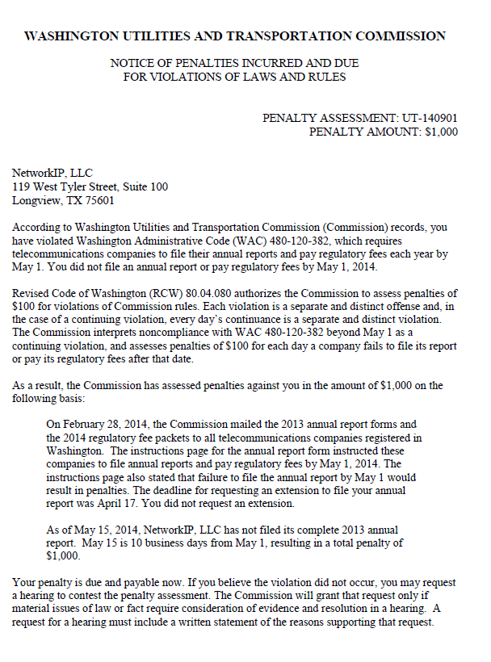

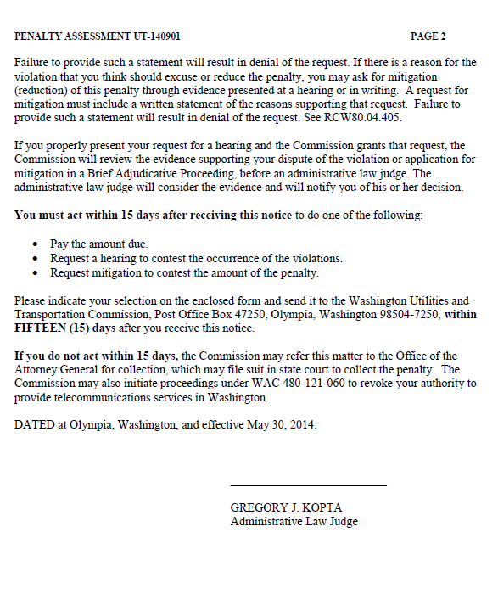

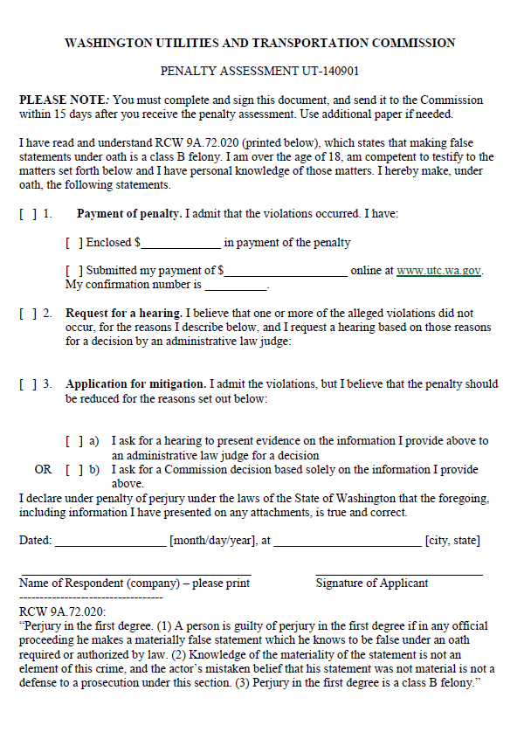

ATTACHMENT B
