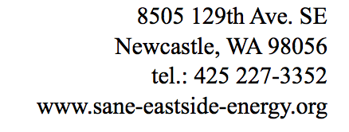
Citizens for Sane Eastside Energy (CSEE)

October 17, 2018

Executive Director and Secretary
Washington Utilities and Transportation Commission
1300 S. Evergreen Park Drive S.W.
P.O. Box 47250
Olympia, WA 98504-7250 submitted by email to records@utc.wa.gov

Re: Puget Sound Energy’s Proposed Sale of Non-Controlling Interest in Puget Holdings LLC
Docket U-180680

To the Commission:

Citizens for Sane Eastside Energy (CSEE) is an Eastside citizen’s action group committed to safe and sound Washington energy policies. Unfortunately, as evidenced by PSE’s persistent foot-dragging in providing the WUTC a long-overdue, transparent and meaningful IRP as repeatedly requested by the WUTC, PSE has not been serving the public interest. This irresponsible resistance is primarily motivated by and connected to PSE’s proposed Energize Eastside project. If PSE ever comes clean with the substantial amounts of data it has managed to hide regarding this project and as demanded by the WUTC to be included in PSE’s IRP, it would become crystal clear that there is no need for it, and in any event there are far better least-cost alternatives.

For further technical and historical detail regarding much of the information PSE has kept hidden about this project, CSEE refers you to and endorses the comments submitted in this Docket by retired former PSE Vice President for Power Planning, Richard Lauckhart, attached hereto for your convenience.

For numerous reasons outlined at our web site at www.sane-eastside-energy.org, CSEE submits Energize Eastside is a massive fraud, driven solely for the purpose of maximizing profits for PSE’s foreign owners. It does not serve the public interest for its Washington ratepayers.

WAC 480-100-238 - “Integrated resource planning,” provides inter alia the following:

“(6) The commission will consider the information reported in the integrated resource plan when it evaluates the performance of the utility in rate and other proceedings.” (emphasis added).

This Docket is such an “other proceeding.” Clearly implicit in subsection (6) is the obvious fact that WUTC can and should impose consequences and conditions if insufficient information exists in a regulated utility’s defective IRP, such as is the case with PSE. The WUTC should condition its approval of the sale subject to approval in this Docket on receiving a complete, overdue, and transparent PSE IRP.

The WUTC has now the rare opportunity to exercise meaningful regulation to exact IRP compliance from a rogue utility before its disastrous project is built. If there is to be a successor to Macquarie as a major investor in PSE, then it should not get entry into Washington State without the WUTC’s first obtaining from PSE a compliant IRP.

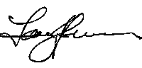
Sincerely,

Larry G. Johnson
Attorney at Law, WSBA #5682
Citizens for Sane Eastside Energy (CSEE), www.sane-eastside-energy.org
8505 129th Ave. SE
Newcastle, WA 98056
tel.: 425 227-3352
larry.ede@gmail.com

cc: CENSE

