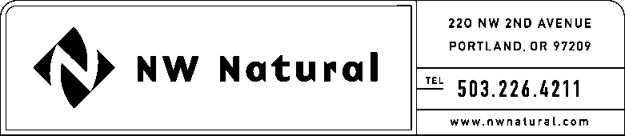

GAIL A. HAMMER
Tariffs and Regulatory Compliance
Tel: 503.226.4211, ext. 5865
Fax: 503.721.2516
email: gail.hammer@nwnatural.com

December 1, 2016 NWN Advice No. WUTC 16-07

VIA ELECTRONIC FILING

Steven King, Executive Director and Secretary
Washington Utilities and Transportation Commission
1300 S. Evergreen Park Drive, S.W.
P.O. Box 47250
Olympia, Washington 98504-7250

RE: Schedule G, Energy Efficiency Services and Programs – Residential and Commercial
Schedule I, Washington Low-Income Energy Efficiency (WA-LIEE) Programs

Northwest Natural Gas, dba NW Natural (“NW Natural” or the “Company”), files herewith the following revisions to its Tariff WN U-6, stated to become effective with service on and after January 1, 2017:

Thirteenth Revision of Sheet G.1,
Schedule G,
“Energy Efficiency Services and Programs – Residential and Commercial,”

Fourth Revision of Sheet I.1,
Schedule I,
“Washington Low-Income Energy Efficiency (WA-LIEE) Programs.”

The first purpose of this filing is to revise the Company’s Energy Efficiency Plan (“EE Plan” or “Plan”), which by reference in Sheet G.1 is part of the Company’s Tariff. In accordance with the parameters of the Plan, the Company is required to submit an annual filing to establish program goals and budget for the following year.

The second purpose of this filing is to remove the temporary one-year allowances included in the 2016 EE Plan, which were reflected in the Third Revision of Sheet I.1 of the Company’s Tariff. In an effort to stimulate greater program participation in the Company’s WA-LIEE program, the one-year program funding efforts included:

- Customer outreach: For the 2016 program year only, funding up to $11,000 was available for outreach to promote customer participation.
- NW Natural program administration: For the 2016 program year only, NW Natural’s program administration costs were reimbursed up to $7,700 due to the planned increase in administrative activities to strengthen the WA-LIEE program.

The Fourth Revision of Sheet I.1 included with this filing reflects the program funding language in effect prior to the 2016 EE Plan.

In 2017, the Company expects to spend approximately $2,083,775 on the acquisition of 282,539 therm savings in the residential and commercial sector. The Company’s WA-LIEE program will seek to treat 20 to 25 low income homes, and achieve up to 9,150 therms saved at a cost of $186,638.

In support of the 2017 EE Plan, attached are the following work papers:

- Appendix A – Energy Trust’s measure approval documents and blessing memos
- Appendix B – List of active 2017 measures

The Company has shared this filing with its Energy Efficiency Advisory Group.

The Company respectfully requests that the tariff sheets filed herein be approved to become effective with service on and after January 1, 2017.

As requested by WAC 480-80-103(4)(a), I certify that I have authority to issue tariff revisions on behalf of NW Natural.

A copy of the filing is available for public inspection in the Company’s main office in Portland, Oregon and on its website at www.nwnatural.com.

Please address correspondence on this matter to me with copies to the following:

eFiling
NW Natural Rates & Regulatory Affairs
220 NW Second Avenue
Portland, Oregon 97209
Telecopier: (503) 721-2516
eFiling@nwnatural.com

If you have any questions, please contact me at 1-503-226-4211, extension 5865.

Sincerely,

/s/ Gail A. Hammer

Gail A. Hammer
Rates & Regulatory Affairs

Attachments

cc: EEAG

