4/10/15

San Juan Sanitation Co.
Calvin Den Hartog,
P.O. Box 267
Lynden, WA 98264

RE: Notice of San Juan Island Transfer Station Tip Fee

Dear Calvin,

I want to thank you for considering the use of San Juan Island Transfer Station for your disposal needs. The tip fee for MSW delivered by your company will be $165.00 per ton plus applicable taxes. We have yet to establish a program for handling commercially collected recyclables. We will provide ample advanced notice should a change in tip fee arise.

Please do not hesitate to call me to discuss any questions you may have.

Sincerely,

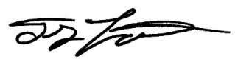

Troy Lautenbach,
President
Lautenbach Industries
DBA: San Juan Transfer Station
360-815-3222 cell

