Corporate Profits Are Soaring. Here's Why It Can't Last

By SHAWN TULLY December 7, 2017
Some of the trends behind America’s earnings boom and stock market surge are about to change. Investors beware.
Milton Friedman wasn’t buying the profit boom. It was late 1997, corporate earnings had surged to heights unseen in over a decade, and the Wall Street crowd was predicting years of near-double-digit gains to come. So I called the Nobel Prize–winning economist, the most celebrated monetarist of the 20th century, to get his take on whether the bull case for long-term profit growth was reasonable—or mostly bull.

The 85-year-old Friedman phoned back, collect as usual, from his office at the Hoover Institution. “Would you accept the charges from Milton?” asked the operator. I said I would, and Friedman got straight to the point. “Beware of predictions that earnings can grow faster than the economy for long periods,” he warned. “When earnings are exceptionally high, they don’t just keep booming.” Eventually, Friedman explained, profits must move back down to their traditional share of GDP. Earnings can get only so high, Friedman said. “They can’t break loose from economic gravity.”
Two decades later, Friedman’s warning is as timely as ever. Earnings are again in the stratosphere: Consider that in the second quarter, corporate profits in the U.S. were equal to 9.5% of GDP vs. the long-term average since 1950 of 6.6%. And Wall Street analysts are forecasting that cumulative earnings per share for the S&P 500 will jump by 11% in 2018 and another 10% in 2019, according to analytics and data provider FactSet.
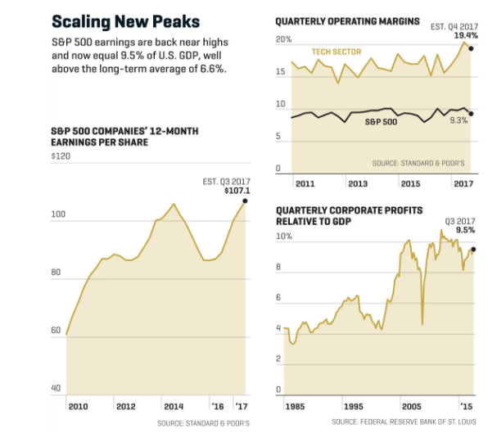
Nic Rapp
Here’s one problem with that projection: The S&P 500’s profit margins are now near all-time highs. Even if they remain elevated, a questionable assumption, earnings can grow only as fast as sales. “And sales grow along with the economy,” says Roger Ibbotson, professor emeritus at Yale and chief of investment firm Zebra Capital. In other words, as Friedman preached, it’s the fundamentals underpinning GDP—basics such as consumer spending and capital investment—that will guide earnings growth in the years ahead. Nobody is projecting GDP growth of 11% in 2018; the consensus, including inflation, is around 4%.
It’s highly uncertain, however, that profits can even manage to climb in step with GDP. That’s because they’re already highly elevated thanks to those super-rich margins. Put simply, U.S. companies have benefited in recent years from an unusual combination of tailwinds—including flat labor costs, super-low interest rates, and, in 2017, a falling dollar. Those factors have outraced a plodding economy, so that the share of the economic pie flowing to corporate profits has swelled while the slice going to labor has shrunk. Last year, wages and salaries were just 43% of GDP—well below the long-term average of 47%.
Those factors are starting to reverse. Labor costs are rising, interest rates are poised to trend higher, and the greenback is starting to strengthen. It all adds up to a looming squeeze on profits. What does that mean for stocks?

