June 25, 2014

Steven V. King, Executive Director and Secretary
Utilities and Transportation Commission
1300 S. Evergreen Park Dr. SW
P.O. Box 47250
Olympia, WA 98504-7250

RE: Washington Utilities and Transportation Commission v. Adam’s Moving and Delivery Service, LLC

Commission Staff’s Response to Application for Mitigation of Penalties TV-140935

Dear Mr. King:

On June 4, 2014, the Utilities and Transportation Commission issued a $1,000 Penalty Assessment in Docket TV-140935 against Adam’s Moving and Delivery Service, LLC for 10 violations of Washington Administrative Code (WAC) 480-15-480, which requires household goods carrier companies to furnish annual reports to the commission no later than May 1 each year.¹

On June 11, 2014, Adam’s Moving and Delivery Service, LLC wrote the commission requesting mitigation of penalties (Mitigation Request).² In its Mitigation Request, Adam’s Moving and Delivery Service, LLC does not dispute that the violation occurred. The company provided an understanding of the seriousness of filing requirements and requests leniency for this oversight referencing prior filing history compliance in support of a favorable mitigation decision.

It is the company’s responsibility to ensure that the regulatory fee is paid and the annual report is filed by the May 1 deadline. On February 28, 2014, Annual Report packets were mailed to all regulated household goods companies. The instructions for annual report completion page of the annual report informed the regulated company that it must complete the annual report form, pay the regulatory fees, and return the materials by May 1, 2014, to avoid enforcement action.

UTC Annual Reports
June 25, 2014
Page 2

On May 29, 2014, Adam’s Moving and Delivery Service, LLC Inc. filed the 2013 annual report and paid the required regulatory fees and late payment penalty. The company has been active since August 7, 2006. No previous violations of WAC 480-15-480 are on commission record. Staff supports the company’s request for mitigation as this is the company’s first delinquent filing. Staff recommends a reduced penalty assessment of $200.

If you have any questions regarding this recommendation, please contact Amy Andrews, Regulatory Analyst, at (360) 664-1157, or aandrews@utc.wa.gov.

Sincerely,

Sondra Walsh, Director
Administrative Services

ATTACHMENT A
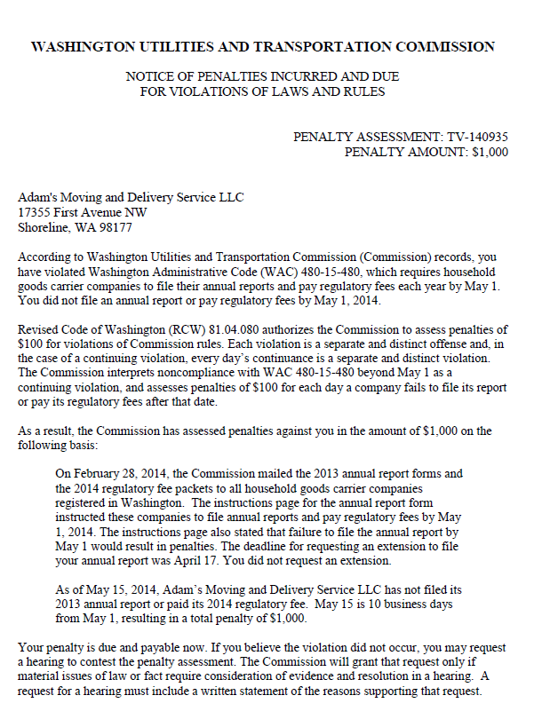

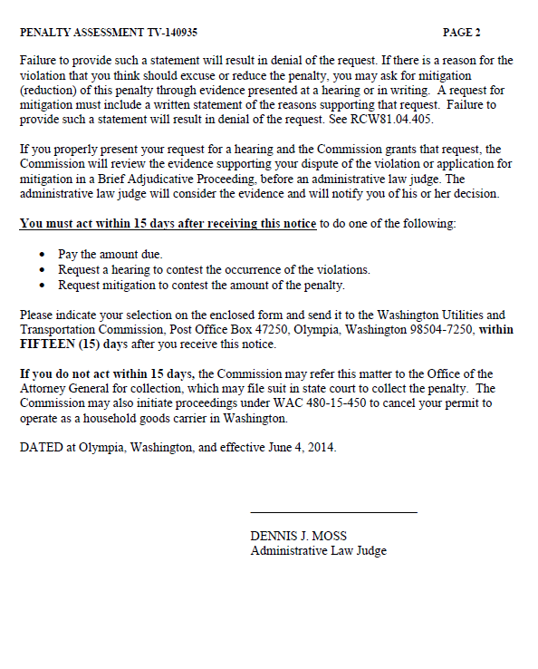

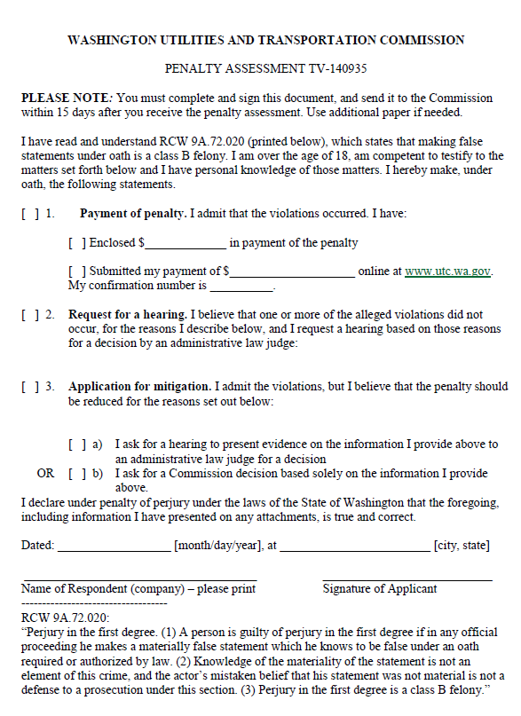

ATTACHMENT B
