November 8, 2012

David W. Danner, Executive Director and Secretary
Washington Utilities and Transportation Commission
1300 S. Evergreen Park Dr. SW
P. O. Box 47250
Olympia, Washington 98504-7250

RE: Washington Utilities and Transportation Commission v. S & S Security Systems, Inc.
Commission Staff’s Response to Application for Mitigation of Penalties
Docket UT-121006

Dear Mr. Danner:

On August 1, 2012, the Washington Utilities and Transportation Commission issued a $375 Penalty Assessment in Docket UT-121006 against S & S Security Systems, Inc., (S & S Security) for 15 violations of Washington Administrative Code (WAC) 480-120-382, which requires competitively classified telecommunications companies to furnish annual reports to the commission no later than May 1 each year.

On August 10, 2012, S & S Security wrote the commission requesting mitigation of penalties (Mitigation Request). In its Mitigation Request, S & S Security does not dispute that the violation occurred. The company states, “I am writing this letter for your consideration to have the penalty waved. I admit that our company failed to submit the annual form by the date that is [sic] was due. I somehow overlooked the form that was mailed. I did not have any tax due so I was not aware that a form was missing for your jurisdiction. As soon as I received your notice that our form had not file, [sic] I filed the form immediately. When filling out the form I realized that we had registered our company with your department incorrectly. I submitted a request for cancellation of registration on 7/17/2012. I am asking for the penalty to be removed since I did not knowing [sic] file the form late and our company did not and will not have any future financial obligation for the tax type report on the annual form.”

It is the company’s responsibility to ensure that the regulatory fee and the annual report are filed by the May 1 deadline. On February 29, 2012, Annual Report forms and Regulatory Fee packets were mailed to all regulated telecommunications companies. In addition to other information, the cover letter informed the regulated company it must complete the annual report form, pay any regulatory fees and return the material by May 1, 2012 to avoid enforcement action. On May 14, 2012, the commission mailed a letter to those companies that had not yet filed an annual report notifying them that, to date, they had incurred a penalty of $800. The letter went on to explain that companies who filed their annual reports no later than May 25, 2012, would receive mitigated penalties of $25 per day, with an additional $25 per day for each instance in the previous five years that the company received a penalty for filing a late report.

S & S Security filed its annual report on May 29, 2012, which is 15 business days past the deadline of May 1, 2012. The penalty was administratively mitigated from $100 per day to $25 per day, for a total of $375. S & S Security has never received a penalty for filing a delinquent annual report in the past. S & S Security has been authorized to provide telecommunications service in Washington state since 2011.

S & S Security stopped offering service in Washington state during the current year but after May 1, 2012. S & S Security is required to file an annual report and pay a regulatory fee.

On July 23, 2012, John Garner of S & S Security submitted the company’s request for cancellation of registration. The registration was cancelled on August 9, 2012.

Commission staff recommends waiving any and all penalties related to S & S Security’s 2011 annual report. The commission’s practice in this scenario is to not enforce the annual report and regulatory fee requirements even though it has the authority to do so.

If you have questions regarding this recommendation, please contact Mathew Perkinson, Compliance Investigator, at (360) 664-1105 or at mperkinson@utc.wa.gov.

Sincerely,

Sharon Wallace, Assistant Director
Consumer Protection and Communications

Attachment A

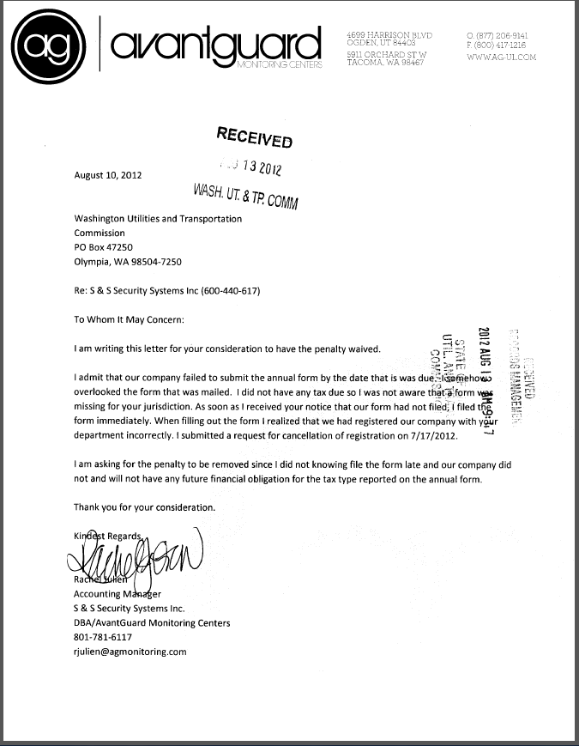
Attachment B

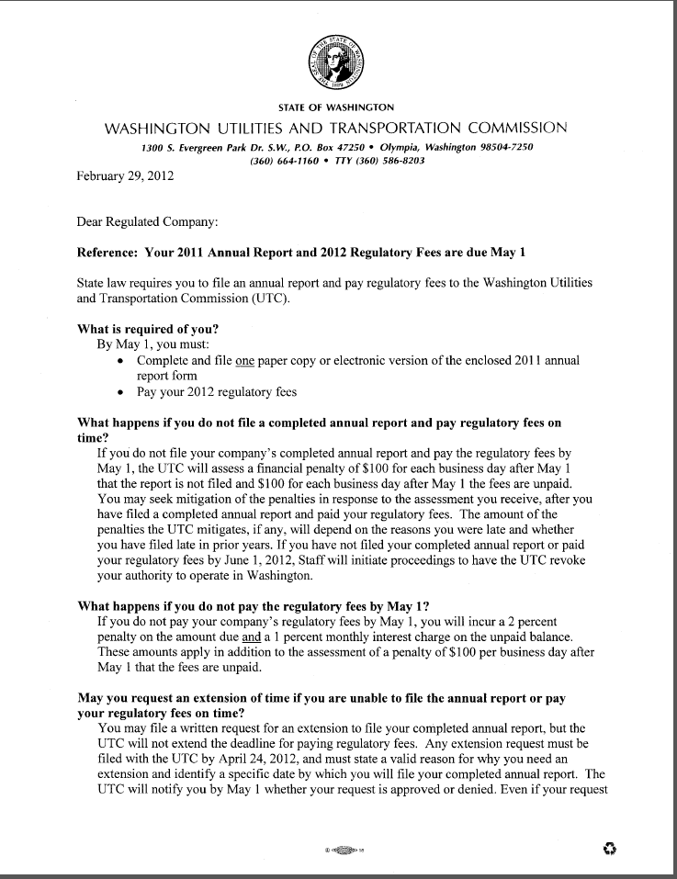
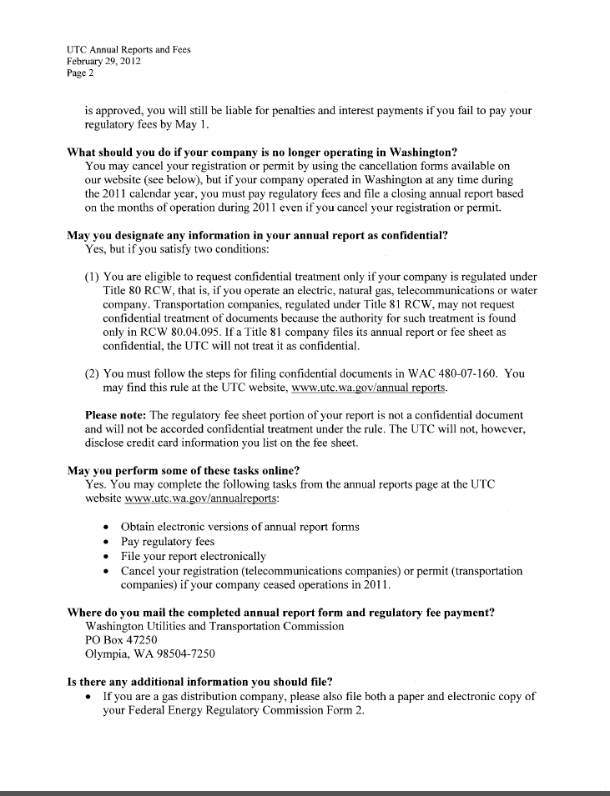
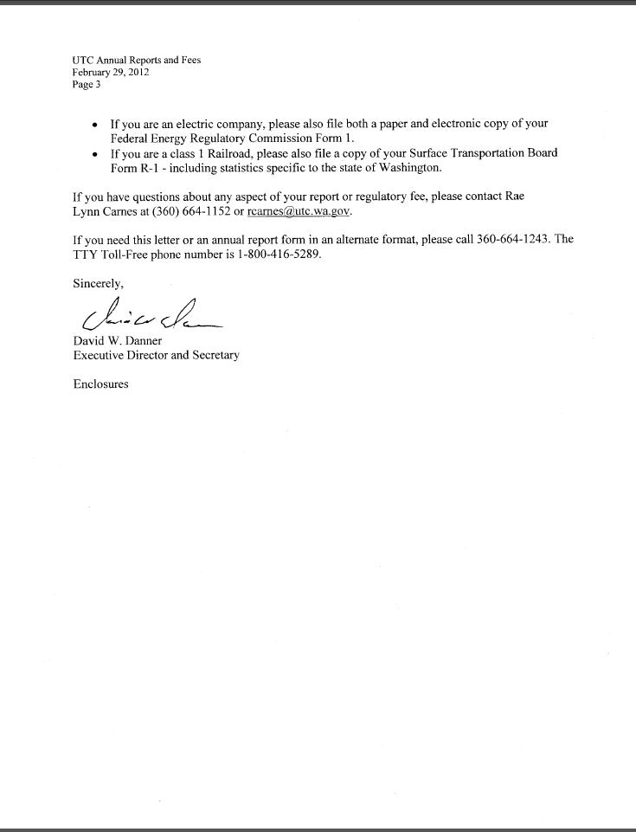
Attachment C
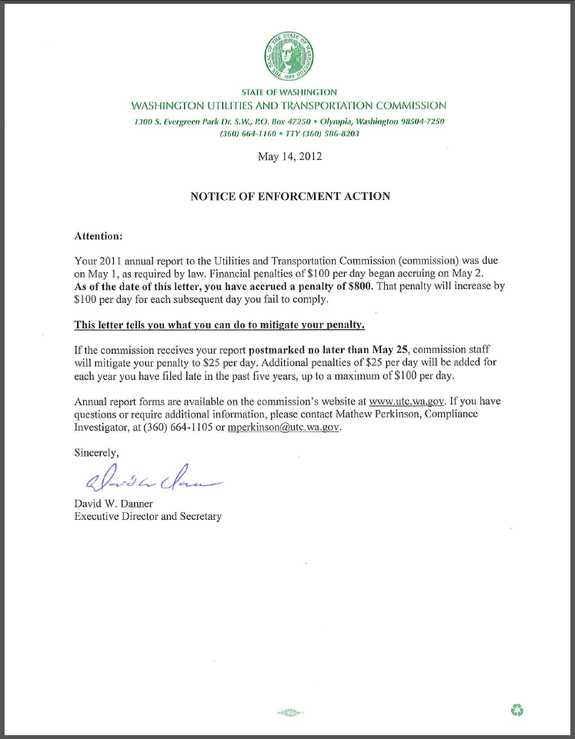

Attachment D

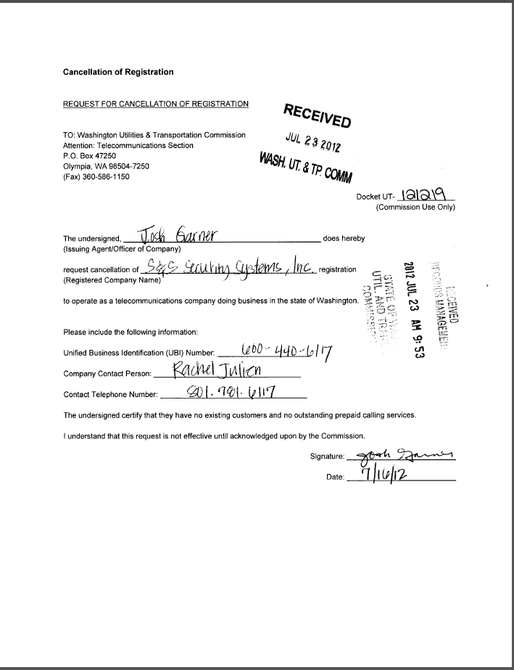

See attachment A for a copy of S & S Security Systems Inc.’s Mitigation Request.
See attachment B for a copy of the letter sent to all regulated companies on February 29, 2012.
See attachment C for a copy of the enforcement letter sent to the company on May 14, 2012.
See attachment D for a copy of the company’s request for cancellation of registration.

