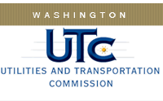

Memorandum

June 30, 2015

To: TR-143833- File

From: Lori Halstead, Transportation Specialist, Rail Safety

Subject: TR-143833 – Washington State Department of Transportation
Completion of Grade Crossing Protective Fund (GCPF) Project
To Upgrade Signs for Increased Public Safety

On December 30, 2014, the Washington Utilities and Transportation Commission (Commission) awarded a GCPF grant totaling $12,250 to Washington State Department of Transportation for a project related to crossing signage improvements. The GCPF grant will pay most of the total costs of the improvements. The total project cost was $12,425.13.

On June 26, 2015, Washington State Department of Transportation submitted a request for reimbursement for the project. Rail Safety staff received pictures of the new signage verifying that the project was completed according to the specifications outlined in the order approving the grant. The total GCPF cost is $12,250.

Please close this docket.

