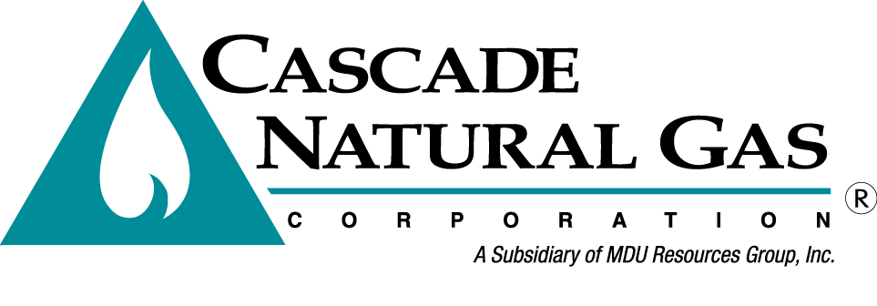
August 10, 2018
8113 W. GRANDRIDGE BLVD., KENNEWICK, WASHINGTON 99336-7166
TELEPHONE 509-734-4500 FACSIMILE 509-737-9803
www.cngc.com

Mr. Mark L. Johnson
Executive Director and Secretary
Washington Utilities & Transportation Commission
P.O. Box 47250
Olympia, WA 98504-7250

Re: UG-170929, Cascade Natural Gas Corporation General Rate Case

Dear Mr. Johnson,

On March 23, 2018, Cascade Natural Gas Corporation (“Cascade”) mailed a CD in its rebuttal case in UG-170929 to the record center. Per Betty Erdahl’s email on August 8, 2018, she is asking Cascade to re-submit the files through the records center portal.

The following files are electronically submitted as part of this filing:

- UG-170929, CNGC BR-12, Attach A, 3.23.18.xlsx
- UG-170929, CNGC BR-12, Attach B, 3.23.18.xlsx
- UG-170929, CNGC Exh BR-13, Customer Count, 3.23.18.xlsx
- UG-170929, CNGC Exh BR-13, Weather Normalization, 3.23.18.xlsx
- UG-170929, CNGC WP RJA-R2 and RJA-R3 Cost of Service Study 03-23-18(C).xlsx
- UG-170929, CNGC Exh MPP 8-14 and WP-3-23-18.xlsx
- UG-170929, CNGC WP RJA-R2 and RJA-R3 Cost of Service Study 03-23-18(R)

Questions regarding this filing should be directed to Michael Parvinen at (509) 734-4593.

Sincerely,

/s/ Michael Parvinen

Michael Parvinen
Director, Regulatory Affairs
Cascade Natural Gas Corporation
8113 W. Grandridge Blvd.
Kennewick, WA 99336-7166
michael.parvinen@cngc.com

Enclosures

