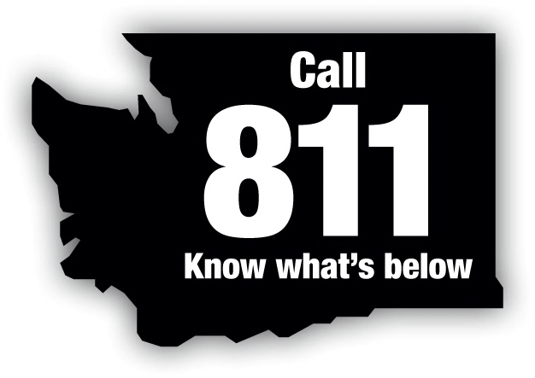

Committee Members Represent:
Local Government
Natural Gas Utility
Contractors
Excavators
Electric Utility
Consumer – Owned Utility
Pipeline Utility
Insurance Industry
Utilities and Transportation Commission
Telecommunications Company
Three At – Large Positions
Washington State Dig Law Safety Committee
A Standing Committee of Washington Utilities Coordinating Council
COMMUNICATION – COOPERATION - COORDINATION
P.O. Box 734 • Poulsbo, WA 98370

February 16, 2017

Steve King, Executive Director and Secretary
Members of the UTC
1300 Evergreen Park Drive SW
Olympia, WA 98504-7250

Re: Review Committee Decision – Case 16-040 – 16-048
Puget Sound Energy vs. Earthscapes NW, Inc.

Dear Mr. King:

The Washington State Dig Law Safety Committee received a series of complaints regarding potential violation of the Washington State Dig Law RCW 19.122 for work performed in 2016. On January 25, 2017 the Review Board of the Safety Committee heard the complaints. The Complainant in these cases is Puget Sound Energy and the Respondent is Earthscapes NW, Inc.

The complainant alleged violation of RCW 19.122.030. The Review Board finds that the respondent, Earthscapes NW, Inc did violate RCW 19.122.030(2) for failure to notify one-call prior to digging and for digging prior to two days for Cases 16-040 and 16-043. After hearing testimony from Earthscapes, Puget Sound Energy withdrew Cases 16-044 through 16-048.

The Review Board recommends the following penalty be assessed to the respondent:

$1000 for violating 19.122.030(2) Case 16-040
$5000 for violating 19.122.030(2) Case 16-043

Penalty assessment recommended by the Review Board totals $6000.
The Review Board further requires mandatory NUCA dig safe training for ownership, management and residential side employees.

Please let me know if you have any questions regarding this case. I can be contacted at 425.430.7212.

Sincerely,

Dave Christensen, Chair

Cc: Lynda Holloway, UTC
Puget Sound Energy
Earthscapes NW, Inc.
www.washington-ucc.org

