February 4, 2016

Mr. Steven King
Executive Director and Secretary
Washington Utilities and Transportation Commission
1300 South Evergreen Park Drive SW
Olympia WA 98504-7250

RE: Tariff Revision – WN U-4 for Ellensburg Telephone Company d/b/a FairPoint Communications; Docket UT-160170

Dear Mr. King:

On February 3, 2016 Ellensburg Telephone Company d/b/a FairPoint Communications submitted a one-day filing in the above referenced docket, to clean-up residual language left in the tariff related to WTAP, which has been removed.

Included in that filing was Second Revised Sheet No. 2. We have since discovered that this page was included in error as no changes have been made at this time. Ellensburg Telephone Company d/b/a FairPoint Communications respectfully requests that this page be withdrawn from the filing.

Please contact Beth Westman at 207.535.4249 or bwestman@fairpoint.com with any questions or concerns regarding this filing.

Sincerely,
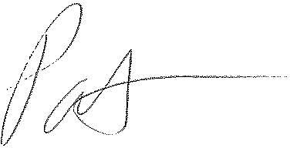
Patrick L. Morse
Senior VP Governmental Affairs
FairPoint Communications
P: 620-227-4409
F: 620-227-8576

