July 3, 2014

Steven V. King, Executive Director and Secretary
Utilities and Transportation Commission
1300 S. Evergreen Park Dr. SW
P.O. Box 47250
Olympia, WA 98504-7250

RE: Washington Utilities and Transportation Commission v. Bergman, Heidi Ann

Commission Staff’s Response to Application for Mitigation of Penalties TV-140945

Dear Mr. King:

On June 4, 2014, the Utilities and Transportation Commission issued a $600 Penalty Assessment in Docket TV-140945 against Bergman, Heidi Ann for 6 violations of Washington Administrative Code (WAC) 480-15-480, which requires household goods carrier companies to furnish annual reports to the commission no later than May 1 each year.¹

On June 19, 2014, Heidi A. Bergman wrote the commission requesting mitigation of penalties (Mitigation Request).² In its Mitigation Request, Heidi A. Bergman does not dispute that the violation occurred. The company statement provided information regarding a recent change in company ownership as of March 2014 and awaiting information from the prior owner before sending in the completed report. The company attempted to contact the commission on May 2nd and left a voicemail for commission staff without receiving a return call for a week. Upon speaking with commission staff on May 9th the report was immediately filed.

It is the company’s responsibility to ensure that the regulatory fee is paid and the annual report is filed by the May 1 deadline. On February 28, 2014, Annual Report packets were mailed to all regulated household goods companies. The instructions for annual report completion page of the annual report informed the regulated company that it must complete the annual report form, pay the regulatory fees, and return the materials by May 1, 2014, to avoid enforcement action.

On May 9, 2014, Bergman, Heidi Ann filed the 2013 annual report and paid the regulatory fees and late payment penalty. On January 10, 2014 the company did submit an application to transfer authority from Terry Munsell, d/b/a/ Alice the Mover, to Heidi Bergman, d/b/a Alice the
UTC Annual Reports
July 3, 2014
Page 2

Mover. The company original household good permit application was received on April 11, 2013. No prior violations of WAC 480-15-480 are on commission record. Staff supports the company’s request for mitigation due to the ownership change and good faith effort of new ownership to comply with commission rules. Staff recommends the penalty be reduced to $25 per day for a total penalty assessment of $150.

If you have any questions regarding this recommendation, please contact Amy Andrews, Regulatory Analyst, at (360) 664-1157, or aandrews@utc.wa.gov.

Sincerely,

Sondra Walsh, Director
Administrative Services

ATTACHMENT A
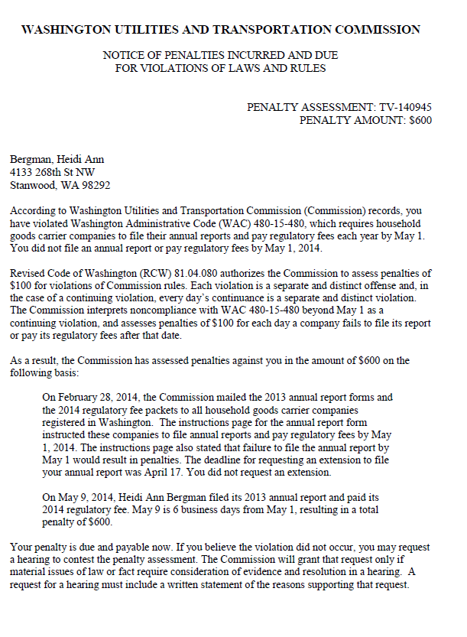

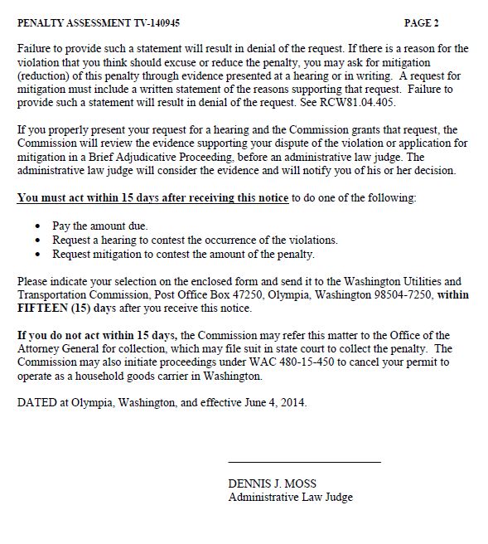

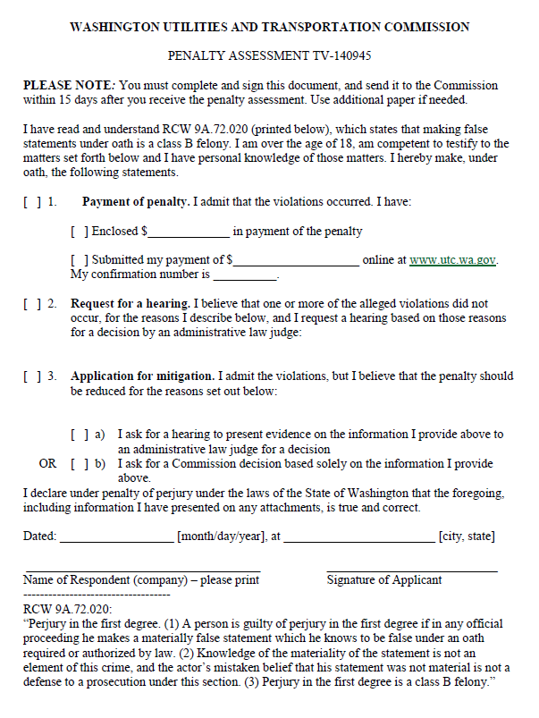

ATTACHMENT B
