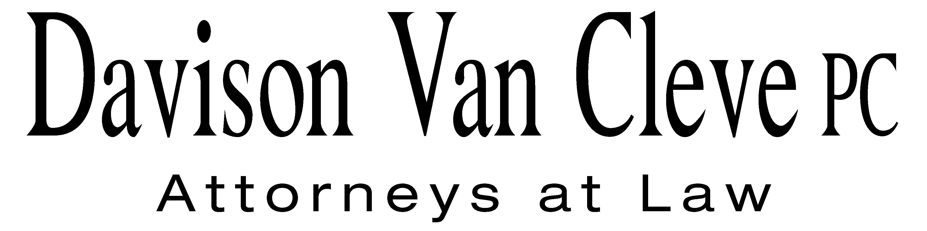
TEL (503) 241-7242 ● FAX (503) 241-8160 ● mail@dvclaw.com
Suite 400
333 SW Taylor
Portland, OR 97204

November 21, 2012

Chair Jeffrey Goltz
Commissioner Phil Jones
Commissioner Patrick Oshie
Washington Utilities and Transportation Commission
PO Box 47250
1300 S Evergreen Park Drive SW
Olympia, WA 98504-7250

Re: Joint Petition of PSE and NW Energy Coalition for an Order Authorizing PSE to Implement Electric Decoupling Mechanisms
Docket No. UE-121697

Dear Commissioners:

The Industrial Customers of Northwest Utilities (“ICNU”) appreciates the opportunity to submit comments regarding its views on the appropriate procedures for review of the Joint Petition of Puget Sound Energy (“PSE”) and the Northwest Energy Coalition (“NWEC”) (jointly, the “Petitioners”) requesting authorization for PSE to implement their decoupling proposal.

As ICNU noted in its letter to the Commission dated November 5, 2012, the appropriate forum and procedure for considering the decoupling proposal filed by the Petitioners is PSE’s next general rate case. The Commission and the parties have devoted a great deal of time and attention to the issue of decoupling over the past several years. The Commission issued its Policy Statement on Regulatory Mechanisms, Including Decoupling in Docket No. U-100522 (the “Policy Statement”) after considering extensive comments presented by over a dozen parties. Numerous workshops were also held in the Policy Statement docket. The Commission concluded that if a utility desires full decoupling, it should be presented in the context of a general rate case./ ICNU urges the Commission to apply its guidance from the Policy Statement and reject the present proposal from the Petitioners.

The Petitioners present a mechanism that acts simultaneously as a full decoupling mechanism and also as a means to recover PSE’s claimed attrition losses, which makes it even more important that this proposal be considered in a general rate case, wherein all of PSE’s costs and revenues can be considered. For example, such an aggressive proposal would warrant careful evaluation of a cost of capital adjustment. PSE’s current return on equity appears to be out of line with the current financial and economic environment. There are many other issues that warrant consideration in the context of a general rate case.

The Petitioners’ full decoupling and attrition mechanism would represent a radical change to the Commission’s traditional ratemaking procedures. Therefore, if the Commission determines that the Petitioners’ mechanism should be considered in this docket, it is important that the Commission and the parties have the opportunity for the fullest possible review. If the Petition is not rejected, ICNU recommends that the Commission open a contested case proceeding including full discovery rights and the right to a hearing.

Thank you for your consideration of ICNU’s comments.

Sincerely yours,

/s/ Melinda J. Davison
Melinda J. Davison

cc: Sheree Strom Carson
Simon ffitch
Don Trotter
Tommy Brooks
Todd True

/ Re WUTC Investigation into Energy Conservation incentives, Docket No. U-100522, Report and Policy Statement on Regulatory Mechanism, Including Decoupling at ¶¶ 18, 28 (Nov. 4, 2010).

