TATOOSH WATER COMPANY 15TH AVE WATER MAIN EXTENSION
REVISION
LEED ACCREDITED PROFESSIONAL" & THE RELATED ACRONYM, & THE LEGACY LEED AP LOGO ARE TRADEMARKS OWNED BY THE U.S. GREEN BUILDING COUNCIL & ARE AWARDED TO INDIVIDUALS UNDER LICENSE BY THE GREEN BUILDING CERTIFICATION INSTITUTE.
ARLINGTON, WA
DATE
BY
TM

SKAGIT COUNTY SNOHOMISH COUNTY
CAD FILE NUMBER: P:\CLIENTS-WATER\TATOOSH\DEVELOPER EXTENSION\DWG\DRAWING\TATOOSH_WM EXTENSION.DWGLAST MODIFIED BY: GREG - SAVE DATE: 6/18/2018 11:11 AM - SHEET SET: TATOOSH WM EXTENSION - ORIGINAL SHEET SIZE: ARCH FULL BLEED D (24.00 X 36.00 INCHES)AUTOCAD VERSION: CIVIL 3D 2015
No.
2210 Riverside Drive
Suite 210 Mount Vernon WA 98273
P: 360.899.1110
F: 360.331.5131
www.dcgengr.com

STANWOOD

ARLINGTON
DARRINGTON

PORT SUSAN
MARYSVILLE

GRANITE FALLS

EVERETT
LAKE STEVENS

Jeffrey M.

Digitally signed by Jeffrey M. Tasoff, PE
Reason: I am approving this
document

MUKILTEO
Tasoff, PE Date: 2018.06.19 11:21:24 -07'00'
41424

EDMONDS WOODWAY

MILL CREEK

BOTHELL

MONROE

SULTAN
GOLD BAR

SNOHOMISH COUNTY KING COUNTY

BASE MAP/TOPOGRAPHY PROVIDED BY OTHERS. DCG CANNOT BE HELD LIABLE FOR ACCURACY. CONTRACTOR SHALL FIELD VERIFY GRADES, UTILITIES, & ALL OTHER EX FEATURES & CONDITIONS. IF CONDITIONS ARE NOT AS SHOWN &/OR PLANS CANNOT BE CONSTRUCTED AS SHOWN, CONTACT DCG PRIOR TO CONSTRUCTION.

SNOHOMISH COUNTY MAP
TATOOSH WATER COMPANY 14263 CALHOUND ROAD MOUNT VERNON, WA 98273
TATOOSH WATER
15TH AVE NE WATER MAIN EXTENSION COVER SHEET
NOT TO SCALE

PROJECT INFORMATION:
DRAWING LIST
DRAWING NO. | PLAN NO. | DRAWING TITLE
1 | C01 | COVER SHEET
2 | C02 | NOTES
3 | C03 | STREAM CROSSING PLAN VIEW
4 | C04 | PLAN & PROFILE - 15TH AVE
5 | C05 | PLAN & PROFILE - 15TH AVE
6 | C06 | PLAN & PROFILE - 15TH AVE
7 | C07 | PLAN & PROFILE - 15TH AVE
8 | C08 | DETAILS
9 | C09 | DETAILS

APPLICANT:

TATOOSH WATER COMPANY 14263 CALHOUND ROAD MOUNT VERNON, WA 98273

CIVIL ENGINEER:
JEFFREY M. TASOFF, P.E.
DAVIDO CONSULTING GROUP, INC. 2210 RIVERSIDE DRIVE SUITE 210 MOUNT VERNON, WA 98273
OWNER:
PROJECT:

PROJ. MANAGER: DESIGNED BY: DRAWN BY: CHECKED BY: SCALE:

JT SG RB JT
AS SHOWN

DATE:
REV. SHEET
1

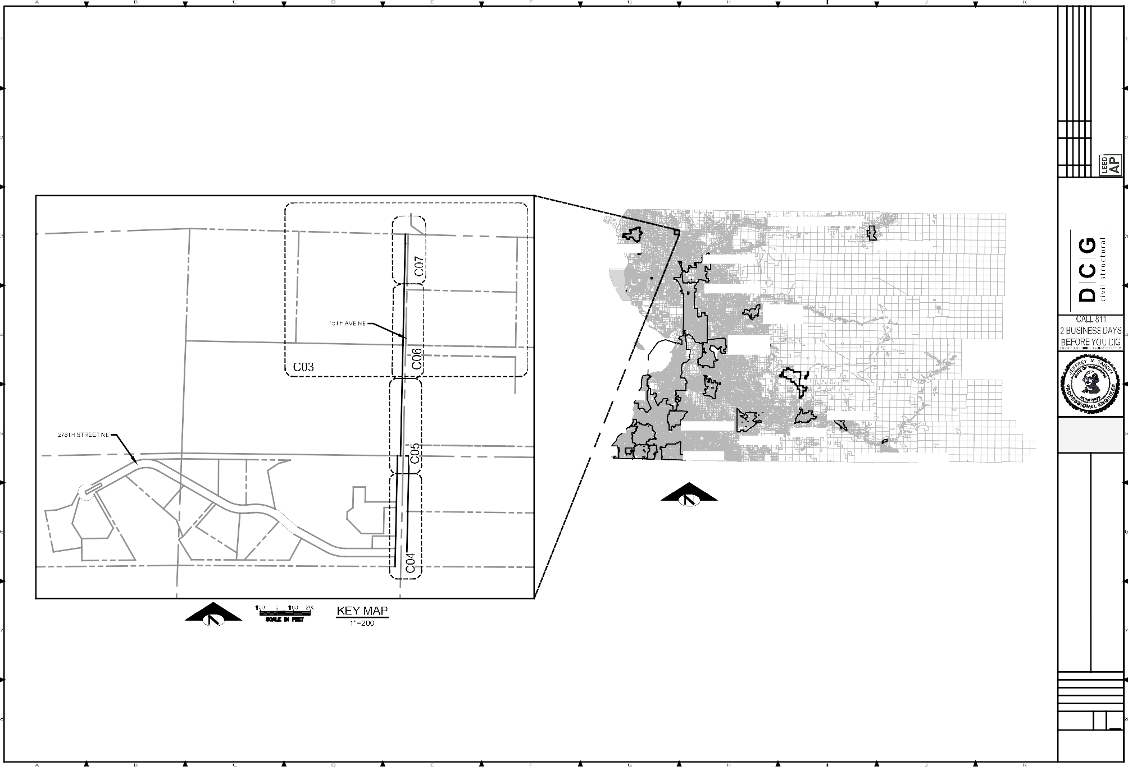
6/19/2018 A OF
9
SHEET NUMBER
C01

WATER NOTES: EROSION AND SEDIMENTATION CONTROL (ESC) NOTES: GENERAL NOTES:  - WATER MAINS, VALVES, FITTINGS, HYDRANTS, SERVICES, AND ALL OTHER COMPONENTS SHALL BE 1. THE CONTRACTOR SHALL MEET ISLAND COUNTY STANDARDS AND REQUIREMENTS BY USING 1. THE CONTRACTOR SHALL NOTIFY JURISDICTION A MINIMUM OF 24 HOURS PRIOR TO STARTING ANY WORK. INSTALLED AND PRESSURE TESTED IN ACCORDANCE WITH THE STANDARD SPECIFICATIONS FOR ROAD AND APPROPRIATE BEST MANAGEMENT PRACTICES (BMPS) FOR EROSION AND SEDIMENTATION CONTROL.  BRIDGE AND MUNICIPAL CONSTRUCTION, WASHINGTON STATE DEPARTMENT OF TRANSPORTATION, SECTION 2. THE CONTRACTOR SHALL NOTIFY THE UNDERGROUND UTILITY LOCATE CENTER AT 1-800-424-5555 AT LEAST 7-09. 2. EROSION ON- AND OFF-SITE. DURING AND AFTER CONSTRUCTION, THE CONTRACTOR SHALL 48 HOURS PRIOR TO CONSTRUCTION.  MINIMIZE EROSION AND SEDIMENTATION ON-SITE AND SHALL PROTECT PROPERTIES AND WATER  - THE CONTRACTOR SHALL GIVE THE TATOOSH WATER COMPANY AND WATER AND WASTEWATER SERVICE COURSES DOWNSTREAM FROM THE SITE FROM EROSION DUE TO INCREASES IN THE VELOCITY AND 3. THE CONTRACTOR SHALL PROTECT IN PLACE, ALL UTILITIES, STRUCTURES AND FEATURES, WHETHER OR 360-466-4443 A MINIMUM OF 72 HOURS NOTICE OF ANY PLANNED CONNECTION TO AN EXISTING PIPELINE. PEAK FLOW RATE OF STORM WATER RUNOFF FROM THE SITE. NOT SHOWN ON THESE PLANS. ANY DAMAGE TO EXISTING UTILITIES OR FEATURES SHALL BE REPAIRED AT THIS INCLUDES LIVE TAPS. NOTICE IS REQUIRED SO ANY DISRUPTIONS TO EXISTING SERVICES CAN BE THE CONTRACTOR'S EXPENSE.  SCHEDULED. THE CONTRACTOR SHALL NOTIFY CUSTOMERS INVOLVED OR AFFECTED OF THE WATER 3. TRANSPORT OF SEDIMENT. THE CONTRACTOR SHALL PREVENT THE TRANSPORT OF SEDIMENT FROM  SERVICE INTERRUPTION 24 HOURS IN ADVANCE OF THE INTERRUPTION. THE CONTRACTOR SHALL MAKE THE SITE THROUGH MEASURES SUCH AS MULCHING, MATTING, COVERING, SILT FENCES, SEDIMENT 4. LOCATIONS OF EXISTING FEATURES AND UTILITIES AS SHOWN ON THESE DRAWINGS ARE APPROXIMATE EVERY EFFORT TO SCHEDULE WATER MAIN CONSTRUCTION WITH A MINIMUM INTERRUPTION OF WATER TRAPS, SETTLING PONDS AND PROTECTIVE BERMS USING THE FOLLOWING BMPS: FILTER FENCE, AND BASED ON THE BEST AVAILABLE INFORMATION. ACTUAL LOCATIONS SHALL BE DETERMINED BY THE SERVICE. STRAW BALE BARRIER, BRUSH BARRIER, GRAVEL FILTER BERM, SEDIMENT TRAP, TEMPORARY CONTRACTOR.  SEDIMENT POND, PRESERVING NATURAL VEGETATION, AND/OR BUFFER ZONES. TRANSPORT OF  - IN CERTAIN SITUATIONS, THE ASSOCIATION MAY DICTATE SCHEDULING OF WATER MAIN SHUTDOWNS SO AS SEDIMENT ONTO PAVED SURFACES SHALL BE MINIMIZED, AND IF SEDIMENT IS TRANSPORTED ONTO A 5. THE CONTRACTOR SHALL BE RESPONSIBLE FOR THE MEANS, METHODS AND SEQUENCE OF CONSTRUCTION. NOT TO IMPOSE UNNECESSARY SHUTDOWNS DURING SPECIFIC PERIODS TO EXISTING CUSTOMERS. PAVED SURFACE, THE PAVED SURFACE SHALL BE CLEANED AT THE END OF EACH DAY IN  ACCORDANCE WITH BMPS IN THE DRAINAGE MANUAL, OR APPROVED BY THE DIRECTOR. 6. ALL WORK SHALL CONFORM TO CURRENT APPROVED STANDARD PLANS AND WSDOT/APWA STANDARD  - ALL WATER MAINS SHALL BE PVC SCH 80 (2" OR LESS), PVC C900, OR DI CLASS 52 PIPE AS SPECIFIED ON THE SPECIFICATIONS FOR ROAD, BRIDGE, AND MUNICIPAL CONSTRUCTION. PLANS. HIGH DENSITY POLYETHYLENE (HDPE) PIPE SDR 9 MAY BE USED IN PLACE OF PVC SPECIFIED ON 4. STABILIZING EXPOSED SOIL. THE CONTRACTOR SHALL PREVENT ON-SITE EROSION BY STABILIZING  PLANS. HDPE PIPE SHALL BE BLACK PE 3408 MADE OF NEW RESINS AND MEETING THE REQUIREMENTS OF ALL SOILS THAT ARE TEMPORARILY EXPOSED AND NOT BEING ACTIVELY WORKED, THROUGH SUCH 7. THE CONTRACTOR SHALL BE REQUIRED TO KEEP ACCURATE AS-BUILT DRAWINGS AND DELIVER THIS  ASTM D 3350 CELL CLASSIFICATION 345464C, ASTM F714, AWWA C901, AND AWWA C906. PROVISIONS FOR METHODS AS THE INSTALLATION OF SEEDING, MULCHING, MATTING AND COVERING. CONTRACTOR INFORMATION TO THE OWNER FOR PREPARATION OF AS-BUILT DRAWINGS. PIPE EXPANSION MUST BE ACCOUNTING FOR WHEN INSTALLING HDPE PIPING. SHALL APPLY ONE OR MORE OF THE FOLLOWING TEMPORARY ESC BMPS: TEMP SEEDING, MULCHING  AND MATTING, CLEAR PLASTIC COVERING, AND/OR DUST CONTROL. 8. WATER MAINS SHALL BE PROPERLY DISINFECTED, FLUSHED, AND HAVE A SATISFACTORY BACTERIOLOGICAL  - WATER MAIN FITTINGS SHALL BE DUCTILE IRON. DUCTILE IRON FITTINGS SHALL MEET THE REQUIREMENTS TEST RESULTS FROM A WATER SAMPLE COLLECTED FROM THE PIPE BEFORE ENTERING SERVICE.  OF AWWA C153 AND JOINTS SHALL MEET THE REQUIREMENTS OF AWWA C111. DUCTILE IRON FITTINGS 5. DENUDED AREAS SHALL BE STABILIZED AND SOIL STOCKPILES AS ESTABLISHED IN THE DRAINAGE  SHALL BE CEMENT MORTAR LINED, MEETING THE REQUIREMENTS OF AWWA C104. GASKETS FOR FLAT MANUAL. 9. UTILITY SERVICE INTERRUPTIONS SHALL NOT EXCEED TWO HOURS. FACED OR RAISED FACED FLANGES SHALL BE 1/8-INCH THICK NEOPRENE HAVING A DUROMETER OF 60 PLUS  OR MINUS 5 OR 1/16-CLOTH INSERTED. THE TYPE, MATERIAL, AND IDENTIFICATION MARK FOR BOLTS AND 6. STORM DRAIN INLETS SHALL BE PROTECTED USING BMP STORM DRAIN INLET PROTECTION. THE 10. 24 HOUR NOTICE SHALL BE PROVIDED TO ALL PROPERTY OWNERS/OCCUPANTS OF ANY UTILITY SERVICE OR NUTS SHALL BE PROVIDED. BOLTS, NUTS, AND WASHERS USED FOR SECURING FITTINGS SHALL BE OF RECOMMENDED INLET PROTECTION ALTERNATIVES ARE TRIANGULAR SILT DIKES; BIOLOGS; EXERTS ACCESS INTERRUPTIONS.  SIMILAR MATERIALS. STEEL BOLTS SHALL MEET THE REQUIREMENTS OF ASTM A 307 OR ASTM F 568 FOR (FOSS ENVIRONMENTAL); DANDY BAGS; AND, STRAW WATTLES.  CARBON STEEL OR ASTM F 593 OR ASTM F 738 FOR STAINLESS STEEL. NUTS SHALL MEET THE 11. ONE LANE TRAFFIC MUST BE MAINTAINED AT ALL TIMES ON COUNTY ROADS. ROAD CLOSURES WILL NOT BE  REQUIREMENTS OF ASTM A 563 OR ASTM A 563 FOR CARBON STEEL OR ASTM F 594 OR ASTM F 836 FOR 7. NO MORE THAN THREE HUNDRED (300) FEET OF TRENCH MAY REMAIN OPEN AT ONE TIME. ALLOWED UNLESS EXPRESSLY AUTHORIZED AND APPROVED BY ISLAND COUNTY. STAINLESS STEEL. IRON BOLTS AND NUTS SHALL MEET THE REQUIREMENTS OF ASTM A 536, GRADE 65-45-12. EXCAVATED MATERIAL SHALL BE PLACED ON THE UPHILL SIDE OF TRENCHES, UNLESS INCONSISTENT  WITH SAFETY OR SITE CONSTRAINTS. 12. PROPER SIGNAGE AND FLAGGERS ARE REQUIRED PER THE MUTCD. FLAGGERS SHALL HAVE CURRENT  - ALL NON-METALLIC PIPE AND SERVICES SHALL BE INSTALLED WITH CONTINUOUS TRACER TAPE INSTALLED CARDS INDICATING THAT THEY ARE QUALIFIED TO PERFORM THE REQUIRED TRAFFIC CONTROL.  12 TO 18 INCHES UNDER THE FINAL GROUND SURFACE. NO BREAKS OR SPLICES WILL BE ALLOWED. A 8. DISCHARGE FROM DEWATERING DEVICES. WATER FROM A DEWATERING DEVICE SHALL DISCHARGE  CONTINUOUS LOOP SHALL BE PLACED FROM THE MAIN LINE TO THE METER BOX AND BACK TO THE MAIN INTO A SEDIMENT-RETENTION BMP. 13. ACCESS TO PRIVATE PROPERTY SHALL BE RESTORED DAILY. LINE. THE MARKER SHALL BE PLASTIC NON-BIODEGRADABLE, METAL CORE OR BACKING WHICH CAN BE  DETECTED BY A STANDARD METAL DETECTOR. TAPE SHALL BE TERRA TAPE "D" OR APPROVED EQUAL. IN 9. MAINTENANCE AND REPAIR OF EROSION AND SEDIMENTATION CONTROL MEASURES. THE 14. STREETS SHALL BE SWEPT DAILY OR AS NEEDED. ADDITION TO TRACER TAPE, INSTALL 14 GAUGE COATED COPPER WIRE, TAPED TO THE TOP OF PIPE, CONTRACTOR SHALL MAINTAIN AND REPAIR AS NECESSARY ALL TEMPORARY AND PERMANENT  BROUGHT UP AND TIED OFF AT VALVE BODY. EROSION AND SEDIMENTATION CONTROL BMPS TO ASSURE THEIR CONTINUED PERFORMANCE.  - THE MINIMUM COVER FOR ALL WATER MAINS FROM TOP OF PIPE TO FINISH GRADE SHALL BE 36 INCHES 10. TEMPORARY EROSION AND SEDIMENTATION CONTROL MEASURES SHALL BE MAINTAINED UNTIL FINAL UNLESS OTHERWISE APPROVED BY THE ENGINEER. SITE STABILIZATION.  - ALL VALVES AND FITTINGS SHALL BE DUCTILE IRON WITH ANSI FLANGES OR MECHANICAL JOINT ENDS. ALL EXISTING VALVES SHALL BE OPERATED BY DISTRICT PERSONNEL. VALVE BOXES SHALL BE INSTALLED ON ALL BURIED VALVES. THE BOX SHALL BE OF CAST IRON, TWO-PIECE SLIP TYPE, 5-1/4 INCH SHAFT, WITH A  BASE CORRESPONDING TO THE SIZE OF THE VALVE. THE COVER SHALL HAVE THE WORD "WATER" CAST IN IT. UNANTICIPATED DISCOVERY PLAN: ENVIRONMENTAL NOTES:  THE VALVE BOX SHALL BE TYLER PIPE 6855 SERIES OR EQUAL APPROVED BY THE DISTRICT. THE COVER  SHALL BE A TYLER PIPE STANDARD DROP LID 145325 OR EQUAL APPROVED BY THE DISTRICT. 1. IF EARTH DISTURBING ACTIVITIES DURING PROJECT CONSTRUCTION UNCOVER CULTURAL 1. EQUIPMENT MUST MEET CURRENT STATE OF WASHINGTON REGULATIONS FOR NOISE. NOISE PRODUCING  MATERIALS (I.E. STRUCTURAL REMAINS, HISTORIC ARTIFACTS, OR PREHISTORIC ARTIFACTS), ALL EQUIPMENT WILL BE LOCATED IN ENCLOSURES WITH ACOUSTIC PANELS DESIGNED TO REDUCE NOISE.  - GATE VALVES, 6 INCH TO 12 INCH. THE DESIGN, MATERIALS AND WORKMANSHIP OF ALL GATE VALVES SHALL WORK SHALL CEASE AND THE WASHINGTON STATE ARCHAEOLOGIST AT THE DEPARTMENT OF  CONFORM TO, OR EXCEED THE REQUIREMENTS OF AWWA C509-80 LATEST REVISION. GATES VALVES SHALL ARCHAEOLOGY AND HISTORIC PRESERVATION (DAHP), THE HISTORY/ARCHAEOLOGY OFFICE OF THE 2. CONSTRUCTION ACTIVITIES WILL BE SCHEDULED TO REDUCE TRAFFIC, DUST AND NOISE IMPACTS IN BE RESILIENT SEAT NON-RISING STEM (NRS) WITH TWO INTERNAL O-RING STEM SEALS. GATE VALVES SHALL SWINOMISH AND TULALIP TRIBES, THE CULTURAL RESOURCES PROGRAM OF THE SWINOMISH AND RESIDENTIAL AREAS.  TULALIP TRIBES, AND THE RURAL DEVELOPMENT STATE ENVIRONMENTAL COORDINATOR (RD SEC)  BE MUELLER A-2360. GATE VALVES SHALL BE USED ON ALL 6 TO 12 INCH LINES. SHALL BE NOTIFIED IMMEDIATELY. 3. THE APPLICANT SHALL OBTAIN ANY NECESSARY PERMITS FROM LOCAL AND OTHER GOVERNMENTAL  - VALVE BOX. ALL VALVES SHALL HAVE A STANDARD CAST IRON WATER VALVE BOX SET TO GRADE. IF VALVES 2. IF HUMAN REMAINS ARE UNCOVERED, ALL WORK SHALL CEASE IMMEDIATELY IN ACCORDANCE WITH AGENCIES.  ARE NOT SET IN PAVED AREA, A 3 FOOT BY 3 FOOT BY 4 INCH CONCRETE PAD SHALL BE SET AROUND EACH THE NATIVE AMERICAN GRAVES PROTECTION AND REPATRIATION ACT OF 1990 (NAGPRA) AND 4. WORK IN PUBLIC RIGHT-OF-WAYS SHALL HAVE ALL NECESSARY PERMITS. VALVE BOX AT FINISHED GRADE. IN AREAS WHERE VALVE BOX FALLS IN ROAD SHOULDER, THE DITCH AND WASHINGTON STATE STATUTES RCW 27.44. THE AREA AROUND THE DISCOVERY SHALL BE SECURED  SHOULDER SHALL BE GRADED BEFORE PLACING ASPHALT OR CONCRETE PAD. AND THE ISLAND COUNTY CORONER AND THE STATE ARCHEOLOGIST AT DAHP SHALL BE NOTIFIED 5. WORK ON THIS PROJECT SHALL BE NO EARLIER THAN TWO HOURS AFTER SUNRISE AND NO LATER THAN  IMMEDIATELY. THE STATE ARCHEOLOGIST SHALL NOTIFY RD SEC AND SWINOMISH AND AND TULALIP TWO HOURS BEFORE SUNSET TO ACCOMMODATE LOCAL NESTING BALD EAGLES.  - VALVE MARKER POST. VALVE MARKER POSTS SHALL BE 4 INCH X 4 INCH REINFORCED CONCRETE OR TRIBES.  SCHEDULE 40 STEEL POSTS 5 FEET LONG, WITH 2 FOOT MINIMUM BURY, STAMPED WITH "W" AND DISTANCE 3. CONSTRUCTION SHALL BE HALTED OR SHIFTED TO A NEW LOCATION PENDING THE NOTIFICATION TO VALVE. POST SHALL BE PAINTED WITH 1 BASE COAT AND 2 COATS BLUE OIL BASE ENAMEL. PROCESS AND FURTHER INSTRUCTIONS ISSUED BY THE AGENCY AFTER CONULTATION WITH THE  STATE HISTORIC PRESERVATION OFFICE, SWINOMISH AND TULALIP TRIBES, AND OTHER  - ALL FORM RELEASE AGENTS AND ADMIXTURES USED IN THE CONCRETE WORK MUST CONFORM TO NSF 60 APPROPRIATE AUTHORITIES. REQUIREMENTS. | REVISION |  |  |  |  | LEED ACCREDITED PROFESSIONAL" & THE RELATED  TM  OWNED BY THE U.S. GREEN BUILDING COUNCIL & ARE AWARDED TO INDIVIDUALS UNDER LICENSE BY THE GREEN BUILDING CERTIFICATION INSTITUTE.
 | BY
 | DATE
 | No.
2210 Riverside Drive
Suite 210 Mount Vernon WA 98273
P: 360.899.1110
F: 360.331.5131
www.dcgengr.com
Jeffrey M. Digitally signed by Jeffrey M.
Tasoff, PE
Reason: I am approving this
Tasoff, PE Date: 2018.06.19 11:22:27 -07'00'
document

41424
 | BASE MAP/TOPOGRAPHY PROVIDED BY OTHERS. DCG CANNOT BE HELD LIABLE FOR ACCURACY. CONTRACTOR SHALL FIELD VERIFY GRADES, UTILITIES, & ALL OTHER EX FEATURES & CONDITIONS. IF CONDITIONS ARE NOT AS SHOWN &/OR PLANS CANNOT BE CONSTRUCTED AS SHOWN, CONTACT DCG PRIOR TO CONSTRUCTION.
 | OWNER: TATOOSH WATER COMPANY 14263 CALHOUND ROAD  MOUNT VERNON, WA 98273 |  |  |  |  | PROJECT:  15TH AVE NE WATER MAIN EXTENSION NOTES
 | PROJ. MANAGER: JT
 | DESIGNED BY: SG
 | DRAWN BY: RB
 | CHECKED BY: JT
 | SCALE: AS SHOWN
 | DATE:  6/19/2018 |  |  |  |  |  | REV.  A | SHEET  2  OF  9
SHEET NUMBER
C02
CAD FILE NUMBER: P:\CLIENTS-WATER\TATOOSH\DEVELOPER EXTENSION\DWG\DRAWING\TATOOSH_WM EXTENSION.DWGLAST MODIFIED BY: GREG - SAVE DATE: 6/18/2018 11:11 AM - SHEET SET: TATOOSH WM EXTENSION - ORIGINAL SHEET SIZE: ARCH FULL BLEED D (24.00 X 36.00 INCHES)AUTOCAD VERSION: CIVIL 3D 2015
TATOOSH WATER
ACRONYM, & THE LEGACY LEED AP LOGO ARE TRADEMARKS

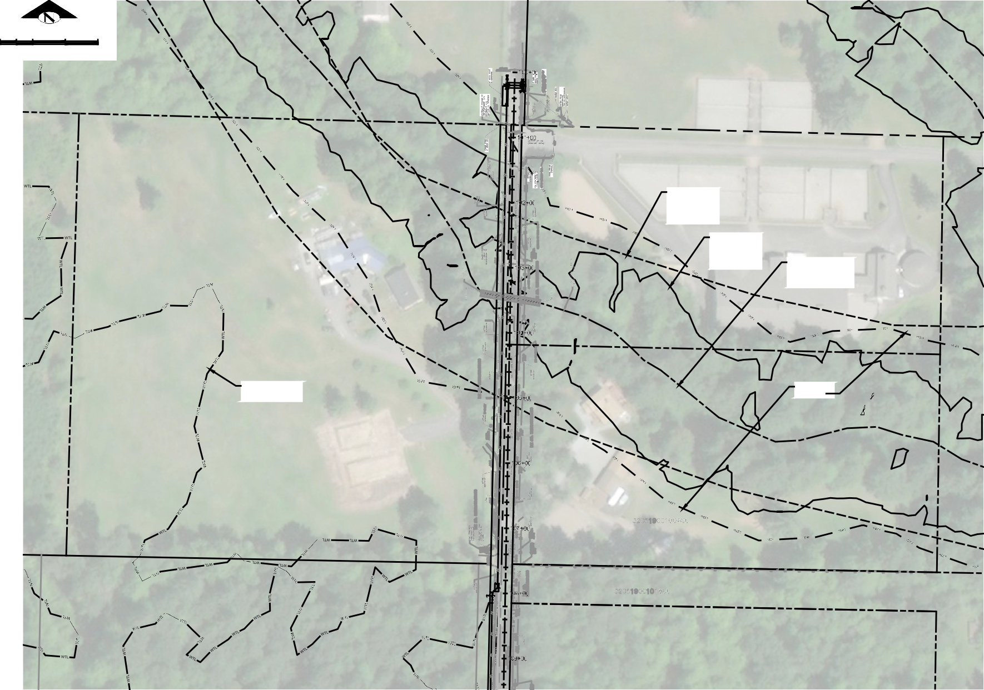
TATOOSH WATER
ACRONYM, & THE LEGACY LEED AP LOGO ARE TRADEMARKS
50 25 0 50 100  SCALE IN FEET  APPROX  SOIL EROSION HAZARD AREAS PER SNOHOMISH COUNTY GIS  APPROX LANDSLIDE HAZARD AREAS  PER SNOHOMISH APPROX STREAM  COUNTY GIS CENTERLINE PER  SNOHOMISH COUNTY GIS, STREAM TYPE F  APPROX WETLAND 150' STREAM  LIMITS PER SNOHOMISH SETBACK  COUNTY GIS  PLAN  SCALE: 1"=50' | REVISION |  |  |  |  | LEED ACCREDITED PROFESSIONAL" & THE RELATED  TM  OWNED BY THE U.S. GREEN BUILDING COUNCIL & ARE AWARDED TO INDIVIDUALS UNDER LICENSE BY THE GREEN BUILDING CERTIFICATION INSTITUTE.
 | BY
 | DATE
 | No.
2210 Riverside Drive
Suite 210 Mount Vernon WA 98273
P: 360.899.1110
F: 360.331.5131
www.dcgengr.com
Jeffrey M. Tasoff, PE
Digitally signed by Jeffrey M.

Reason: I am approving this
Tasoff, PE Date: 2018.06.19 11:22:47 -07'
document

41424
 | BASE MAP/TOPOGRAPHY PROVIDED BY OTHERS. DCG CANNOT BE HELD LIABLE FOR ACCURACY. CONTRACTOR SHALL FIELD VERIFY GRADES, UTILITIES, & ALL OTHER EX FEATURES & CONDITIONS. IF CONDITIONS ARE NOT AS SHOWN &/OR PLANS CANNOT BE CONSTRUCTED AS SHOWN, CONTACT DCG PRIOR TO CONSTRUCTION.
 | OWNER: TATOOSH WATER COMPANY 14263 CALHOUND ROAD  MOUNT VERNON, WA 98273 |  |  |  |  | PROJECT:  15TH AVE NE WATER MAIN EXTENSION STREAM CROSSING PLAN VIEW
 | PROJ. MANAGER: JT
 | DESIGNED BY: SG
 | DRAWN BY: RB
 | CHECKED BY: JT
 | SCALE: AS SHOWN
 | DATE:  6/19/2018 |  |  |  |  |  | REV.  A | SHEET  3  OF  9
SHEET NUMBER
C03

00'
CAD FILE NUMBER: P:\CLIENTS-WATER\TATOOSH\DEVELOPER EXTENSION\DWG\DRAWING\TATOOSH_WM EXTENSION.DWGLAST MODIFIED BY: GREG - SAVE DATE: 6/18/2018 11:11 AM - SHEET SET: TATOOSH WM EXTENSION - ORIGINAL SHEET SIZE: ARCH FULL BLEED D (24.00 X 36.00 INCHES)AUTOCAD VERSION: CIVIL 3D 2015

20 10 0
CAD FILE NUMBER: P:\CLIENTS-WATER\TATOOSH\DEVELOPER EXTENSION\DWG\DRAWING\TATOOSH_WM EXTENSION.DWGLAST MODIFIED BY: GREG - SAVE DATE: 6/18/2018 11:11 AM - SHEET SET: TATOOSH WM EXTENSION - ORIGINAL SHEET SIZE: ARCH FULL BLEED D (24.00 X 36.00 INCHES)AUTOCAD VERSION: CIVIL 3D 2015
MATCHLINE STA 115+20 SEE SHEET C05
20 40
PROFILE

SCALE IN FEET SCALE: H.1"=20'; V.1"=10'

Jeffrey M.

Digitally signed by Jeffrey M. Tasoff, PE
Reason: I am approving this

Tasoff, PE Date: 2018.06.19 11:23:04 -07'00'
document
41424

APPROX WETLAND

20 10 0

20 40

LIMITS PER SNOHOMISH COUNTY GIS
SCALE IN FEET

LEGEND:
ASPHALT PAVEMENT PATCH
BASE MAP/TOPOGRAPHY PROVIDED BY OTHERS. DCG CANNOT BE HELD LIABLE FOR ACCURACY. CONTRACTOR SHALL FIELD VERIFY GRADES, UTILITIES, & ALL OTHER EX FEATURES & CONDITIONS. IF CONDITIONS ARE NOT AS SHOWN &/OR PLANS CANNOT BE CONSTRUCTED AS SHOWN, CONTACT DCG PRIOR TO CONSTRUCTION.

W WATER LINE
MATCHLINE STA 115+20 SEE SHEET C05
TATOOSH WATER COMPANY 14263 CALHOUND ROAD MOUNT VERNON, WA 98273
TATOOSH WATER
15TH AVE NE WATER MAIN EXTENSION PLAN & PROFILE - 15TH AVE

PLAN
SCALE: 1"=20'
PROJ. MANAGER: DESIGNED BY: DRAWN BY: CHECKED BY: SCALE:

JT SG RB JT
OWNER:
PROJECT:
AS SHOWN

DATE:
REV. SHEET
4

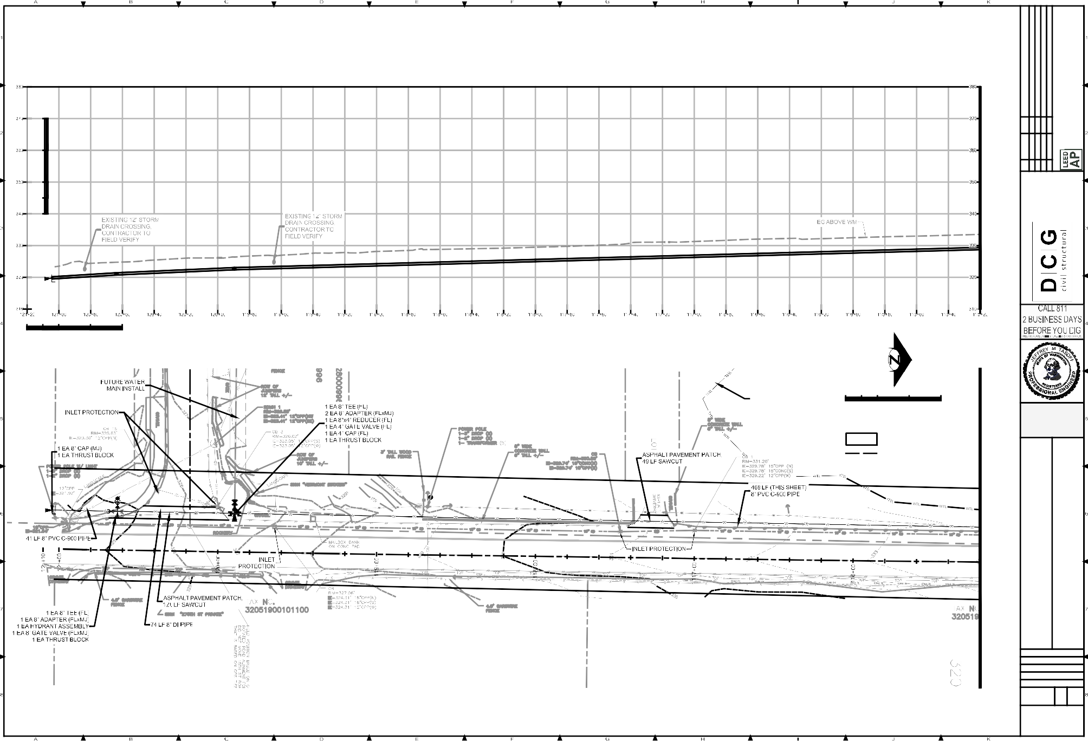
6/19/2018 A OF
10
5
0
10
20
SCALE IN FEET
No.
DATE
BY
REVISION
2210 Riverside Drive
Suite 210 Mount Vernon WA 98273
LEED ACCREDITED PROFESSIONAL" & THE RELATED ACRONYM, & THE LEGACY LEED AP LOGO ARE TRADEMARKS OWNED BY THE U.S. GREEN BUILDING COUNCIL & ARE AWARDED TO INDIVIDUALS UNDER LICENSE BY THE GREEN BUILDING CERTIFICATION INSTITUTE.
P: 360.899.1110
F: 360.331.5131
www.dcgengr.com
TM
9
SHEET NUMBER
C04

PROFILE
CAD FILE NUMBER: P:\CLIENTS-WATER\TATOOSH\DEVELOPER EXTENSION\DWG\DRAWING\TATOOSH_WM EXTENSION.DWGLAST MODIFIED BY: GREG - SAVE DATE: 6/18/2018 11:11 AM - SHEET SET: TATOOSH WM EXTENSION - ORIGINAL SHEET SIZE: ARCH FULL BLEED D (24.00 X 36.00 INCHES)AUTOCAD VERSION: CIVIL 3D 2015

20 10 0
MATCHLINE STA 115+20 SEE SHEET C04

20 40
MATCHLINE STA 109+40 SEE SHEET C06
10
5
0
10
SCALE IN FEET

SCALE: H.1"=20'; V.1"=10' SCALE IN FEET

Jeffrey M.

Digitally signed by Jeffrey M. Tasoff, PE
Reason: I am approving this

Tasoff, PE Date: 2018.06.19 11:23:21 -07'00'
document
41424

LEGEND:

ASPHALT PAVEMENT PATCH

20 10 0

20 40

BASE MAP/TOPOGRAPHY PROVIDED BY OTHERS. DCG CANNOT BE HELD LIABLE FOR ACCURACY. CONTRACTOR SHALL FIELD VERIFY GRADES, UTILITIES, & ALL OTHER EX FEATURES & CONDITIONS. IF CONDITIONS ARE NOT AS SHOWN &/OR
PLANS CANNOT BE CONSTRUCTED AS

W WATER LINE
SCALE IN FEET
SHOWN, CONTACT DCG PRIOR TO CONSTRUCTION.

APPROX WETLAND LIMITS PER SNOHOMISH COUNTY GIS
TATOOSH WATER COMPANY 14263 CALHOUND ROAD MOUNT VERNON, WA 98273
TATOOSH WATER
15TH AVE NE WATER MAIN EXTENSION PLAN & PROFILE - 15TH AVE

PLAN
MATCHLINE STA 115+20 SEE SHEET C04
MATCHLINE STA 109+40 SEE SHEET C06
PROJ. MANAGER: DESIGNED BY: DRAWN BY: CHECKED BY: SCALE:

JT SG RB JT
OWNER:
PROJECT:
AS SHOWN

SCALE: 1"=20'
DATE:
REV. SHEET
5

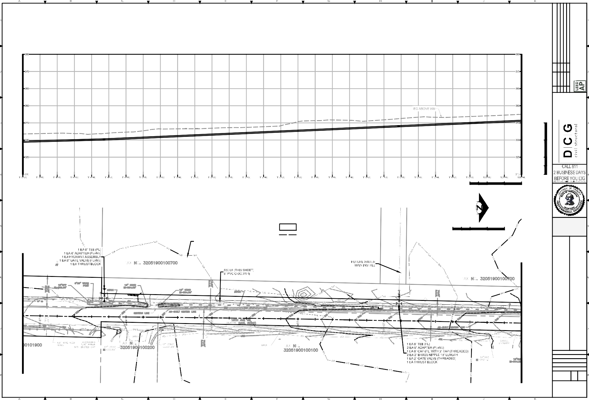
6/19/2018 A OF
20
No.
DATE
BY
REVISION
2210 Riverside Drive
Suite 210 Mount Vernon WA 98273
LEED ACCREDITED PROFESSIONAL" & THE RELATED ACRONYM, & THE LEGACY LEED AP LOGO ARE TRADEMARKS OWNED BY THE U.S. GREEN BUILDING COUNCIL & ARE AWARDED TO INDIVIDUALS UNDER LICENSE BY THE GREEN BUILDING CERTIFICATION INSTITUTE.
P: 360.899.1110
F: 360.331.5131
www.dcgengr.com
TM
9
SHEET NUMBER
C05

PROFILE
CAD FILE NUMBER: P:\CLIENTS-WATER\TATOOSH\DEVELOPER EXTENSION\DWG\DRAWING\TATOOSH_WM EXTENSION.DWGLAST MODIFIED BY: GREG - SAVE DATE: 6/18/2018 11:11 AM - SHEET SET: TATOOSH WM EXTENSION - ORIGINAL SHEET SIZE: ARCH FULL BLEED D (24.00 X 36.00 INCHES)AUTOCAD VERSION: CIVIL 3D 2015

20 10 0
MATCHLINE STA 109+40 SEE SHEET C05

20 40
10
5
0
10
SCALE IN FEET
MATCHLINE STA 103+60 SEE SHEET C07

SCALE: H.1"=20'; V.1"=10' SCALE IN FEET

Jeffrey M.

Digitally signed by Jeffrey M. Tasoff, PE
Reason: I am approving this

Tasoff, PE Date: 2018.06.19 11:23:40 -07'00'
document
41424

APPROX WETLAND LIMITS PER SNOHOMISH COUNTY GIS
LEGEND:
ASPHALT PAVEMENT PATCH

APPROX
SOIL EROSION HAZARD AREAS PER SNOHOMISH COUNTY GIS

BASE MAP/TOPOGRAPHY PROVIDED BY OTHERS. DCG CANNOT BE HELD LIABLE FOR ACCURACY. CONTRACTOR SHALL FIELD VERIFY GRADES, UTILITIES, & ALL OTHER EX FEATURES & CONDITIONS. IF CONDITIONS ARE NOT AS SHOWN &/OR
PLANS CANNOT BE CONSTRUCTED AS

W WATER LINE
150' STREAM SETBACK

20 10 0

20 40
SHOWN, CONTACT DCG PRIOR TO CONSTRUCTION.

SCALE IN FEET

APPROX LANDSLIDE HAZARD AREAS PER SNOHOMISH COUNTY GIS
MATCHLINE STA 109+40 SEE SHEET C05
TATOOSH WATER COMPANY 14263 CALHOUND ROAD MOUNT VERNON, WA 98273
TATOOSH WATER
15TH AVE NE WATER MAIN EXTENSION PLAN & PROFILE - 15TH AVE

PLAN
PROJ. MANAGER: DESIGNED BY: DRAWN BY: CHECKED BY: SCALE:

JT SG RB JT
MATCHLINE STA 103+60 SEE SHEET C07
OWNER:
PROJECT:
AS SHOWN

SCALE: 1"=20'
DATE:
REV. SHEET
6

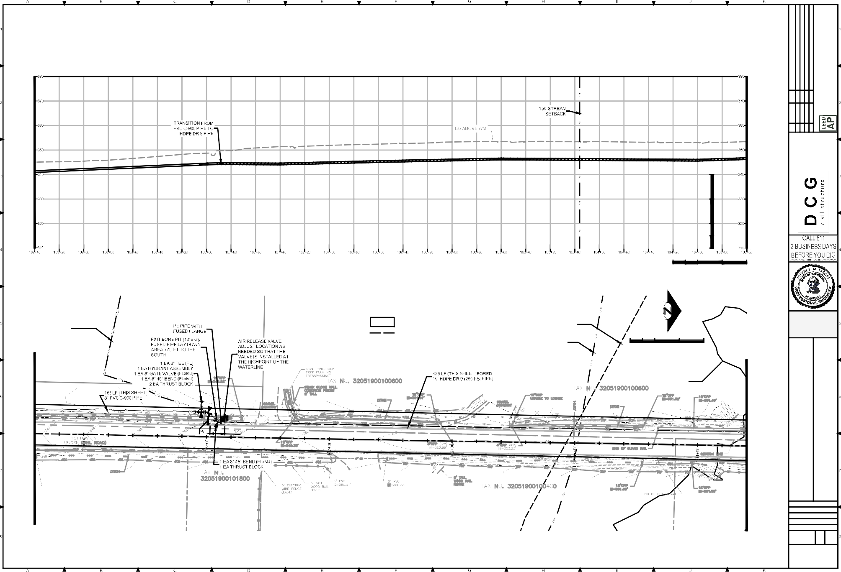
6/19/2018 A OF
20
No.
DATE
BY
REVISION
2210 Riverside Drive
Suite 210 Mount Vernon WA 98273
LEED ACCREDITED PROFESSIONAL" & THE RELATED ACRONYM, & THE LEGACY LEED AP LOGO ARE TRADEMARKS OWNED BY THE U.S. GREEN BUILDING COUNCIL & ARE AWARDED TO INDIVIDUALS UNDER LICENSE BY THE GREEN BUILDING CERTIFICATION INSTITUTE.
P: 360.899.1110
F: 360.331.5131
www.dcgengr.com
TM
9
SHEET NUMBER
C06

20 10 0 20 40
CAD FILE NUMBER: P:\CLIENTS-WATER\TATOOSH\DEVELOPER EXTENSION\DWG\DRAWING\TATOOSH_WM EXTENSION.DWGLAST MODIFIED BY: GREG - SAVE DATE: 6/18/2018 11:11 AM - SHEET SET: TATOOSH WM EXTENSION - ORIGINAL SHEET SIZE: ARCH FULL BLEED D (24.00 X 36.00 INCHES)AUTOCAD VERSION: CIVIL 3D 2015
MATCHLINE STA 103+60 SEE SHEET C06
5
10
0
10
SCALE IN FEET

SCALE IN FEET

PROFILE SECTION A-AC07 SECTION B-BC07

APPROX STREAM
SCALE: H.1"=20'; V.1"=10'
SCALE: H.1"=20'; V.1"=10'
SCALE: H.1"=20'; V.1"=10'

Jeffrey M.

Digitally signed by Jeffrey M. Tasoff, PE
Reason: I am approving this
document

20 10 0

20 40
CENTERLINE PER SNOHOMISH COUNTY GIS, STREAM TYPE F

APPROX
SOIL EROSION HAZARD AREAS PER SNOHOMISH
APPROX LANDSLIDE HAZARD AREAS PER SNOHOMISH COUNTY GIS

150' STREAM
Tasoff, PE Date: 2018.06.19 11:23:57 -07'00'
41424

BASE MAP/TOPOGRAPHY PROVIDED BY OTHERS. DCG CANNOT BE HELD LIABLE FOR ACCURACY. CONTRACTOR SHALL FIELD VERIFY GRADES, UTILITIES, & ALL OTHER EX FEATURES & CONDITIONS. IF CONDITIONS ARE NOT AS SHOWN &/OR PLANS CANNOT BE CONSTRUCTED AS SHOWN, CONTACT DCG PRIOR TO CONSTRUCTION.

SCALE IN FEET
A
C07
COUNTY GIS
SETBACK

B BC07
MATCHLINE STA 103+60 SEE SHEET C06
TATOOSH WATER COMPANY 14263 CALHOUND ROAD MOUNT VERNON, WA 98273
TATOOSH WATER
15TH AVE NE WATER MAIN EXTENSION PLAN & PROFILE - 15TH AVE

PROJ. MANAGER: DESIGNED BY: DRAWN BY: CHECKED BY: SCALE:
OWNER:
PROJECT:
A

JT SG RB JT
AS SHOWN

DATE:
REV. SHEET

LEGEND:

ASPHALT PAVEMENT PATCH
PLAN
SCALE: 1"=20'
7
6/19/2018 A OF
9
SHEET NUMBER

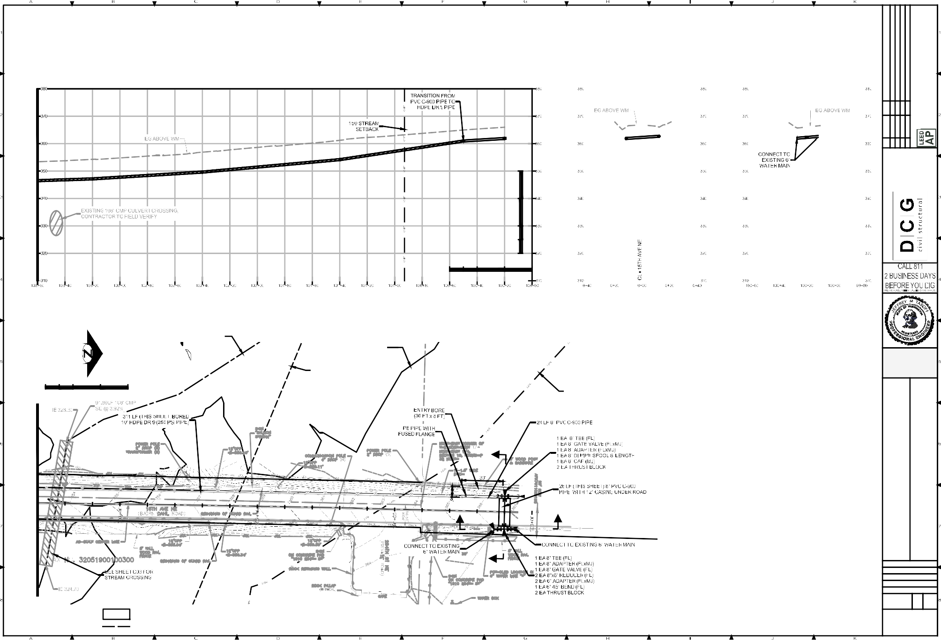
20
No.
DATE
BY
REVISION
2210 Riverside Drive
Suite 210 Mount Vernon WA 98273
LEED ACCREDITED PROFESSIONAL" & THE RELATED ACRONYM, & THE LEGACY LEED AP LOGO ARE TRADEMARKS OWNED BY THE U.S. GREEN BUILDING COUNCIL & ARE AWARDED TO INDIVIDUALS UNDER LICENSE BY THE GREEN BUILDING CERTIFICATION INSTITUTE.
P: 360.899.1110
F: 360.331.5131
www.dcgengr.com
TM

W WATER LINE
C07

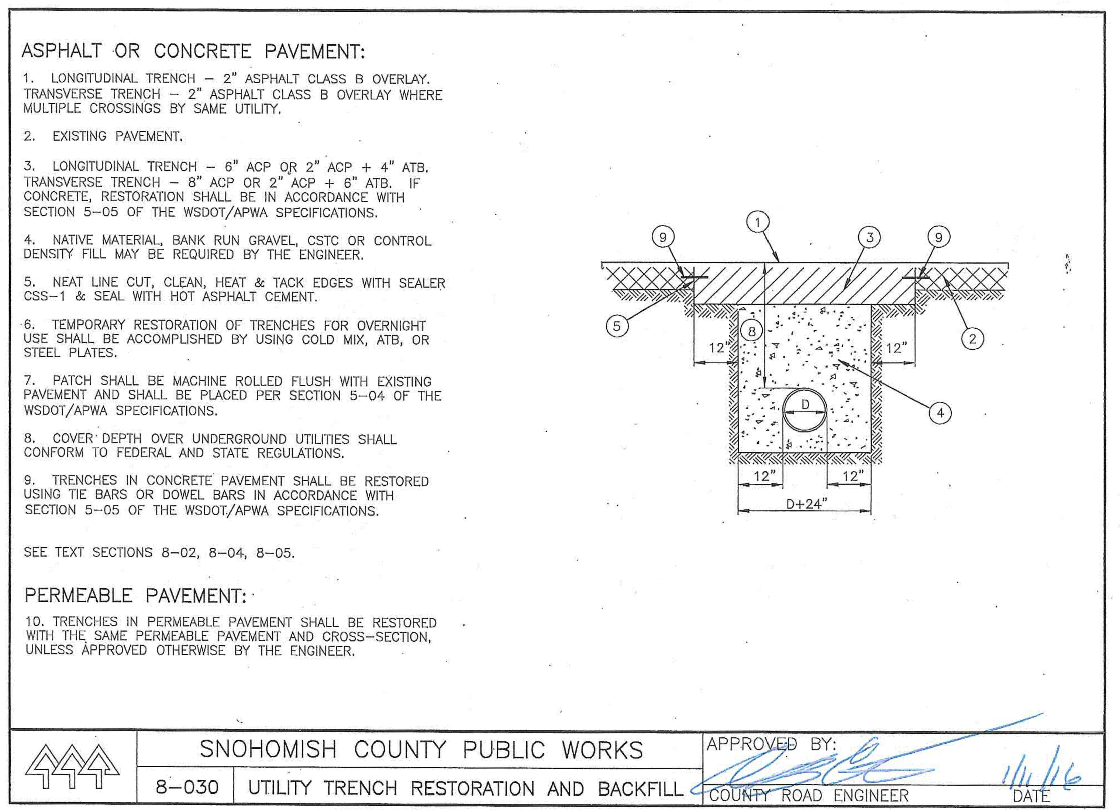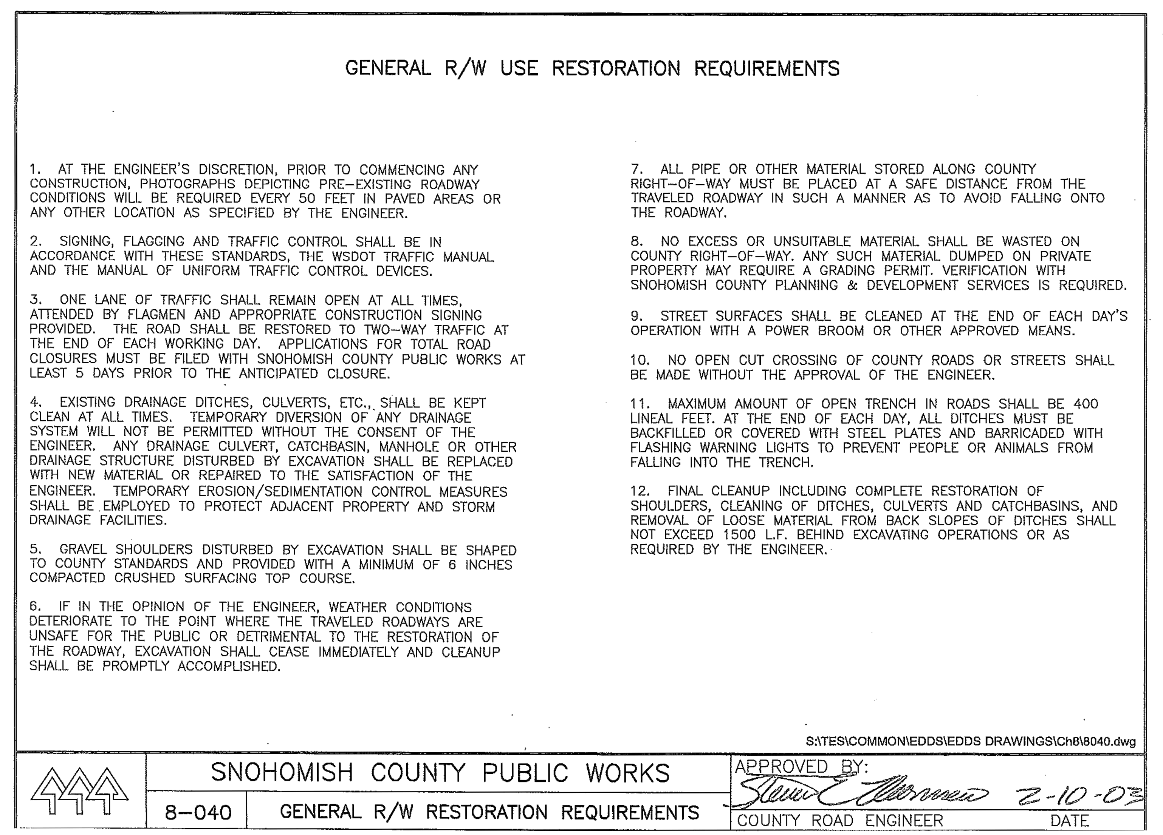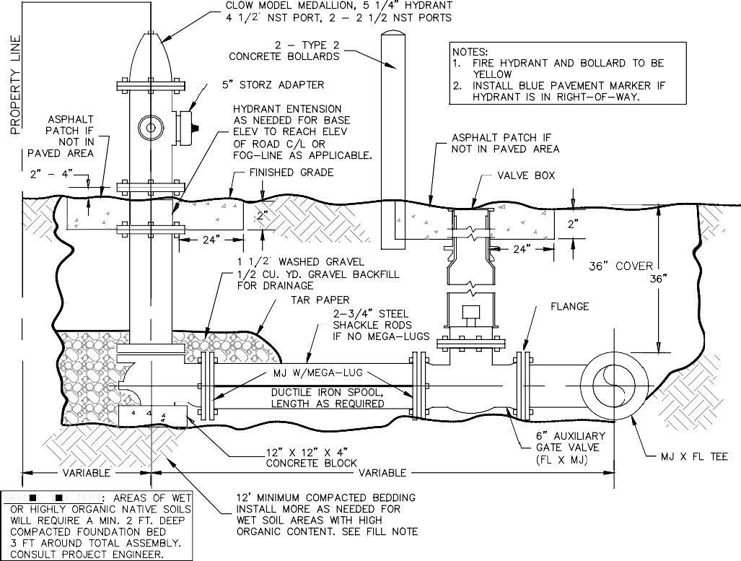  1 2 FIRE HYDRANT ASSEMBLY 3  NTS VARIES NTS VARIES NTS VARIES  NOTES:  - INSTALL WATERLINE MARKER/DETECTOR TAPE & LOCATOR WIRE 12" ABOVE TOP OF PIPE CASING.  - LOCATOR WIRES SHALL BE BLUE COATED 14 GAGE COPPER WIRE CONTINUOUS TO ABOVE GROUND ACCESS POINTS (METERS & HYDRANTS) SPLICES I WIRE, IF NEEDED SHALL BE MAKE WITH WATERPROOF SPLICE KITS.  NOTES:  SEE THRUST BLOCK TABLE, DETAIL  PROVIDE POLYETHYLENE SHEETING TO COVER BOLTS AND JOINTS FOR DISMANTLING.  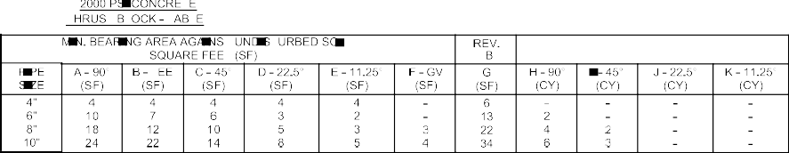  WATER MAIN THRUST BLOCKING 4 WATER VALVE EXTENTION 5 HYDRANT PROTECTION/ VALVE MARKER 6 MAIN FILLING 7  NTS VARIES VARIES VARIES NTS VARIES  NTS NTS | REVISION |  |  |  |  | LEED ACCREDITED PROFESSIONAL" & THE RELATED  TM  OWNED BY THE U.S. GREEN BUILDING COUNCIL & ARE AWARDED TO INDIVIDUALS UNDER LICENSE BY THE GREEN BUILDING CERTIFICATION INSTITUTE.
 | BY
 | DATE
 | No.
2210 Riverside Drive
Suite 210 Mount Vernon WA 98273
P: 360.899.1110
F: 360.331.5131
www.dcgengr.com
 | 41424
 | BASE MAP/TOPOGRAPHY PROVIDED BY OTHERS. DCG CANNOT BE HELD LIABLE FOR ACCURACY. CONTRACTOR SHALL FIELD VERIFY GRADES, UTILITIES, & ALL OTHER EX FEATURES & CONDITIONS. IF CONDITIONS ARE NOT AS SHOWN &/OR PLANS CANNOT BE CONSTRUCTED AS SHOWN, CONTACT DCG PRIOR TO CONSTRUCTION.
 | OWNER: TATOOSH WATER COMPANY 14263 CALHOUND ROAD  MOUNT VERNON, WA 98273 |  |  |  |  | PROJECT:  15TH AVE NE WATER MAIN EXTENSION DETAILS
 | PROJ. MANAGER: JT
 | DESIGNED BY: SG
 | DRAWN BY: RB
 | CHECKED BY: JT
 | SCALE: AS SHOWN
 | DATE:  6/19/2018 |  |  |  |  |  | REV.  A | SHEET  8  OF  9
SHEET NUMBER
C08
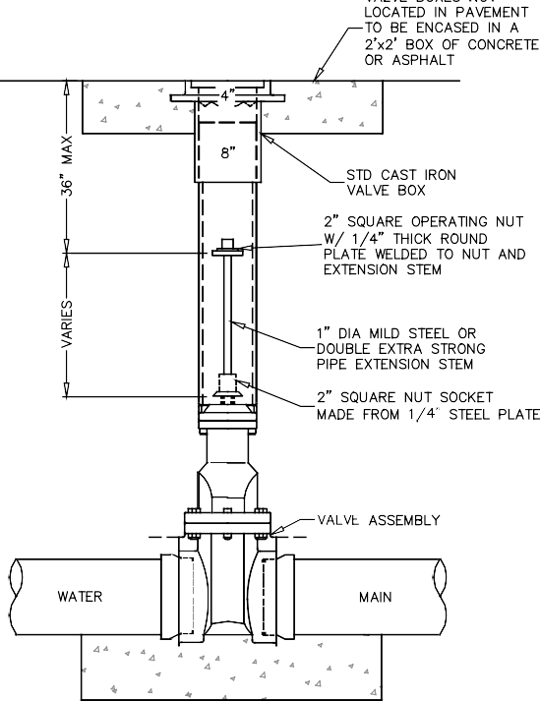
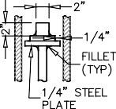
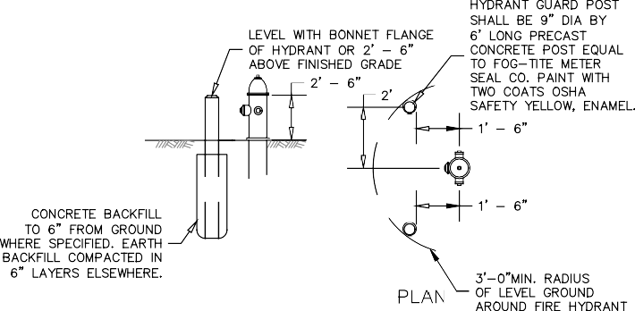
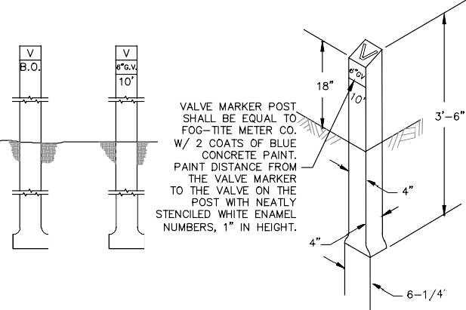
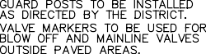
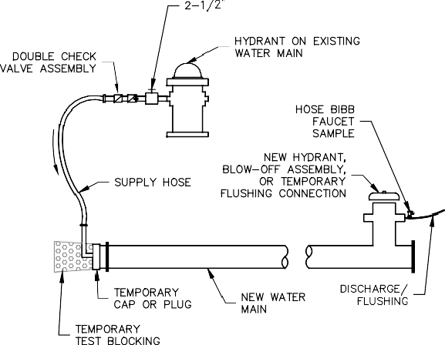
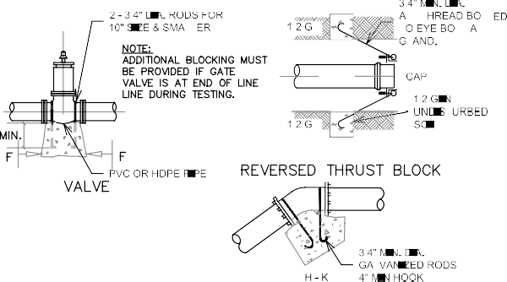
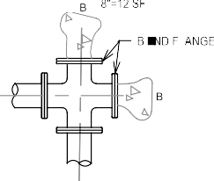
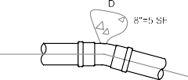
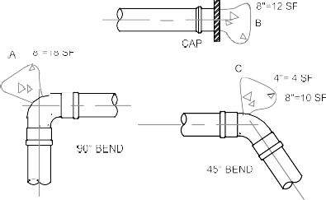
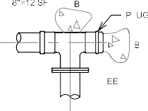
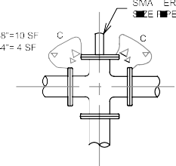
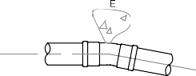
CAD FILE NUMBER: P:\CLIENTS-WATER\TATOOSH\DEVELOPER EXTENSION\DWG\DRAWING\TATOOSH_WM EXTENSION.DWGLAST MODIFIED BY: GREG - SAVE DATE: 6/18/2018 11:11 AM - SHEET SET: TATOOSH WM EXTENSION - ORIGINAL SHEET SIZE: ARCH FULL BLEED D (24.00 X 36.00 INCHES)AUTOCAD VERSION: CIVIL 3D 2015
TATOOSH WATER
ACRONYM, & THE LEGACY LEED AP LOGO ARE TRADEMARKS

18"  BLOW OFF ASSEMBLY 8  NTS VARIES | 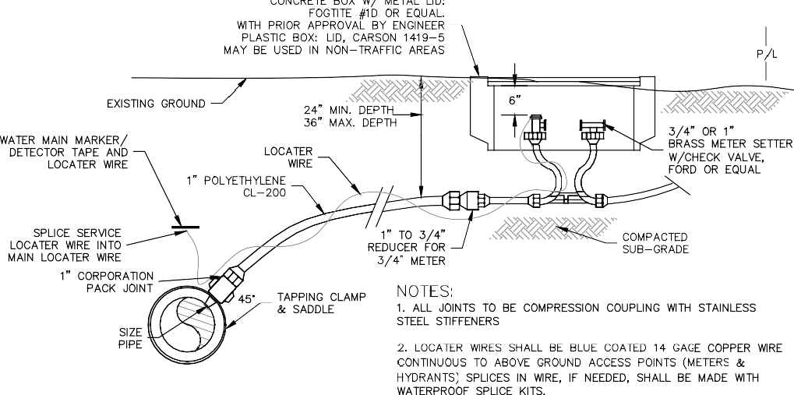  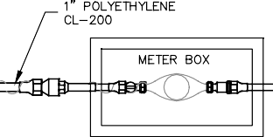  WATER METER 9  NTS VARIES  CATCH BASIN INLET PROTECTION 11  NTS VARIES | 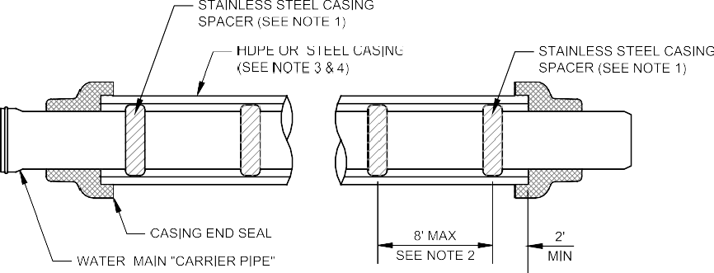  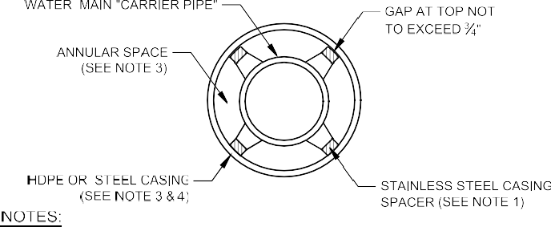  PIPE CASING INSTALLATION 10  NTS VARIES |  | REVISION |  |  |  |  | ACCREDITED PROFESSIONAL" & THE RELATED  D BY THE U.S. GREEN BUILDING COUNCIL & ARE  D TO INDIVIDUALS UNDER LICENSE BY THE GREEN BUILDING CERTIFICATION INSTITUTE.
 |  |  |  | BY |  |  |  |  | LEED  OWNE WARDE
 |  |  |  | DATE |  |  |  |  | TM  A
 |  |  |  | No.
2210 Riverside Drive
Suite 210 Mount Vernon WA 98273
P: 360.899.1110
F: 360.331.5131
www.dcgengr.com
Jeffrey M. Tasoff, PE
Digitally signed by Jeffrey M.

Reason: I am approving this
asoff, PE Date: 2018.06.19 11:24:12 -07'00'
document

41424
 |  |  |  | BASE MAP/TOPOGRAPHY PROVIDED BY OTHERS. DCG CANNOT BE HELD LIABLE FOR ACCURACY. CONTRACTOR SHALL FIELD VERIFY GRADES, UTILITIES, & ALL OTHER EX FEATURES & CONDITIONS. IF CONDITIONS ARE NOT AS SHOWN &/OR PLANS CANNOT BE CONSTRUCTED AS SHOWN, CONTACT DCG PRIOR TO CONSTRUCTION.
 |  |  |  | OWNER: TATOOSH WATER COMPANY 14263 CALHOUND ROAD  MOUNT VERNON, WA 98273 |  |  |  |  | PROJECT:  15TH AVE NE WATER MAIN EXTENSION DETAILS
 |  |  |  | PROJ. MANAGER: JT
 |  |  |  | DESIGNED BY: SG
 |  |  |  | DRAWN BY: RB
 |  |  |  | CHECKED BY: JT
 |  |  |  | SCALE: AS SHOWN
 |  |  |  | DATE:  6/19/2018 |  |  |  |  |  | REV.  A | SHEET  9  OF  9
SHEET NUMBER
C09
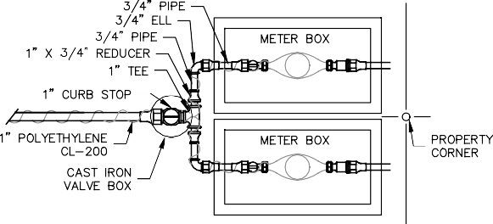
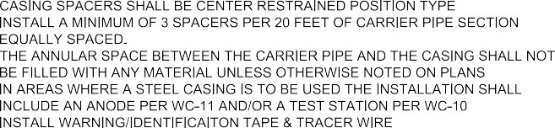
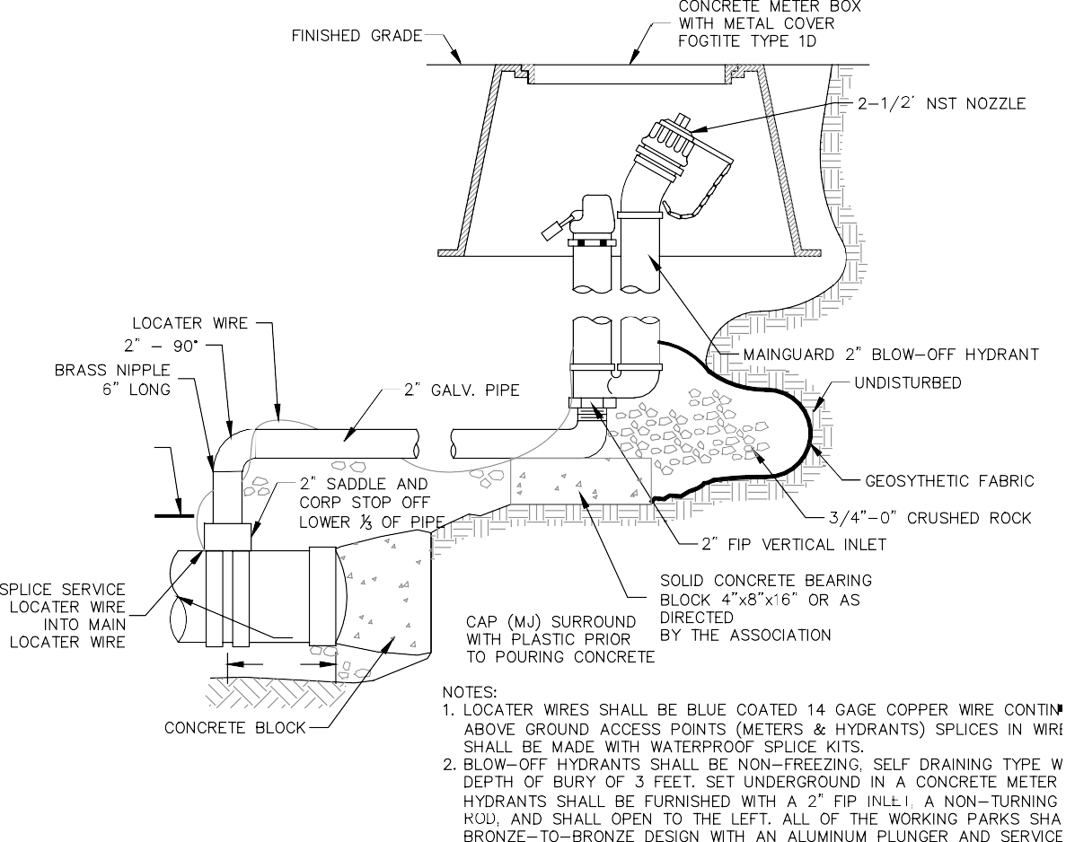
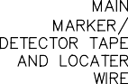
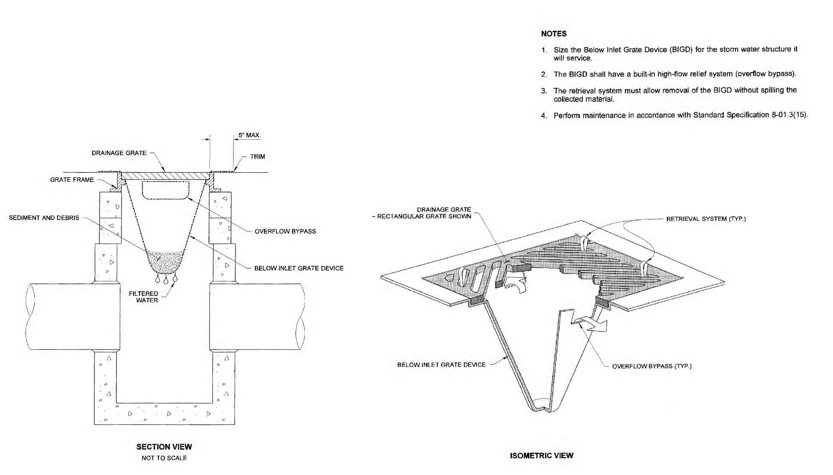
CAD FILE NUMBER: P:\CLIENTS-WATER\TATOOSH\DEVELOPER EXTENSION\DWG\DRAWING\TATOOSH_WM EXTENSION.DWGLAST MODIFIED BY: GREG - SAVE DATE: 6/18/2018 11:11 AM - SHEET SET: TATOOSH WM EXTENSION - ORIGINAL SHEET SIZE: ARCH FULL BLEED D (24.00 X 36.00 INCHES)AUTOCAD VERSION: CIVIL 3D 2015
TATOOSH WATER
ACRONYM, & THE LEGACY LEED AP LOGO ARE TRADEMARKS

