January 31, 2018

Mr. Steven V. King, Executive Secretary
Washington Utilities and Transportation Commission
1300 South Evergreen Park Drive SW
Olympia, WA 98504-7250

Re: UT-180001

Dear Mr. King:

Please find enclosed Form 555 as filed with USAC and the FCC for 2017.

Sincerely,

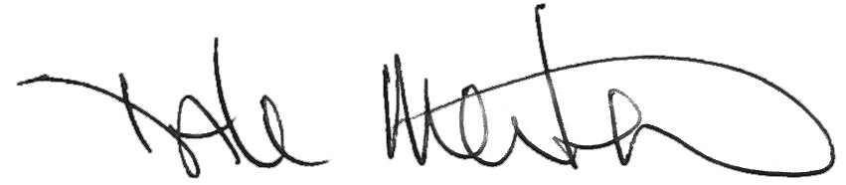

Dale Merten
Chief Operating Officer

Encl/

