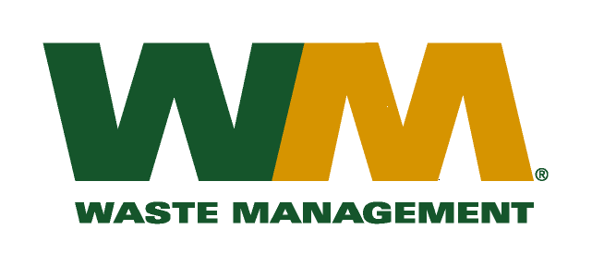
February 19, 2010
Washington Utilities and Transportation Commission
Chandler Plaza Building
1300 S. Evergreen Park Drive SW
P.O. Box 47250
Olympia, WA. 98504-7250

Dear Sirs:
Subject: Waste Management of Greater Wenatchee, a division of Waste Management of Washington, Inc.(G-237); Tariff # 12; TG-100296
Please find enclosed substitute pages 33, 36, 38 and 40 to the above-referenced tariff filing. This page is being submitted in accordance with Staff recommendations. Please do not re-docket.

If you have any questions or need additional information, please contact me at (425) 814-7840.

Very Truly yours,

Michael A. Weinstein
Senior Pricing Manager, Pacific Northwest Market Area

