May 18, 2015

Steven V. King
Executive Director and Secretary
Washington Utilities and Transportation Commission
P.O. Box 47250
1300 S. Evergreen Park Drive S.W.
Olympia, WA 98504-7250

RE: Comments of Renewable Northwest
Docket UE-140546—Commission’s April 17, 2015 Notice of Opportunity to File Written Comments on the Pacific Power and Light Company 2015 Integrated Resource Plan.

- INTRODUCTION
Renewable Northwest would like to congratulate Pacific Power and Light Company (“PacifiCorp” or the “Company”) on the high degree of stakeholder involvement and communication during its 2015 Integrated Resource Plan (“IRP”) Public Process, which can be continued into future IRPs and used as a model for other utilities. Furthermore, at the beginning of this process, the U.S. Environmental Protection Agency (“EPA”) issued a major proposed rule under §111(d) of the Clean Air Act (“111(d)”) that would regulate carbon dioxide emissions from existing fossil fuel power plants. Renewable Northwest would like to acknowledge the Company’s efforts in attempting to model this proposed rule in its 2015 IRP.

Renewable Northwest would also like to recognize the progress that PacifiCorp has made in planning for variable energy resource integration, as reflected in the Company’s 2014 Wind Integration Study (“WIS”) and the Distributed Generation Resource Assessment for Long-Term Planning Study. The 2014 WIS determined that a modest increase of only 1 MW in wind regulating margin (the incremental amount of reserves required to accommodate deviations of wind generation from forecasts) was required between 2012 and 2014 to accommodate a 417 MW increase in wind capacity.

In these comments, Renewable Northwest will address how PacifiCorp can improve its modeling of 111(d) in its IRP Update by ensuring that 111(d) attributes are not artificially separated from other environmental attributes contained within Renewable Energy Credits (“RECs”). In addition, we recommend that the Company explore more fully the interaction between 111(d) and a future carbon price. Renewable Northwest also recommends that PacifiCorp explore how both these changes to 111(d) affect the Company’s procurement of renewable energy.

- PACIFICORP’S STRONG 111(D) MODELING EFFORTS ARE HAMPERED BY FLAWED ASSUMPTIONS, WHICH SHOULD BE CORRECTED IN THE IRP UPDATE
PacifiCorp considered 111(d) in its 2015 IRP by “studying a range of assumed compliance requirements and alternative compliance strategies.” The Company characterized the proposed 111(d) rule as applying “on a portfolio basis to all of the resources and loads within a state.” PacifiCorp’s 2015 preferred portfolio meets the company’s share of state emission rate targets among those states in which PacifiCorp serves retail customers and owns existing fossil generation that would be affected by 111(d). PacifiCorp developed the 111(d) Scenario Maker, a spreadsheet modeling tool, in order to ensure that their portfolios complied with the Company’s assumptions about the proposed 111(d) rule. The Company describes its compliance solution as a “BSER [Best System of Emission Reduction] that is primarily comprised of allocating system renewable generation among states, acquiring energy efficiency resources, and re-dispatching fossil-fired generation resources.”

While Renewable Northwest welcomes this attempt to prepare for carbon regulation in the resource planning process, we are very concerned with PacifiCorp’s proposed treatment of RECs. At the fifth public input meeting, PacifiCorp presented the following statement: “Compliance costs could be partially mitigated if PacifiCorp were able to use 111(d) compliance attributes from all qualifying facility resources, regardless of REC ownership.” PacifiCorp also assumed that a REC that it owned and retired for compliance with one state’s RPS could be bifurcated to use the so-called “111(d) attribute” for compliance with a different state’s Clean Power Plan obligation, without any overarching multi-state agreement.

RCW 19.285.030 defines a Renewable Energy Credit as:

“[…] a tradable certificate of proof of at least one megawatt-hour of an eligible renewable resource where the generation facility is not powered by freshwater. The certificate includes all of the nonpower attributes associated with that one megawatt-hour of electricity, and the certificate is verified by a renewable energy credit tracking system selected by the department [emphasis added].”

The plain language of the statute includes “all of the nonpower attributes,” implicitly including what PacifiCorp terms “111(d) compliance attributes.” Therefore, the retirement of a REC in one state would also lead to the “111(d) compliance attributes” being counted by that same state. Even if state RPS law did not prevent a REC from being surrendered for compliance while the same MWh is used as renewable energy to meet 111(d) in another state, this situation would likely double-count 111(d) emissions reductions. In order to avoid double-counting 111(d) emissions reductions, care would have to be taken to ensure that the first state’s RPS was not used as part of that state’s 111(d) compliance plan.

Renewable Northwest recommends that the Commission encourage the Company to explore cases in their IRP Update where such “flexible allocation” is not treated as a viable 111(d) compliance solution, and to consider the implications this would have for renewable resource acquisitions, as discussed further in Section IV, below. Renewable Northwest notes that despite the problems underlying the “flexible allocation” of 111(d) attributes, the approach does suggest that there is benefit to investigating a multi-state solution to 111(d) compliance, and we recommend that the Commission explore that option in appropriate forums.

PacifiCorp should be applauded for its Regional Haze analysis. At the urging of regulators, PacifiCorp finally undertook an inter-temporal and intra-fleet analysis of its coal plants. This Regional Haze analysis considered early retirement as a potential lowest cost compliance option. PacifiCorp’s advances in considering early retirement of coal plants in its Regional Haze modeling, however, highlights that PacifiCorp failed to even consider early retirement as a least-cost option for compliance with 111(d). Rather, PacifiCorp looked only at backing down coal plants to a certain minimum operating level. Renewable Northwest suggests that the Commission recommend the Company include early retirement of coal plants as part of the solution set in its IRP Update, following the publication of the final 111(d) rules.

- PACIFICORP SHOULD MODEL 111(D) AND CARBON PRICE INTERACTIONS MORE FULLY
EPA’s proposed 111(d) rules would regulate carbon dioxide emissions from existing power plants. However, the emissions from such plants—and, importantly, from new power plants not explicitly covered by 111(d)—could also be subject to an additional state or federal carbon price in the future. PacifiCorp chose to model the interaction of 111(d) and a carbon price in only two Core Cases, C14 and C14a.

Renewable Northwest believes that limiting carbon price-111(d) interactions to only two core cases is problematic for two reasons: first, it underestimates the likelihood of 111(d) and a price of carbon existing simultaneously; and, second, it fails to capture how a carbon price would affect the way the Company complies with 111(d). Unsurprisingly, under conditions including a high CO₂ price, the Company’s stochastic simulation Planning and Risk (“PaR”) results showed that these two portfolios (C14 and C14a) were “lower cost and lower risk relative to portfolios that were developed with 111(d) considerations but without incremental CO₂ price assumptions.”

Renewable Northwest recommends that the Commission require PacifiCorp to explore the interactions of 111(d) and a carbon price in the IRP Update given the risks of making resource decisions that fail to account for both types of carbon regulation existing simultaneously.

- ASSUMPTION OF FLEXIBLE ALLOCATION OF RENEWABLE ENERGY 111(D) ATTRIBUTES COULD LIMIT PROCUREMENT OF RENEWABLE ENERGY

In the Company’s sensitivity case definitions, fourteen of the fifteen cases allowed for the so-called “flexible system allocation” of renewable generation for 111(d) compliance purposes as described above in Section II. Only one sensitivity case (S-15), benchmarked to case C05-1, examined what would happen if “111(d) and REC Attributes Must be Used Simultaneously”, i.e. the retirement of a REC in one state for RPS compliance would also require the “111(d) compliance attributes” to be counted by that same state. As can be seen in the Company’s reported results of the S-15 sensitivity in its seventh public meeting, removing the flexible allocation assumption changes how PacifiCorp would procure renewable resources. The Company states that:
“In Washington, linking the state RPS program to 111(d) would force PacifiCorp to meet its share of the state’s emission rate target with situs assigned renewable resources or alternatively, eliminate PacifiCorp’s Washington compliance obligation by retiring [the 520 MW gas plant] Chehalis at the end of 2019 [...] It is assumed that retirement of Chehalis at the end of 2019 is lower cost than meeting PacifiCorp’s share of the Washington 111(d) emission rate target with incremental renewables.”

Situs-assigned renewable resources are allocated to, and paid for by, a specific state; otherwise, renewable energy allocation is based on the multistate protocol or other accounting treatment. The Company spent only one paragraph on page 207 of its IRP trying to explain the outcome of S-15, and does not explain their conclusions sufficiently. Our understanding is that RECs do not necessarily need to be retired for the Washington RPS in order to meet the 111(d) obligation caused by the Chehalis gas plant; rather, the RECs merely need to not count for another state’s RPS or 111(d) obligation. If the Company had surplus RECs from other states that are not assigned to an RPS or used for 111(d) compliance, these could be assigned to the Washington 111(d) obligation. If there are insufficient surplus RECs available, then the Company could build additional system renewable energy resources to meet its Washington 111(d) obligation. It does not follow that those additional renewable energy resources have to be situs-assigned to Washington. Renewable Northwest deems this issue worthy of further attention, and recommends that the Commission require PacifiCorp to explain it further. Again, this approach implies that there may be benefit to a formal multi-state solution to 111(d) compliance, and we recommend that the Commission and the Company explore this option.

- 2014 WIND INTEGRATION STUDY REFLECTS INCREASING EFFICIENCY
PacifiCorp’s 2014 Wind Integration Study (“WIS”) calculated wind integration costs used for IRP modeling, incorporating the additional 417 MW of wind projects on the Company’s system since the 2012 WIS. A comparison of the wind regulating margin—the incremental amount of reserves anticipated to accommodate deviations in wind from forecasts—required in the 2012 WIS to the level required in the 2014 WIS reveals PacifiCorp’s increasing ability to integrate variable resources into its system. The wind regulating margin remained relatively flat, increasing from 185 MW in 2011 (2012 WIS) to 186 MW in 2013 (2014 WIS), while the wind capacity increased 417 MW from 2,135 MW in 2011 to 2,552 MW in 2013. Looking to the next IRP, Renewable Northwest welcomes PacifiCorp’s intention to use data from the Energy Imbalance Market to inform future wind integration studies.

- DISTRIBUTED GENERATION STUDY HIGHLIGHTS OPPORTUNITY TO ENABLE MORE COMMERCIAL SOLAR PV

PacifiCorp hired Navigant Consulting to analyze the retail Levelized Cost of Energy (“LCOE”) of Distributed Generation (“DG”), and use it to project the market penetration of DG resources for the next 20 years for the IRP. These results were presented to stakeholders as part of the 2015 IRP Public Process. Navigant identified that the technical potential (the amount that can be physically installed without taking economics into account) for all DG technologies analyzed for PacifiCorp was 10 GW, which is comparable to the Company’s forecasted system coincidental peak load over the next decade. To determine the market penetration—i.e., the economic potential—they considered the level of DG adoption based on acceptable payback periods. In the base case (medium penetration), Navigant projects 910 MW of DG installations by 2034. Navigant reports that Washington, “with a relatively small PacifiCorp area, and rates that are somewhat lower, is projected to achieve 10 MW by 2034 in the base case,” as shown in Figure 1. The Navigant study suggests there is a large techno-economic potential for commercial solar PV in Washington. Navigant defines this as the application of solar on commercial buildings, with PV systems ranging in size from approximately 2 kW to 250 kW.

Renewable Northwest recommends that the Commission consider, where possible, removing unnecessary barriers to the development of the commercial PV solar sector. One such barrier is the unresolved Commission “Investigation of the Costs and Benefits of Distributed Generation” (UE-131883). Concluding such an investigation, such as through a comprehensive solar resource value study, could enable solar policy to move forward in Washington.

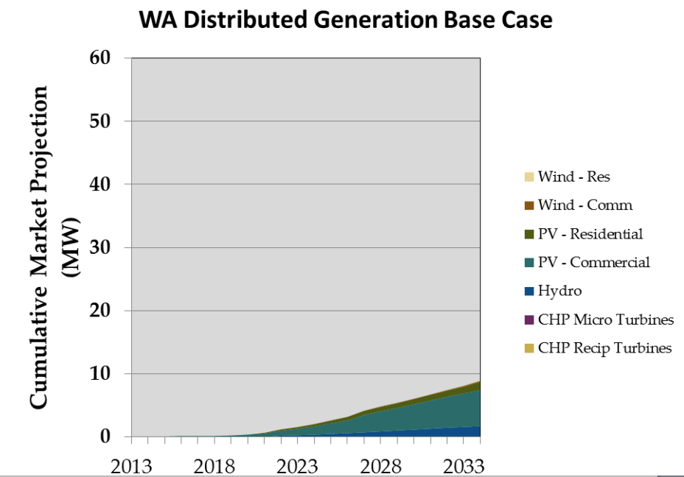
Figure 1—Washington Distributed Generation Base Case Results.²²

- CONCLUSION
Renewable Northwest appreciates the opportunity to comment to the Commission on PacifiCorp’s 2015 IRP. We would also like to acknowledge our appreciation of the Company’s well-run and engaging stakeholder process.

While PacifiCorp made great efforts to model the impacts of the proposed 111(d) rule on its resource planning, most of their portfolios were based upon the assumption that the “111(d) attributes” of renewable energy could be “flexibly allocated” among states for 111(d) compliance, regardless of whether or not that renewable energy had been used for compliance with an RPS in a specific state. The Company also did not fully explore the interaction of 111(d) and a carbon price. Therefore, Renewable Northwest recommends that the Commission encourage PacifiCorp to investigate these issues in its 2015 IRP Update, and also to discern the effect they would have on renewable procurement.

Finally, Renewable Northwest welcomes the work that the Company has done in efficiently integrating variable generation, as shown in its 2014 Wind Integration Study. PacifiCorp should also be applauded for undertaking a study into the market penetration of distributed generation resources. This investigation revealed that Washington had a large potential market for commercial solar PV. Renewable Northwest recommends that the Commission consider continuing and concluding its investigation into the costs and benefits of distributed generation (UE-131883) in order that solar policy can take a step forward and opportunities such as commercial solar PV might be realized.

Sincerely,

Michael H O’Brien
(michael@renewablenw.org)
Renewable Northwest
421 SW 6th Avenue, Suite 1125
Portland, OR 97204
503-223-4544

Note that many references are to the slides from the stakeholder process (in which we engaged extensively) rather than the IRP, owing to the short period of time between filing of the 238 page IRP and 619 pages of appendices (March 31, 2015) and comments being due (May 18, 2015).
PacifiCorp, 2015 IRP, Public Input Meeting 3, August 7–8, 2015, slide 73 www.pacificorp.com/content/dam/pacificorp/doc/Energy_Sources/Integrated_Resource_Plan/2015IRP/PacifiCorp_2015IRP_PIM03_8-7-8-2014.pdf
PacifiCorp, 2015 IRP, Volume I, March 31, 2015 p6
PacifiCorp, 2015 IRP, Volume I, March 31, 2015 p28
PacifiCorp, 2015 IRP, Volume I, March 31, 2015 p131
PacifiCorp, 2015 IRP, Volume I, March 31, 2015 p6
PacifiCorp, 2015 IRP, Public Input Meeting 5, November 14, 2014, slide 32. www.pacificorp.com/content/dam/pacificorp/doc/Energy_Sources/Integrated_Resource_Plan/2015IRP/PacifiCorp_2015IRP_PIM05_11-14-2014_FINAL.pdf
PacifiCorp, 2015 IRP, Volume I, March 31, 2015 p140
RCW 19.285.030 Definitions
PacifiCorp, Core Case Factsheets, November 14, 2014 www.pacificorp.com/content/dam/pacificorp/doc/Energy_Sources/Integrated_Resource_Plan/2015IRP/PacifiCorp_2015IRP_DRAFTCoreCase_FactSheets_11-14-14.pdf
PacifiCorp, 2015 IRP, Public Input Meeting 7, February 26, 2015, slide 8. www.pacificorp.com/content/dam/pacificorp/doc/Energy_Sources/Integrated_Resource_Plan/2015IRP/PacifiCorp_2015IRP_PIM07_2015-02-26.pdf
PacifiCorp, 2015 IRP, Public Input Meeting 6, January 29–30, 2015, slide 74. www.pacificorp.com/content/dam/pacificorp/doc/Energy_Sources/Integrated_Resource_Plan/2015IRP/PacifiCorp_2015IRP_PIM06_2015-01-29-30.pdf
PacifiCorp, 2015 IRP, Public Input Meeting 7, February 26, 2015, slide 29. www.pacificorp.com/content/dam/pacificorp/doc/Energy_Sources/Integrated_Resource_Plan/2015IRP/PacifiCorp_2015IRP_PIM06_2015-01-29-30.pdf
PacifiCorp, 2015 IRP, Public Input Meeting 7, February 26, 2015, slide 29. www.pacificorp.com/content/dam/pacificorp/doc/Energy_Sources/Integrated_Resource_Plan/2015IRP/PacifiCorp_2015IRP_PIM06_2015-01-29-30.pdf
PacifiCorp, 2015 IRP, Volume I, March 31, 2015 p139
PacifiCorp, 2015 IRP, Public Input Meeting 3, August 7–8, 2015, slide 70 www.pacificorp.com/content/dam/pacificorp/doc/Energy_Sources/Integrated_Resource_Plan/2015IRP/PacifiCorp_2015IRP_PIM03_8-7-8-2014.pdf
PacifiCorp, 2015 IRP, Public Input Meeting 3, August 7–8, 2015, slide 73 www.pacificorp.com/content/dam/pacificorp/doc/Energy_Sources/Integrated_Resource_Plan/2015IRP/PacifiCorp_2015IRP_PIM03_8-7-8-2014.pdf
Navigant, Distributed Generation Resource Assessment for Long-Term Planning Study—Supply Curve Report, Prepared for PacifiCorp, June 9, 2014.
Navigant, 2015 IRP Distributed Generation (DG) Supply Curves, Stakeholder Presentation, August 7, 2014. www.pacificorp.com/content/dam/pacificorp/doc/Energy_Sources/Integrated_Resource_Plan/2015IRP/Navigant_2015IRP_DistributedGeneration_8-7-14.pdf
Solar Photovoltaic, Small Scale Wind, Small Hydro, Combined Heat and Power Reciprocating Engines, Combined Heat and Power Micro-turbines.
PacifiCorp, 2015 IRP, Volume I, March 31, 2015 p 62
Navigant, Distributed Generation Resource Assessment for Long-Term Planning Study—Supply Curve Report, Prepared for PacifiCorp, June 9, 2014, p6–13
Navigant, Distributed Generation Resource Assessment for Long-Term Planning Study—Supply Curve Report, Prepared for PacifiCorp, June 9, 2014, p 2–4.

