July 1, 2014

Steven V. King, Executive Director and Secretary
Utilities and Transportation Commission
1300 S. Evergreen Park Dr. SW
P.O. Box 47250
Olympia, WA 98504-7250

RE: Washington Utilities and Transportation Commission v. Ballard Terminal Railroad Company

Commission Staff’s Response to Application for Mitigation of Penalties TR-140999

Dear Mr. King:

On May 27, 2014, the Utilities and Transportation Commission issued a $1,000 Penalty Assessment in Docket TR-140999 against Ballard Terminal Railroad Company for 10 violations of Washington Administrative Code (WAC) 480-62-300, which requires railroad companies to furnish annual reports to the commission no later than May 1 each year.¹

On June 17, 2014, Ballard Terminal Railroad Company wrote the commission requesting mitigation of penalties (Mitigation Request).² In its Mitigation Request, Ballard Terminal Railroad Company does not dispute that the violation occurred. The company states, “To the best of my knowledge, the initial 2013 WUTC annual report form for Ballard Terminal Railroad (BDTL) was not received by our parent company, BALLARD TERMINAL RAILROAD COMPANY, LLC. Had it been received, the report would have been filed for completion and payment by its due date as have been all previous WUTC requested reports from BTRC, LLC. Unfortunately, the filing date for this report, and the absence of the required report form, were overlooked until the WUTC report form, sent by certified mail, was received.”

It is the company’s responsibility to ensure that the regulatory fee is paid and the annual report is filed by the May 1 deadline. On February 28, 2014, Annual Report packets were mailed to all regulated railroad companies. The instructions for annual report completion page of the annual report informed the regulated company that it must complete the annual report form, pay the regulatory fees, and return the materials by May 1, 2014, to avoid enforcement action.

UTC Annual Reports
July 1, 2014
Page 2

On June 16, 2014, Ballard Terminal Railroad Company filed the 2013 annual report and paid the regulatory fees and late payment penalty. The company was previously delinquent in filing the 2004 and 2005 annual reports but has filed timely every year since those occurrences. Commission staff supports the company’s request for mitigation. Staff recommends a reduced penalty of $25 per day for a total assessment of $250.

If you have any questions regarding this recommendation, please contact Amy Andrews, Regulatory Analyst, at (360) 664-1157, or aandrews@utc.wa.gov.

Sincerely,

Sondra Walsh, Director
Administrative Services

ATTACHMENT A
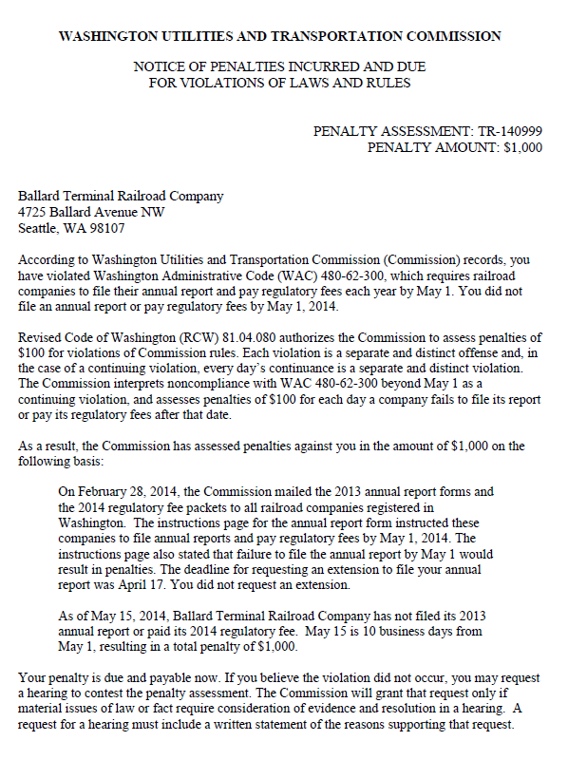

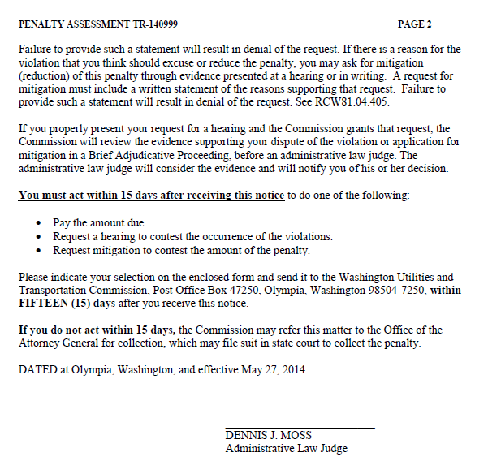

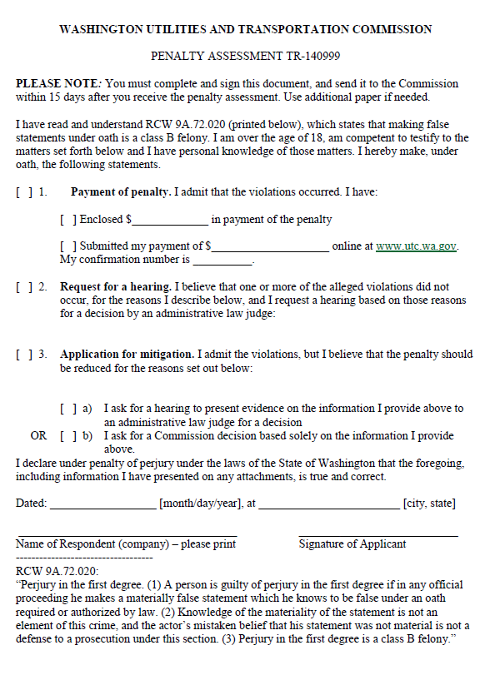

ATTACHMENT B
