Mr. Stephen V. King, Executive Director and Secretary
Washington Utilities and Transportation Commission
Attn: Records Center
P.O. Box 47250
Olympia, WA 98504

Re: Transmittal of SpeediShuttle Washington Tariff No. 1 Revisions Revised Replacement Page 9 (TC-160378)

Dear Mr. King:

SpeediShuttle Seattle respectfully requests approval of the attached Tariff No. 1 revisions with an effective date of May 1, 2017 to reflect an increase of 5% to the maximum fare allowed in accordance with WAC 480-30-420 (2) (c). Rates to customer will not increase at this time, therefore no customer notice is required under WAC 480-30-316. The replacement page has been revised to state “2nd Revised”, as requested.

Respectfully submitted,
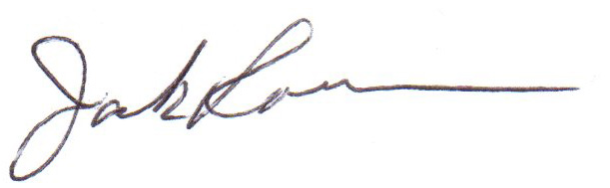
H. Jack Roemer
Chief Financial Officer

