September 23, 2015

Mr. Steven King
Executive Director and Secretary
Washington Utilities and Transportation Commission
1300 South Evergreen Park Drive SW
Olympia WA 98504-7250

RE: Tariff Revision – WN U-4 for Ellensburg Telephone Company d/b/a FairPoint Communications

Dear Mr. King:

Pursuant to WAC 480-80-123, please find enclosed the following revised tariff page. As this is a non-rate affecting change, we are requesting an effective date of September 24, 2015.

- First Revised Sheet No. 13 Cancelling Original Sheet No. 13

The purpose of this filing is to remove language on the page referencing mobile service. We do not offer this service and have no customers using this service. This filing does not affect any customer rates, terms or conditions.

Please contact Beth Westman at 207.535.4249 or bwestman@fairpoint.com with any questions or concerns regarding this filing.

Sincerely,
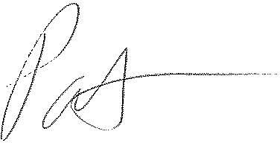
Patrick L. Morse
Senior VP Governmental Affairs
FairPoint Communications
P: 620-227-4409
F: 620-227-8576

