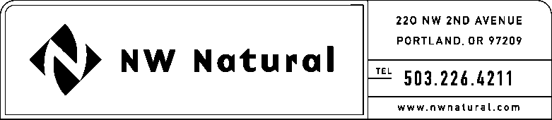
Gail A. Hammer
Rates and Regulation
Telephone: 503-226-4211 ext. 5865
Facsimile: 503.721.2516
Email: gail.hammer@nwnatural.com

February 16, 2017

Steven V. King, Executive Director and Secretary
Washington Utilities and Transportation Commission
1300 South Evergreen Park Drive SW
Post Office Box 47250
Olympia, Washington 98504-7250

Re: WAC 480-143-190: Annual Filing of Property Transferred Without Authorization for 2016

Dear Mr. King:

Pursuant to WAC 480-143-190, Northwest Natural Gas Company (“NW Natural” or the “Company”) hereby submits its annual filing of property transferred without authorization, conveying that no such property was transferred without Commission approval during the previous calendar year (2016).

Please direct any questions regarding this report to me and to e-Filing as follows:

Gail Hammer, Regulatory Consultant e-Filing
Rates & Regulatory Affairs Rates & Regulatory Affairs
220 NW Second Avenue 220 NW Second Avenue
Portland, Oregon 97209 Portland, Oregon 97209
Telephone: (503) 226.4211 x 5865 Telephone: (503) 226.4211 x 3589
Telecopier: (503) 721-2516 Telecopier: (503) 721-2516
E-mail: gail.hammer@nwnatural.com E-mail: eFiling@nwnatural.com

Sincerely,

/S/ GAIL A. HAMMER

Gail A. Hammer
Rates & Regulatory Affairs

