July 29, 2011

VIA ELECTRONIC FILING
AND OVERNIGHT DELIVERY

Washington Utilities and Transportation Commission
1300 S. Evergreen Park Drive SW
Olympia, WA 98504-7250

Attn: David W. Danner
Executive Director and Secretary

RE: Service Standards Report Submitted Pursuant to Docket No. UE-051090

PacifiCorp d.b.a. Pacific Power & Light Company (PacifiCorp or Company) hereby submits an original and two (2) copies of this semi-annual report for the period January 1, 2011 through June 30, 2011 detailing the Company’s performance in meeting the service standards approved in the above docket.

The Company is also refiling an amended version of the 2010 annual report, originally filed on February 23, 2011. An error with the 2009 data has been corrected. The 2009 data is provided as a comparison to the reporting year. The data for the 2010 reporting period is unchanged from the original filing.

If you have any questions or require further information, please call me at (503) 331-4306.

Sincerely,
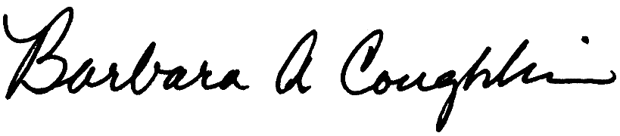

Barbara Coughlin, Director
Customer and Regulatory Liaison

Enclosures

cc: David Pratt, WUTC

Deborah Reynolds, WUTC

