June 25, 2014

Steven V. King, Executive Director and Secretary
Utilities and Transportation Commission
1300 S. Evergreen Park Dr. SW
P.O. Box 47250
Olympia, WA 98504-7250

RE: Washington Utilities and Transportation Commission v. Locus Telecommunications, Inc.

Commission Staff’s Response to Application for Mitigation of Penalties UT-140898

Dear Mr. King:

On May 30, 2014, the Utilities and Transportation Commission issued a $1,000 Penalty Assessment in Docket UT-140898 against Locus Telecommunications, Inc. for 10 violations of Washington Administrative Code (WAC) 480-120-382, which requires telecommunications companies to furnish annual reports to the commission no later than May 1 each year.¹

On June 11, 2014, Locus Telecommunications, Inc. wrote the commission requesting mitigation of penalties (Mitigation Request).² In its Mitigation Request, Locus Telecommunications, Inc. does not dispute that the violation occurred. The company states, “The rejected filing was submitted within the allotted timeframe, as evidence by the attached showing confirmation of receipt by your staff at 9:20am on 05/01/14. The filing was rejected because we mistakenly failed to provide unredacted versions of our financials.”

It is the company’s responsibility to ensure that the regulatory fee is paid and the annual report is filed by the May 1 deadline. On February 28, 2014, Annual Report packets were mailed to all regulated telecommunication companies. The instructions for annual report completion page of
the annual report informed the regulated company that it must complete the annual report form, pay the regulatory fees, and return the materials by May 1, 2014, to avoid enforcement action. Additionally, the instructions for annual report completion referred the company to WAC 480-07-160 for specific steps for filing the financial information with a confidential status.

UTC Annual Reports
June 24, 2014
Page 2

On June 3, 2014 Locus Telecommunications, Inc. filed its completed annual report with no regulatory fees due. The company has been active since February 9, 2010. Locus Telecommunications, Inc. had a previously delinquent filing for the 2012 annual report year and received an automatically mitigated penalty of $25 per day. Due to prior violations of WAC 480-120-382, staff does not support the company’s response for mitigation.

If you have any questions regarding this recommendation, please contact Amy Andrews, Regulatory Analyst, at (360) 664-1157, or aandrews@utc.wa.gov.

Sincerely,

Sondra Walsh, Director
Administrative Services

ATTACHMENT A
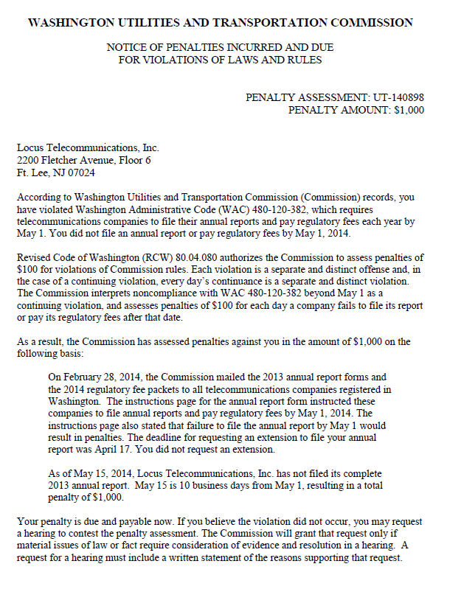

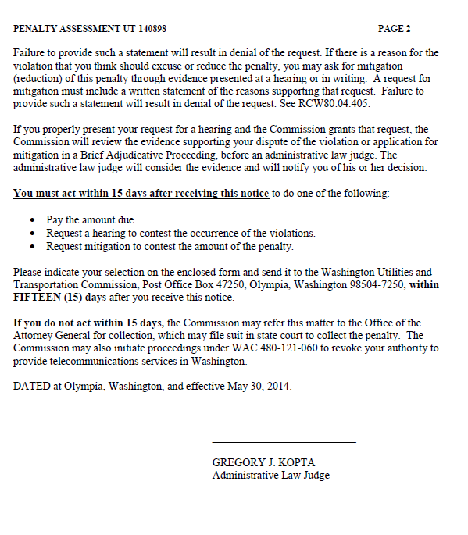

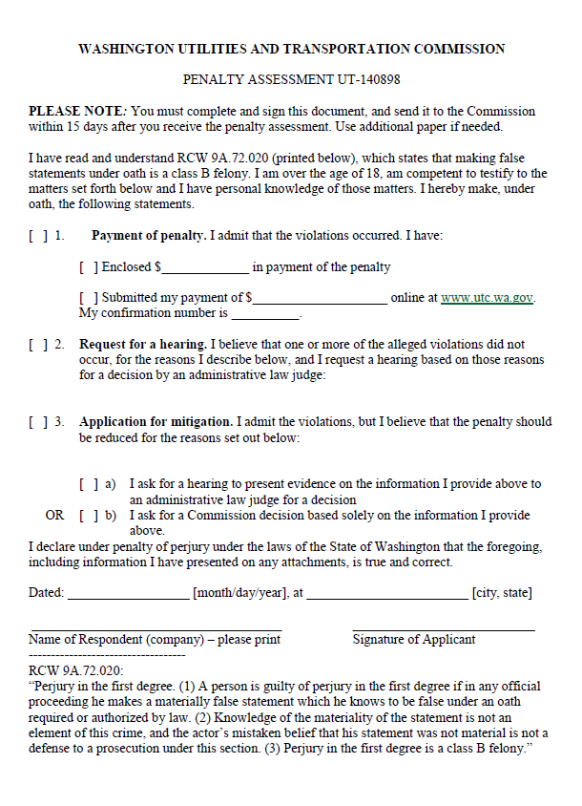

ATTACHMENT B
