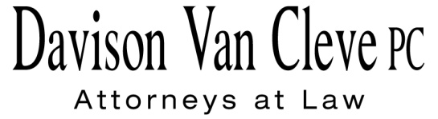
TEL (503) 241-7242 ● FAX (503) 241-8160 ● mail@dvclaw.com
Suite 400
333 SW Taylor
Portland, OR 97204

January 6, 2011

Via Email

Filing Center
Washington Utilities and Transportation Commission
1300 S Evergreen Park Drive, SW
Olympia WA 98504-7250

Re: In the matter of WUTC v. PacifiCorp

Docket No. UE-100749

Dear Filing Center:

On December 6, 2010, ICNU filed errata pages 17 and 26 of Mr. Falkenberg’s originally filed responsive testimony. It has come to our attention that when we filed these revised testimony pages for Randall J. Falkenberg on December 6, 2010, we inadvertently left off the clean version of page 26 from our filing email. We are filing that page now via email. It is our understanding that hard copies of this page have already been provided. We apologize for any inconvenience or confusion. Please do not hesitate to contact our office if you have any questions.

Thank you for your patience in this matter.

Sincerely yours,

/s/ Sarah A. Kohler
Sarah A. Kohler

