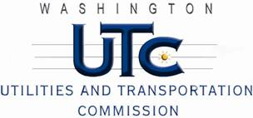

Memorandum
March 25, 2011

To: TR-090406 - File

From: Kathy Hunter, Deputy Assistant Director Transportation Safety

Subject: TR-090406 Spokane County (County)
Grade Crossing Protective Fund (GCPF) Project at the Intersection of
Freya Street and BNSF Railway’s Tracks in Spokane County, Washington

On July 23, 2009, the Washington Utilities and Transportation Commission (Commission) awarded a GCPF grant totaling $20,000 to upgrade the active warning devices and equipment to accommodate advance pre-emption at the Freya Street crossing in Spokane County. The USDOT number assigned to this crossing is 058803V.

On October 1, 2010, the County submitted a request for an extension of time until May 30, 2011, to complete the project. On October 8, 2010, the Commission granted the request to extend the project completion date.

On March 18, 2011, the applicant, Spokane County submitted a request for reimbursement pursuant to Commission order. On March 18 and 22, 2011, Commission staff conducted site visits and verified that the project is completed according to the specifications outlined in the order approving the grant.

Please close this docket.

