March 23, 2017

Mr. Steven V. King, Executive Director and Secretary
Washington Utilities and Transportation Commission
P.O. Box 47250
1300 South Evergreen Park Drive, SW
Olympia, WA 98504-7250

Dear Mr. King:

Re: Docket No. UT-170009 –WAC 480-123-130(1)(e) – Summary FCC Form 477 –
CLAIM OF CONFIDENTIALITY

In accordance with WAC 480-123-130(1)(e) and on behalf of YCOM Networks, Inc. d/b/a FairPoint Communications, accompanying this letter for filing with the Commission is a copy of the “Form 477 Filing Summary” for the Company’s FCC Form 477 as filed with the Federal Communications Commission (“FCC”).

Because of the CONFIDENTIAL nature of the information set forth in portions of the accompanying copy of the Form 477 Filing Summary, pursuant to RCW 80.04.095 and WAC 480-07-160 the Company hereby asserts a claim of confidentiality with respect thereto. The basis for this claim is that the portions of the accompanying copy of the Form 477 Filing Summary that have been marked as “confidential” contain valuable commercial information, including confidential marketing, cost and/or financial information. Accordingly, in compliance with WAC 480-07-160(3)(c), unredacted and redacted versions of that document accompany this letter. As specified in WAC 480-07-160(3)(b)(ii), both redacted and unredacted versions of materials claimed to be confidential have been marked “Confidential per WAC 480-07-160.” The redacted version has been marked “REDACTED” and the information on the unredacted form that is claimed to be confidential has been highlighted with grey shading.

The accompanying electronic copies of the Form 477 Filing Summary are in .pdf format only. Because the Form 477 Filing Summary is generated by an FCC filing system, the Company does not have a copy of it available in any of the other formats listed in WAC 480-07-140(6)(b). A copy of this letter of transmittal, in .docx format, accompanies this letter.

Please contact Beth Westman at 207.535.4249 or bwestman@fairpoint.com with any questions or concerns regarding this filing.

Sincerely,
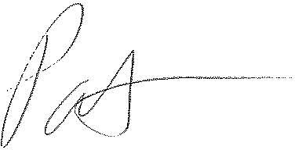
Patrick L. Morse
Senior VP Governmental Affairs
FairPoint Communications
P: 620-227-4409
F: 620-227-8576

