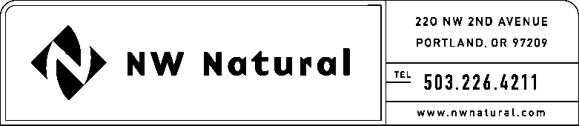

CRISTAN KELLEY
Gas & Regulatory Accounting Manager
Tel: 503.226.4211 ext. 3582
email: cristan.kelley@nwnatural.com

January 13, 2017

Steven V. King, Executive Director and Secretary
Washington Utilities & Transportation Commission
1300 Evergreen Park Drive, SW
Post Office Box 47250
Olympia, Washington 98504-7250

Re: Request for Exemption from WAC 480-90-275

Northwest Natural Gas Company, dba NW Natural, respectfully requests an exemption from WAC 480-90-275 for the Results of Operations for the fourth quarter (October-December), 2016. NW Natural would like to file its report on February 27, 2017. The delay in filing is necessary to avoid having our results of operations report posted on the WUTC website prior to our 4th quarter and full-year earnings release and conference call.

Thank you for your consideration of this matter. Please feel free to call me if you have any questions.

Sincerely,

Cristan Kelley

cc: Kristen Russell, WUTC

