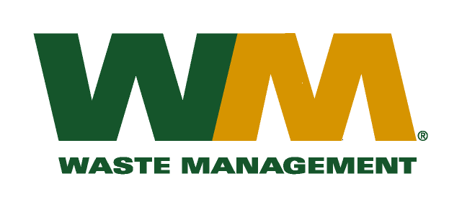
September 20, 2010
Washington Utilities and Transportation Commission
Chandler Plaza Building
1300 S. Evergreen Park Drive SW
P.O. Box 47250
Olympia, WA 98504-7250

Subject: Brem-Air Disposal, a division of Waste Management of Washington, Inc. (G-237); Tariff # 20 – TG-101524
Enclosed are substitute pages 22 and 25 to the above-referenced tariff. In addition, enclosed is a substitute transmittal letter that accompanied our original filing. The purpose of these changes is to correct clerical errors that were brought to our attention by Staff. Please do not re-docket..
If you have any questions or need additional information, please contact or me at (425) 814-7840.
Very truly yours,

Michael A. Weinstein
Senior Pricing Manager, Pacific Northwest Market Area

