February 28, 2012

VIA ELECTRONIC FILING
AND OVERNIGHT DELIVERY

Washington Utilities & Transportation Commission
1300 S. Evergreen Park Drive SW, Mail Stop: FY-11/7250
Olympia, WA 98504-7250

Attention: Carole Washburn, Executive Secretary

RE: Service Standards Report Submitted Pursuant to Docket No. UE-051090

Please find enclosed Pacific Power’s annual report for the period January 1, 2011 through December 31, 2011 detailing Pacific Power’s performance in meeting the service standards approved in the above docket.

If you have any questions or require further information, please call me at (503) 331-4306.

Sincerely,
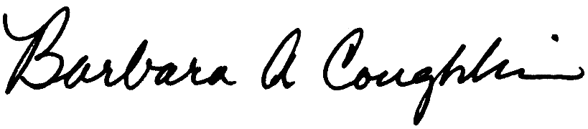

Barbara Coughlin, Director
Customer and Regulatory Liaison

cc: Sharon Wallace - Washington Utilities and Transportation Commission

Deborah Reynolds - Washington Utilities and Transportation Commission
Suzanne Stillwell - Washington Utilities and Transportation Commission
Roger Kouchi - Washington Utilities and Transportation Commission

Enclosures

