Mr. Steven V. King
Executive Director and Secretary
Washington Utilities and Transportation Commission
March 29th, 2017
Subject: Comments on UE-160799 on EVSE policy statement.

Thank you for the opportunity comment on this important policy matter.
Promoting Corridor Charging
One of the biggest impediments to an electric vehicle is the range anxiety for long trips. This requires a robust corridor charging network throughout our state. Greenlots notes in their November comments that “What does not clearly exist currently is a profitable market for providing charging services to drivers”. ChargePoint shared a similar lament with their experience in California at the EV Roadmap Conference in Portland last summer. EVGo, also didn’t report overwhelming commercial success.
The biggest barrier identified by both ChargePoint and EVGo in California was utility demand charges. They noted that even if equipment were free, the site cost nothing to rent, and state subsidies kicked in, a charging station needed somewhere between 90 to 120 charging sessions per week to break even in California due to demand charges. Getting rid of the demand charges lowers that to somewhere around 50-60 charging sessions per week.
In terms of times of usage, ChargePoint provides the following data from their network:
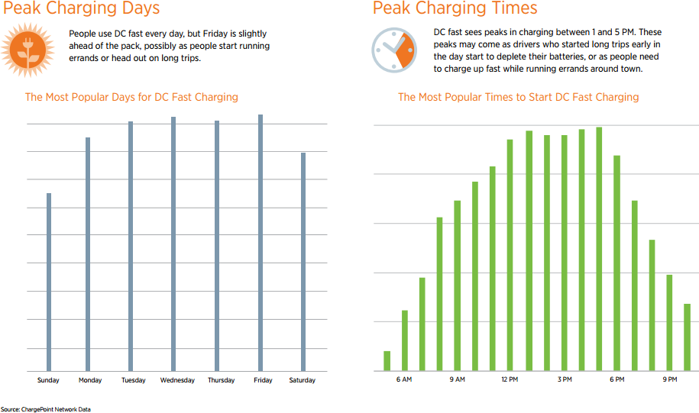

Utility demand charges serve two purposes:
- To recover costs for peak capacity needs, distribution system upgrades, and ancillary services.
- To encourage people to rearrange their schedule to match the needs of the utility.
For corridor charging, of course the first applies, but the second does not. Drivers moving from point A to point B want to charge when they arrive at a DC fast charger. Travelers do not arrive at gas stations and give the gas station owner leeway to not deliver gasoline for an hour or two. The same motivation applies for corridor charging. Recognizing that the second part of the justification for demand charges is unobtainable requires a different policy response.
I recommend the UTC prohibit utility demand charges for corridor charging stations, and possibly all L2 charging stations. This may not be a drastic cost shift, because EV’s are charged in a residential setting more often. Observers have noted that having EV’s charge at off-peak times lowers everyone’s costs by providing a higher utilization of all existing assets throughout the night. Considering that the frequency of residential & workplace charging dominate DC fast charging, this seems like a fair tradeoff that could potentially be revenue neutral. (I leave it up to the reader to provide a team of economists to verify this assumption. As for a mechanism for off-peak charging, I have some ideas below.) This is one easy way to promote corridor charging throughout the state.

Allowing Sales based on Energy, Not Time
Pricing a DC fast charge station is challenging, because you cannot easily predict what power a car will draw without knowing much more detailed information about the car’s state-of-charge and battery capacity. The Commission should adopt a policy of allowing EV site hosts to bill based on energy sold, even if they are not a utility. Instead, the current best legal option is billing by time. However, time-based billing runs into problems when you think about DC fast chargers, as well as overnight uses of L2 chargers.
First for a DC fast charger, the energy consumed is not easily related to time spent at the charger due to the battery’s state of charge. Consider a Tesla Model S P85 parked at a Tesla Supercharger. Now, build an EV software data collection tool, and a custom data analyzer. (I have one of those and built the other two.) Below is a graph showing the car charging from 10% to 95% state-of-charge, and the power drawn from the Supercharger. It took about 70 minutes to charge the car through this 85% of the battery’s capacity.
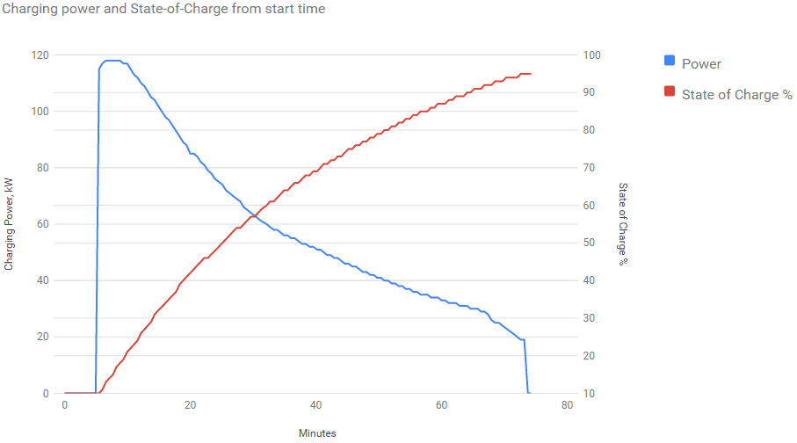
As you can see, the power drawn by the car varied by a factor of 6x throughout the charging session (20 kW vs. 120 kW), and was correlated with the state-of-charge. If someone charges at a DC fast charger for 10 minutes, the energy delivered can vary by 6x. The only constant factor is that the car is not limited by the maximum L2 charger power, not dropping below 20 kW before being disconnected! This will become more dramatic over time, as auto manufacturers consider charging stations delivering 300 kW or 450 kW of power.
It seems only fair to charging station operators to allow charging for energy delivered, without requiring them to be regulated as a utility. For comparison, gas stations aren’t regulated as oil refineries, because it’s a fundamentally different business to extract & refine oil vs. selling gasoline to retail customers. While utilities do sell to end users, I suggest there’s a different enough business model between charging station operators and fully integrated utilities that we can allow both to coexist peacefully without regulating them as the same type of business.
Next, let’s think about overnight charging. Consider a hotel. Many hotels are providing destination chargers at the hotel, to allow customers to charge up their car overnight. But, overnight is a long time, and expecting a driver to wake up in the middle of the night to unplug and move their car is unreasonable. Currently non-utilities cannot bill based on the power consumed – they must bill based on time spent connected to the charger. In the overnight scenario, this is an undue constraint. Yes, there is an availability argument to be made for prompting a driver to disconnect the instant their car is done, but leave that up to the site host and charging network to solve through a creative pricing structure, text messages to the driver, community norms, a reservation system in software, or just dealing with it.
This overnight scenario will become more interesting if we consider curb-side charging. One of the best things cities can do to help apartment dwellers adopt EV’s is allow curb-side charging overnight, perhaps only with an L1 outlet. If we put them evenly spaced along a block, residents could get approximately 50 miles of range by charging overnight. There’s no significant opportunity for load shifting on L1. I’d allow charging based on energy used, not time in this scenario. (Frankly I’d suggest making them free – they may be prohibitively expensive to meter.) Free or cheap curb-side charging may be the best option for both dense urban neighborhoods and economically disadvantaged communities, serving a social justice goal as well.
In all of these cases, decoupling the notion of an electricity reselling business from a utility would keep the UTC from accidentally limiting charging station innovation, deployment, useful adoption, and future business models.

Charging Standards & Protocols
The Commission asks a good question about whether to require utilities to invest in EVSE with specific standards. The Commission’s questions around interoperability and lock-in can be re-expressed this way:
- Can consumers easily pay at charging stations from different vendors?
- Should the charging network adopt an open source software standard, so the charging stations are functional if the network operator ceases business operations?
- Additional services built on top of or around a charging network.

- Paying for Charging
This is a pain today, with each charging network using a different plastic chip. Similarly, Blink requires that you either pay a membership fee (~$15/month?) OR requires that you call up someone and read your credit card number to them over the phone, complete with your billing address. If you only use a Blink charger once a year, this is an annoying hassle.
Perhaps the UTC can help protect consumers by ensuring some standardization here. The simplest option would be to require a credit card reader on every L2 or L3 charging station, unless the charging station provides free charging or back-end billing for at least some of their members. The distinction here encompasses two cases. First, Tesla’s Supercharger network is currently free, though it will have a future charge (based on time, not energy, due to state regulations). It is not truly open to the public, since only Tesla’s owners can physically connect to the Superchargers; there is no adapter between a Supercharger plug and a Leaf charging socket. The second case is to allow a private company with controlled access to a private parking lot to provide free charging, perhaps with utility money to support their needs or help offset some of the installation costs.
However, we also should avoid making almost all installed charging stations illegal. A light, careful touch would be helpful. If that can’t be easily arrived at, then punting regulations for several years would be an acceptable way to not squash innovation.

- Charging Network
Protecting the utility and ratepayers from stranded assets in the event of a bankrupt charging network is useful. As a high order bit, standardization is a really desirable attribute. But, here’s the challenge for corridor charging. The best corridor charging system on the market (possibly including Tesla’s Superchargers) is ChargePoint’s high end DC fast charging system. The charging station architecture is very scalable. Based on the charging station market as of today and if cost were no object, it’s very tempting to recommend that everyone should just buy and install ChargePoint’s top of the line system.
However, ChargePoint doesn’t support Open Charge Point Protocol. Those that do support open standards have their hearts in the right place, but they are presently smaller players. Reading through the list of members in the Open Charge Alliance makes you ask “who’s who?” (present commenters on this docket excluded). Standards are great at solving some problems, but this is a case where requiring a standard to protect against bankruptcy may lead to buying less scalable and weaker hardware.
This raises two questions about ChargePoint:
- Do they allow trusted partners access via computer API’s with their charging network?
- Will ChargePoint go bankrupt?
ChargePoint’s Dave Packard claimed they have their API’s publicly documented. That does not appear to be true today – I was unable to find documentation in 15 minutes of searching. But there are a few software projects on GitHub supporting the claim that their network is at least minimally open. I haven’t verified their usefulness, completeness, nor ChargePoint’s organizational support for partners building software around their charging network. But they may have half-solved the first issue.
On the second issue, ChargePoint raised $165M as of last summer, followed by an additional round with a starting pool of $82M from Daimler & BMW, and the round will likely exceed $100M to allow ChargePoint to expand in Europe. Their revenue numbers are not publicly disclosed, but were estimated at $65M. This probably values ChargePoint at somewhere between $130M - $500M. This doesn’t mean ChargePoint won’t go bankrupt, but I’m willing to bet they will be around.
The only question left is does the Commission object to utilities supporting a potential future monopoly in charging station equipment? We don’t yet have any incentives for made-in-Washington EVSE – no one has asserted in the Legislature that this is a reasonable policy goal. I believe ChargePoint is an acceptable vendor for EV charging stations.
For now, I suggest the Commission stay away from requiring specific technical standards. If the UTC sees fit to lend support for a standard like Open Charge Point Protocol without imposing requirements, that would be helpful. Also, allowing utilities to “pay up” for a better or more open back-end charging network is also a way to protect their investment.
To provide some basic ratepayer protection at the simplest level, the UTC could require utilities investing in charging stations to provide the UTC with a URL for the EVSE supplier’s API documentation, as well as a GitHub repository (or an equivalent open source software link, like SourceForge or CodePlex) for client access to their charging network. This isn’t to allow authentication & control, but rather to clearly demonstrate that the network could be somewhat easily reconstituted if the charging network operator ceases operations. To be clear, not all software should be open source or could be usefully open sourced, but the basic network plumbing to turn on charging stations, see whether they are in use, & bill a credit card is unlikely to be a business differentiator between charging networks. Other parts of the charging network may provide a substantial value add, but not the bare minimum operational controls. Utilities should ask for publicly available documentation and a GitHub repository early in the process of selecting an EVSE vendor. That might even prompt ChargePoint to clarify their policy, publish their documentation in an easy to discover location, and publicly back an open source software project with their copious software engineers.

3) Value-Added Services on top of a Charging Network
I appreciate comments from Greenlots and the Commission on interoperability. Ensuring that EVSE can survive bankruptcy of a charging network is a great idea. I suggest going one step further with the required interoperability analysis. When evaluating vendors for managed charging services, note which types of EV’s could be addressed by certain technologies.
For example, EPRI is working with eight different automakers on a future standard to control charging called Open Vehicle Grid Integration Platform. A prototype implementation may be completed some time this year. However, that working group is only a subset of auto manufacturers and excludes the two largest EV manufacturers, as well as Europe’s largest EV manufacturer. It suggests the EPRI solution may only be limited to handling perhaps 40% of the potential cars on the market. Additionally, it’s not clear (at least to uninformed members of the general public like myself) whether OVGIP will work with cars already in existence, or whether it requires upgrading car firmware and/or EVSE firmware. Even if we assume it will work without modifying existing cars, utilities should project what proportion of the market they could serve with this solution.
This is still a necessary industry building block, and would be perfectly adequate for a pilot project. But it’s hard to tell precisely what EPRI is building, unless you’re paying a substantial amount of money to read EPRI status reports. For instance, it’s unclear whether their system talks to a charging network, specific EVSE, some additional adapter, or cars. This project might be more valuable if development was done in with an “open source” approach through the Apache Software Foundation, but hopefully EPRI will share their learnings, specifications, and a reference implementation with the world at a reasonable price. Closed source software projects are fine, but open source projects with “Open” in the name usually don’t have such a significant pay-to-play (or pay-to-see-if-you-might-want-to-play) barrier. OVGIP remains difficult to plan for, currently. It will be fascinating to see what EPRI will actually build in the future, and whether their project gains traction.

Clarifying the Definition of EVSE
Paragraph 75 of the draft rule carves out a role for utilities as a “manager” of EVSE, for direct load control or demand response. This is a good start, but I suggest the Commission should be slightly more open to ideas here. Specifically, consider a Demand Flexibility program, consistent with my comments in docket U-161024 and in UE-141170.
I don’t think TOU rates are a complete solution for benevolent EV charging. Additionally, many of the economic or business focused people assert that TOU rates will be complied with as a matter of faith. Instead, one study showed utilities can move at most 31% of shiftable load.
Consider a third party vendor that provides flexible charging for cars. This flexible charging vendor could control charging through one of several different control points, including both EVSE and a fourth party charging network (like ChargePoint’s). A utility may conceive of a Demand Flexibility program, going well beyond EIM-inspired Fast DR to provide load shaping. Working together, the utility and flexible charging vendor can onboard drivers, and the drivers’ vehicles can be charged for maximal ecological or economic benefit while delighting the driver. With the right conceptual framework and software, this can be substantially better than direct load control and lead to a higher customer adoption rate.
Utilities will need to incentivize driver participation, because everyone expects smartphone apps & their associated cloud services to be free. This preference for free is still true when shown that drivers can save hundreds of dollars a year due to TOU rate compliance, in exchange for a modest monthly subscription. Getting customer adoption will require some creative marketing and a matching incentive structure.
I believe this goes beyond the definition of EVSE and is more in the realm of a utility conservation program. The utility may be a “manager” in that they instigated a Demand Flexibility program, compensate their ratepayers for participation (perhaps through a fixed monthly on-bill discount or incentive of similar value), and pay a third party flexible charging vendor to do the actual management.
This is the shape of things to come. Maryland’s PEPCO did a hardware-based pilot project for a program like this. There are at least four vendors in North America working on parts of this problem, and another one in Europe. However, the most innovative software company that could have provided a sophisticated DF program decided not to enter the market. This was either because utilities are too hard to sell to, or because they were earning a substantial amount of money by using Nissan Leafs for frequency regulation (selling into the EIM with the support of DoD grant money).
Innovation may come, but it will happen at a junction between the world’s fastest moving industry and the slowest moving one. One of the challenges is incentivizing the software people to build solutions in a space with utilities & regulators. Utilities should be strongly encouraged to invest in pilot projects for programs like this today, with incentive rates of return or whatever carrots the Commission views as appropriate to aggressively promote useful experimentation.
Pilot projects should begin immediately. My current most conservative estimate is our state will have an additional 200 MW of evening peak charging load by 2023, but my more optimistic estimate is EV’s will increase evening peak by 200 MW around mid-2019. No one wants our state utilities to be surprised, however utilities haven’t looked hard at projecting EV load growth and peak capacity impacts. Compared with their planned capacity, our utilities might be collectively short by one natural gas peaker plant in late 2019. Pilots need to start this spring, so vendors and utilities have solutions in hand in 2018, and utilities can start ramping up customer adoption next summer.
Additionally, utilities should be instructed to include an analysis of demand flexibility programs in future IRP’s, starting with BPA’s electric hot water heater project as an example of load shifting’s economics. Just as with energy storage, demand flexibility requires a stacked benefit approach to appreciate its full value to the grid and ratepayers. Rocky Mountain Institute’s Economics of Demand Flexibility article is a high-level starting point. This may include a “locational marginal value”, but also it needs to factor in benefits from load shaping and integrating renewables. Also the Legislature has favored local Washington businesses for solar modules via production incentives (really, this was a revenue-positive jobs program that happened to produce solar installations). Perhaps a similar WA jobs growth component might one day show up for demand flexibility hardware, software, and/or operational aspects.
I have extensive additional thoughts on flexible charging solutions and utility Demand Flexibility program design if the Commission or Staff would like to chat or walk through some slides.

Other Definitional Issues
Inspired by other commenters, I suggest the Commission broaden the definition of energy conservation to include not just conservation of electricity and natural gas, but also of oil. We must get comfortable with fuel switching and increasing electric load as a matter of urgent ecological need. If we look towards Washington State’s goals for the world in 2050, to reduce our carbon emissions to near 0 we must do several things:
- Make the electric grid almost entirely renewable, retiring our natural gas power plants.
- Switch all cars, trucks, trains, some farm equipment, and planes to electric powered or biofuels.
- Replace natural gas home heating furnaces with electric heat pumps.
- Find better ways to make concrete and steel.
This might result in a rough doubling or tripling of energy need, before we talk about population growth or load growth from energy-hungry facilities like data centers or “indoor agriculture”. This huge increase is a necessary step along the way. Let’s agree on the goal, plan for it now, and work backwards to see what we need to retire & replace by when.

Legislature’s Obsession with Charging More than Two Hours
I encourage the UTC to downplay distinctions between stations designed for charging for 2 hours or more. The reason to separate them would be to attempt to carve out different markets and rules for corridor charging (L3 DC fast charging stations) vs. residential, workplace, and destination charging (ie, malls, etc.) There is a qualitative difference between corridor charging and the other charging patterns, but that line is already slightly blurry and may disappear over time.
For example, with the current slow speed 50 kW DC fast chargers and the growing battery pack sizes in cars, you could make a case that a CHAdeMO fast charging station could take more than 2 hours to charge a car with a 100 kWh battery. And similarly, a high power L2 charger at nearly 20 kW could charge one car somewhat quickly and others ridiculously slowly, based on the car’s battery capacity, onboard charging equipment, and battery pack design. A Volt gen 1 battery pack only has 10 kWh of capacity meaning a commonplace L2 charger with 6.6 kW of power should be able to charge the Volt in under 2 hours. But it might take 15 hours to charge a Tesla with a 100 kWh battery. So is that L2 charger something designed to charge a car in more than 2 hours, or less than 2 hours?
Additionally, note that the auto industry is preparing for 200+ mile ranges on mainstream electric cars, and both Tesla & ChargePoint are preparing for 400+ kW charging stations.
I’d ask the Legislature to clear up their intent, or consider removing the distinction between corridor charging vs. all other charging patterns. Ask the Legislature whether they want utilities in the corridor charging market, or whether that should be built with private capital & owned by private companies for forever. It’s nice to have competition, and if all the utilities start buying DC fast chargers and install them everywhere, that may speed up EV adoption. A participant’s viewpoint on whether utilities should build DC fast charging stations probably depends on whether they own a charging network.

Requiring EV Load Estimation in IRP’s
I believe utilities should be required to estimate EV morning & evening peak load impacts in their IRP’s. This will be hard to do accurately. The Northwest Power and Conservation Council has a well-developed top-down model for EV adoption within the state which almost surprisingly fits with current future projections. However I believe the NWPCC’s model for peak load impacts is imperfect in two ways. First, it believes time-of-use rate compliance will just happen, without proposing a mechanism or suitable public education plan for rolling out TOU rates. Second, the model anticipates EV energy consumption tracks today’s best cars. While a Tesla beats a gasoline car in energy efficiency any day, a Model X also uses 40% more Wh/mile than a Chevy Bolt. However, NWPCC’s estimates stand as an interesting projection from a regional authority:
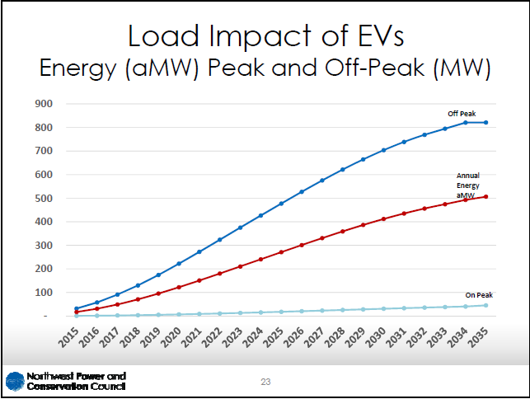

The WA DoT provides a bottoms-up backwards-looking model of what electric cars were purchased. If you couple this with a projection of future sales based on automaker predictions, you can get a bottoms-up projection for what cars might show up. You then adjust for automaker hubris, a CEO that consistently delivers 80% of what he promises, and marketing mistakes like a CEO that pre-announces higher range Leafs a year too early, thus hurting their sales for a year. With this, you can get the following estimates for the number of electric vehicles in Washington state. Like any future forecast, this is uncertain and requires adjustments quarterly. Critically, we’re at a portion of the EV adoption growth curve where we may go from seemingly-linear growth to exponential growth, but an automaker that slips by 6 months or a year affects the estimates substantially.
Accounting for all these corrections, the NWPCC top-down model seems surprisingly plausible from an auto market focused bottoms-up survey based on current trends & estimates. This is the number of EV’s in WA, starting in January of each year.
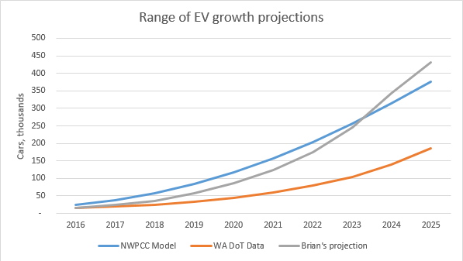
From this, you can also build a useful charging model for WA state. This is currently an art without enough suitable local data, but this can be collected through surveys and apps. From the above car adoption projections and a custom charging model, we get a different range of EV load projections from the NWPCC:
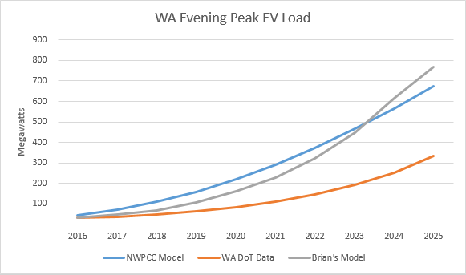
Maybe utilities need an independent analyst that can provide this information for their service territory and update it frequently.
Another approach is to measure EV load directly. PSE’s current pilot project should provide some useful data on times when WA drivers charge their vehicles. This will be particularly interesting due to the near-absence of TOU rates in our state. Future projects could acquire a broader base of EV load data from customers, through working with a flexible charging solutions vendor or a charging network. I suggest a car-based approach is much better than charging-station based approach. Both ChargePoint and FleetCarma happily show graphs of when cars charge, but they have conflicting data. ChargePoint doesn’t get to observe residential charging or any workplace & destination charging done outside their network. FleetCarma has good data for individual fleets, but no two fleets show the same charging profile.

Market Transformation, EV Charging Services, and the Software Industry
Pricing EV charging services w.r.t. avoided costs of generation, transmission, plus ancillary services (as detailed in Rocky Mountain Institute’s Economics of Demand Flexibility) is good. Care must be taken to ensure the Commission doesn’t accidentally grant a utility a monopoly over a charging network, but also that the Commission protects from monopsony power as well. In a geographic area with only one buyer of services, it might be tempting for the buyer to only acquire the cheapest possible service at the lowest price possible. This could starve new services of revenue, undercut future growth potential, and permanently limit the market transformation that the Commission is interested in spawning.
The future of the utility industry is software and Big Data used to mediate power generation, energy storage and consumption together in real time. To adjust to the future, we need the US’s slowest moving, most risk-adverse industry to adopt technologies, techniques & employees from the US’s fastest moving industry. The field we now call “Big Data” has completely replaced its underlying platform twice in six years. Software-based managed charging services will have a relatively high development cost and fixed O&M costs. However, given that a service may be able to offset the construction of several peaker plants, several pilot projects at even $5M/year each may be quite reasonable, even if they are financially not immediately beneficial in the first ~2-3 years.
My EV adoption projections coupled with a model of impact on peak charging load show WA will require one peaker dedicated to EV charging loads between 2019 and 2023, locking in approximately $750M over 35 years. The NWPCC adoption numbers coupled with my charging time model imply we’ll need 2 peakers in 2022 state-wide, costing about $1.6B. The potential scale of energy demand from electric vehicles will grow to an enormous amount, and EV managed charging services will require a substantial R&D budget to build a system capable of meeting the opportunity. Succumbing to the monopsony tendency to go cheap early or going slowly to reduce risks may be penny-wise but pound-foolish.
The future software-mediated utility industry needs a new, younger, more expensive breed of employees, either at utilities or vendors. For example, hiring software engineers is not cheap. The starting salary for software engineers is $100K/year for a new college graduate that needs 6 months of training before they become useful. Recent proposed Federal H-1B visa changes effectively set the starting salary for software engineers nationwide at $100K/year, with a total compensation of $130K/year. The total cost to an employer for hiring an experienced, skilled software engineer in the Big Data space could easily exceed $400K/year in total compensation plus the employer’s share of taxes, healthcare, equity and other benefits. That’s the Washington price – the California price may be up to $800k/year for the right hire in the automotive space. Google accidentally paid their self-driving car engineers so much money they retired – with Bay Area housing prices.
Beyond the compensation package, attracting talent also requires the utility industry to compete for software engineers with aspirational companies like Google, Tesla, Facebook, Netflix, Amazon, Microsoft, and SpaceX. Culturally, these companies achieve a fun work atmosphere and are often the aspirational employers for tech workers, ranked best in the world. It’s more than just private busses and free food, and lets people substantially change how people live, communicate, or work. And there’s a fun aspect - at utility conferences, you don’t see massive parties at Universal Studios theme parks or an open bar with volleyball-sized beer pong games next door.
This cultural difference also shows up in terms of expectations. Netflix runs an Internet-scale service on a team of only 3,500 employees, by paying top dollar in the software industry and regularly dismissing solid, consistent B level performers. This competition for employees (and their abnormal performance) will be a tall order for an industry that has people turn up in suits working from 9 to 5, and has regulators that mean everything must move slowly. How many of the best people will leave the software world to keep the lights on and work in a heavily regulated industry, and why?
A Maryland utility ran an EV charging pilot project lasting 2 years funded with $550K, with half of that money going to hardware and another significant portion to customer acquisition and support. That leaves little room to hire developers to build something interesting. Perhaps they could hire one new college grad for 75% of the pilot’s duration. That may be fine for a simple demonstration, but it will likely not produce a system that could scale past 1000 vehicles. With software services, every order of magnitude improvement will likely require a significant engineering improvement.
The UTC and utilities should keep this in mind, and decide whether they are ready to invest in market transformation or just dipping their toes in the water. Going slowly may drive up costs for ratepayers. If vendors start too early and yet do survive financially, they may incur a lot of debt to pay off through higher fees. A startup’s early funding typically costs at least 8% interest, a 20% discount on equity, and a complicated cap on valuation that dilutes employees more than early investors. Utilities have a much lower cost of capital. But if a solution is found that scales and customers sign up in droves, perhaps in 2025, a single utility may gladly pay $10-15M/year to manage EV charging because the service delivers $30M in avoided costs, and both of those numbers could be on an S-shaped curve that keeps going until 2050.
The challenge for the UTC is to make sure this type of market transformation can take place, and utilities are incentivized to take risks (or contract with those that can take risks). The Commission should consider mandating further utility pilot project participation, and provide an incentive rate of return for potentially transformational pilots, with an eye to signing sizable commercial contracts for the right services within two years. Hopefully utilities can find an interesting partner for this adventure.

Thank you again for your time.
Brian Grunkemeyer

https://techcrunch.com/2017/03/02/daimler-leads-chargepoints-new-82m-round-for-ev-charging-network-growth/
Brian Grunkemeyer’s comments on Demand Flexibility in docket U-161024, https://www.utc.wa.gov/_layouts/15/CasesPublicWebsite/GetDocument.ashx?docID=112&year=2016&docketNumber=161024
Summary of PEPCO flexible car charging program: http://www.utilitydive.com/news/how-pepco-is-finding-ways-to-shift-demand-through-maryland-ev-pilot-program/434156/
Economics of Demand Flexibility: http://www.rmi.org/electricity_demand_flexibility

