Mr. Steven V. King, Executive Director and Secretary
Washington Utilities and Transportation Commission
Attn: Records Center
PO Box 47250
Olympia WA 98504-7250

Re: Transmittal for Ticket Agent Agreements for Expedia
SpeediShuttle Washington, LLC (Certificate C65854).

Dear Mr. King:

SpeediShuttle Washington, LLC herby requests approval of the attached ticket agent agreement in accordance with WAC 480-30-391. The agreement meets all of the requirements of WAC 480-30-391.

The agreement has rates which are less than the maximum fare pursuant to WAC 480-30-420 contained in our flexible fare tariff No. 1. The agreement contains the following as required by WAC-30-391:
- The name and certificate number of the auto transportation company;
- Identifying information about the person entering into the contract or agreement with the company. This information includes:
  - Name;
  - Business address;
  - Business telephone number;
  - Business fax number;
  - Business e-mail address;
- The date on which the contract or agreement becomes valid and the date on which the contract or agreement will expire;
- A clear description of the services that will be provided by the second party on behalf of the company;
- A statement of the percentage of revenue or the set dollar amount that the company will pay the second party for performing those services; and
- A statement as to how and when payment will be made to the company for tickets, less commission.

Should you have any questions or comments, please contact:
Jack Roemer
SpeediShuttle Washington, LLC
1237 S. Director St.
Seattle, Washington 98108
Phone – 206-693-7110
Fax – 206-566-5982
jackr@SpeediShuttleSeattle.com

Thank you for your consideration.

Respectfully,
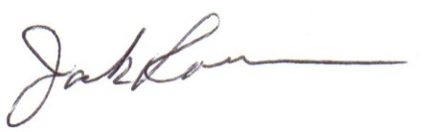
H. Jack Roemer
Chief Financial Officer

