BEFORE THE WASHINGTON STATE
UTILITIES AND TRANSPORTATION COMMISSION

In the Matter of Determining the Proper Carrier Classification of, and Complaint for Penalties against:  HARRIS, THOMAS E. d/b/a BIG EARL’S MOVING AND HAULING  _____________________________________ | )  )  )  )  )  )  )  ) | DOCKET TV-130326  DECLARATION OF  MATHEW PERKINSON
Mathew Perkinson, under penalty of perjury under the laws of the State of Washington, declares as follows:

- I am employed by the Washington Utilities and Transportation Commission (Commission) as a Compliance Investigator in the Consumer Protection and Communications Section. As a Compliance Investigator, my responsibilities include conducting investigations regarding the business practices of regulated utility or transportation companies. As part of those duties, I investigate household goods carriers that may be operating without the required Commission permit.
- Rayne Pearson began an investigation into the activities of Thomas E. Harris d/b/a Big Earl’s Moving and Hauling (Big Earl’s Moving) in January 2011 because Ms. Pearson received information that Big Earl’s Moving had advertisements indicating the company was conducting household goods moves within the state of Washington without a permit.
- On January 27, 2011, Ms. Pearson mailed a compliance letter to Big Earl’s Moving, instructing it to remove any advertisements and cease operating as a household goods operator until it obtained a commission issued permit.
- On January 31, 2011, Ms. Pearson received a call from Mr. Harris who stated he received the compliance letter. Mr. Harris stated he was going to provide pack and load only services, and that he had disabled his website and taken down other advertisements.
- On January 31, 2011, Mr. Harris emailed Ms. Pearson the following from earltharris@gmail.com, “I understand everything we discussed earlier today on the phone and I am msking [sic] the necessary changes that are required. Thanks for getting me on the right track I really appreciate your input. Thanks Earl.”
- I conducted a follow-up investigation into the activities of Big Earl’s Moving in July 2012, and found advertisements indicating the company is still conducting household goods moves within the state of Washington without a permit.
- On September 27, 2012, I mailed a compliance letter to Big Earl’s Moving, however the letter was returned because the zip code on the letter was incorrect. I followed up immediately by emailing the compliance letter to Earltharris@gmail.com. I did not resend the compliance letter because at the time it was returned I could not determine why it was returned. Upon further review, I discovered the zip code was incorrect. The company did receive a compliance letter from Rayne Pearson on Jan. 27, 2011, as previously noted.
- On January 8, 2013, I conducted an Internet search for advertising for Big Earl’s Moving. I found advertisements on www.akjm80.wix.com, www.openhourz.com, www.showmelocal.com, and www.switchboard.com.
- On February 25, 2013, I called telephone number (206) 450-0756, replying to the company’s advertisement listed at www.akjm80.wiz.com. I used an assumed name requesting a quote, including two men and a truck, from a two bedroom in Bothell, WA to another two bedroom in Bothell a few miles apart from each other. I asked Earl if his company would be available in early March. A male answered the telephone and identified himself as Earl. Earl provided a quote of $80 per hour for two men and a truck and confirmed he would be available in early March.
- I reviewed Commission records related to Big Earl’s Moving to determine whether the company held a household goods permit. According to Commission records, as of February 27, 2013, there is no record of Big Earl’s Moving now (or ever) holding a household goods permit.
- On February 27, 2013, I conducted an Internet search for advertising for Big Earl’s Moving. I found additional advertisements on www.angieslist.com, and www.facebook.com.
DATED this 19th day of March, 2013, at Olympia, Washington.

______________________________________
MATHEW PERKINSON

Attachment A

Attachment B
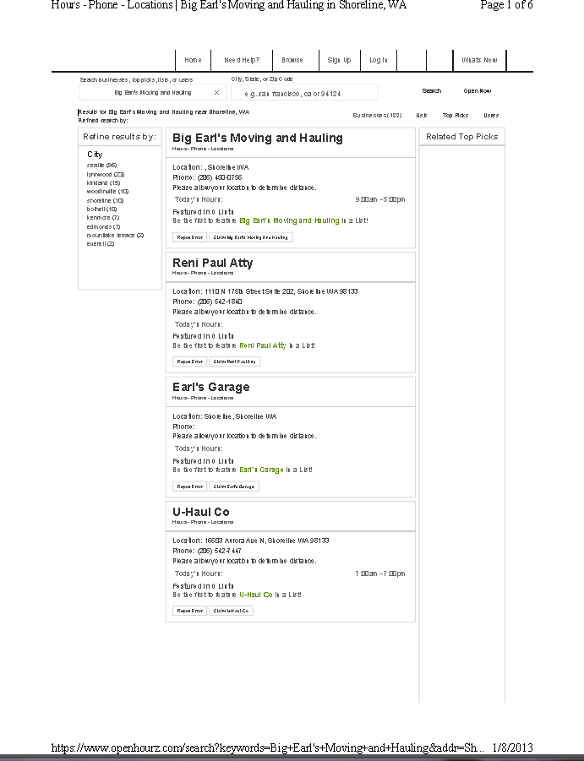

Attachment C
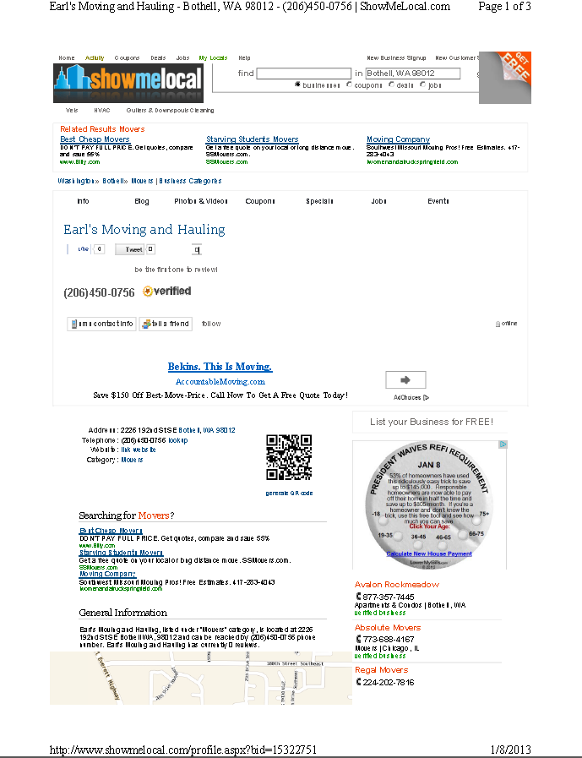

Attachment D
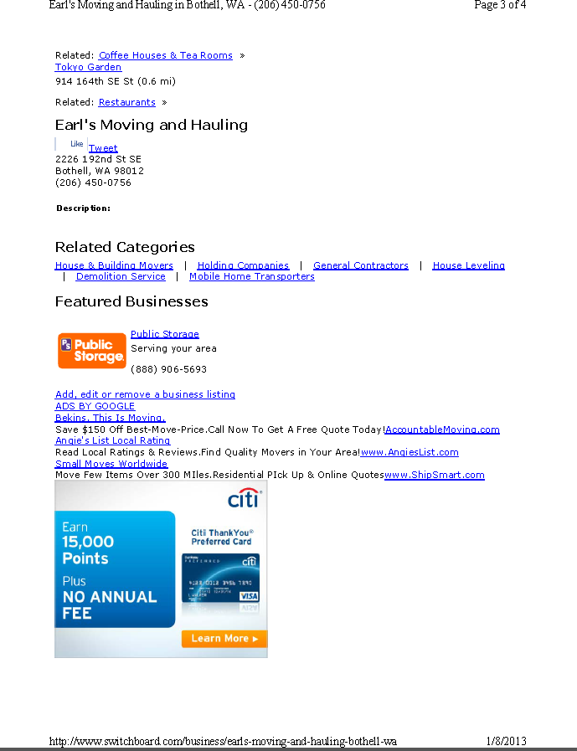

Attachment E
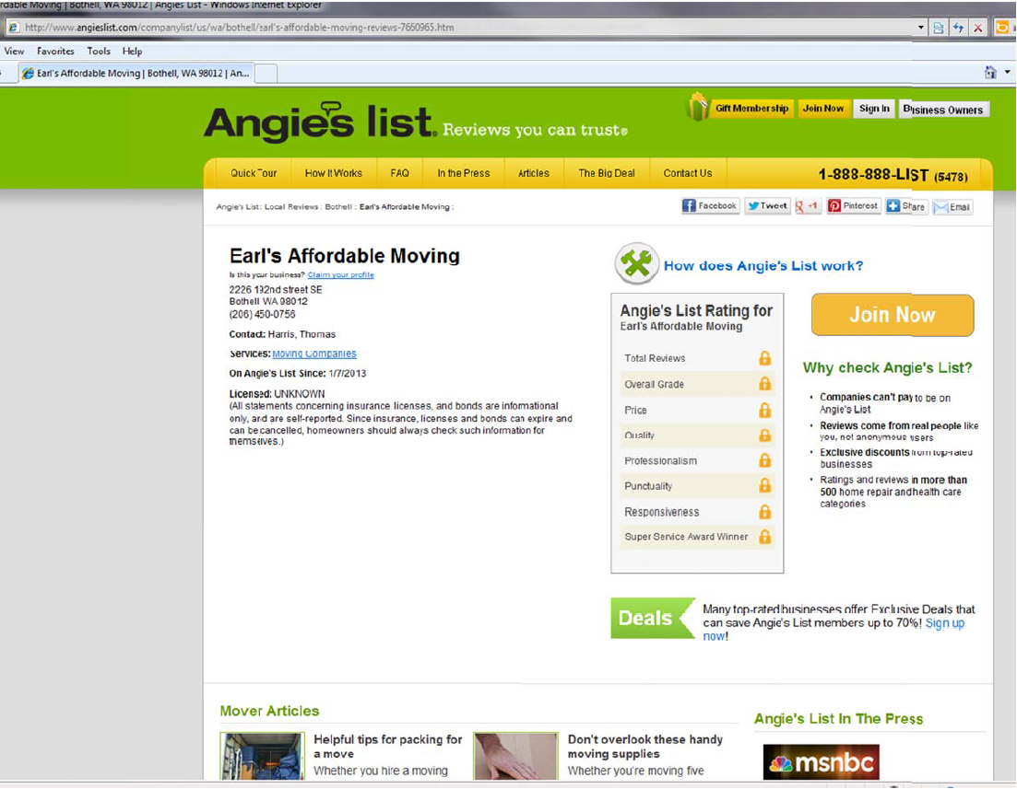

Attachment F
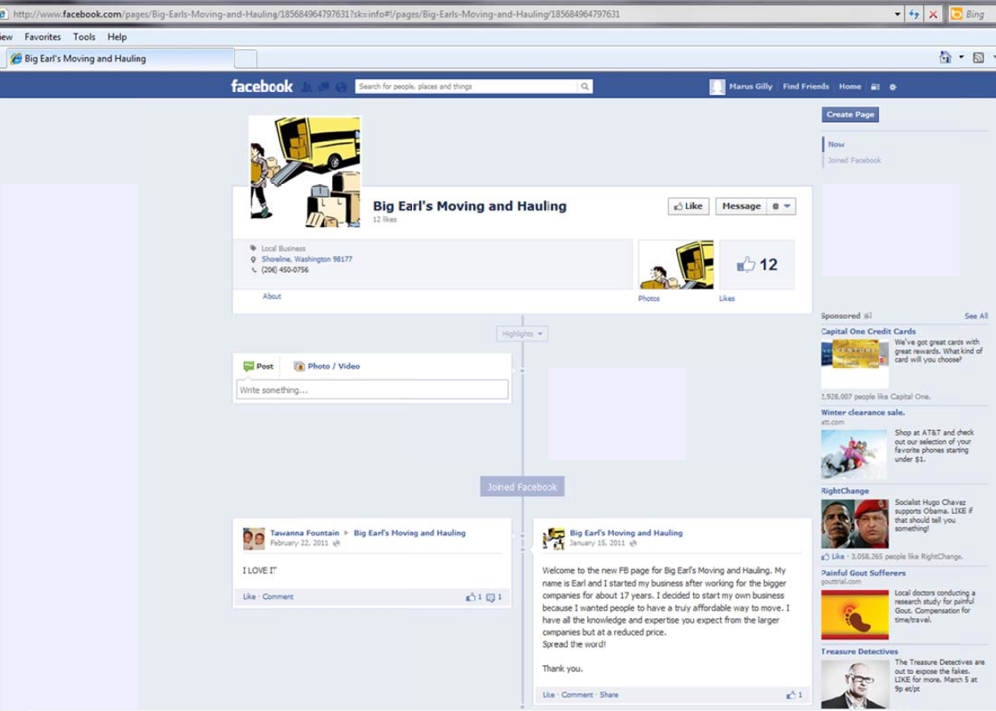

See Attachment A for a copy of the January 2013 advertisement found at www.akjm80.wix.com.
See Attachment B for a copy of the January 2013 advertisement found at www.openhourz.com.
See Attachment C for a copy of the January 2013 advertisement found at www.showmelocal.com.
See Attachment D for a copy of the January 2013 advertisement found at www.switchboard.com.
See Attachment E for a copy of the February 2013 advertisement found at www.angieslist.com.
See Attachment F for a copy of the February 2013 advertisement found at www.facebook.com.

