BEFORE THE WASHINGTON UTILITIES AND
TRANSPORTATION COMMISSION

BREMERTON-KITSAP AIRPORTER, INC.,  Complainant,  v.  SHUTTLE EXPRESS, INC.,  Respondent. | DOCKET TC-110230  ANSWER OF SHUTTLE EXPRESS, INC. IN OPPOSITION TO MOTION TO AMEND COMPLAINT

  - The motion of Bremerton-Kitsap Airporter, Inc. (“BKA”) to amend its complaint should be denied due to futility, as the proposed amended complaint fails to identify any harm—direct or indirect—sufficient to give BKA standing to pursue a claim against Shuttle Express, Inc. d/b/a Shuttle Express (“Shuttle”).
  - The Commission’s rule on amendments states, “The commission may allow amendments to pleadings, motions, or other documents on such terms as promote fair and just results.” WAC 480-07-395(5). Here, it would not be fair or just to require Shuttle to respond to a complaint that is not legally cognizable or justiciable due to complainant’s lack of standing.
  - It is a well-recognized principle of adjudicative law that amendments to complaints that would be futile should be denied. See, e.g., James Madison Ltd. v. Ludwig, 82 F.3d 1085, 1099 (D.C. Cir. 1996) (“[c]ourts may deny a motion to amend a complaint as futile...if the proposed claim would not survive a motion to dismiss.”).
  - The proposed amended complaint is apparently brought pursuant to RCW 80.04.110, which provides that, “No complaint shall be dismissed because of the absence of direct damage to the complainant.” Nevertheless, well-established principles of standing require that complainants must have at least some cognizable interest and sufficient harm to have standing to pursue their claims.
  - In a leading case on standing, Lujan v. Defenders of Wildlife, 504 U.S. 555 (1992), the Supreme Court listed a three part test, as follows: (1) the plaintiff must have suffered an "injury in fact"—an invasion of a legally protected interest which is concrete and particularized and actual or imminent, not conjectural or hypothetical; (2) there must be a causal connection between the injury and the conduct complained of; and (3) it must be "likely," as opposed to merely "speculative," that the injury will be "redressed by a favorable decision." Id., at 561.
  - Although the requirement of standing in federal cases flows from the “case and controversy” requirement of Article 3, Section 2, Clause 1 of the U.S. Constitution, most states apply similar standing requirements. See, e.g., Lakewood Racquet Club v. Jensen, 156 Wn. App. 215, 232 P.3d 1147 (2010). And this Commission, in a recent case involving Shuttle, issued a ruling that—while not using the term “standing” per se—discussed the requirement that an intervenor must have a sufficient interest in the outcome of a matter to participate. In the Matter of Application of Shuttle Express, Final Order Granting Request To Remove Restrictive Language In Certificate No. C-975, Dkt. TC 09-1931 (Apr. 14, 2011)(“Final Order”). The admonition in that order applies equally here:

Allowing one company to attempt to ensure that the other company complies with its certificate solely for the sake of enforcing the law offers too great an opportunity to strategically employ Commission processes in pursuit of personal goals.
  - The proposed amended complaint alleges no specific harm—direct or indirect—traceable to the actions of Shuttle. As with the improper intervention discussed in the recent Final Order, BKA appears to seek to enforce tariff rules and/or statutes as a matter of general principle and not because any alleged violations have any impact on BKA in particular. Indeed, portions of the complaint seem to seek an interpretive ruling or rulemaking.

CONCLUSION

  - Because BKA does not allege any particularized harm from Shuttle’s alleged actions, it lacks standing to complain thereof. Its motion to amend should be denied and its original complaint should be dismissed.
  - Respectfully submitted this 12th day of July, 2011

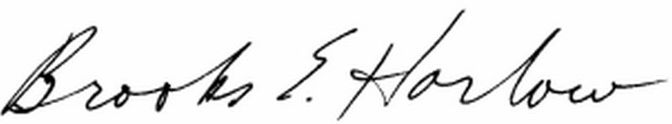LUKAS, NACE, GUTIERREZ & SACHS, LLP

Brooks E. Harlow
WSB No. 11843

Attorney for SHUTTLE EXPRESS, INC.

Id., ¶ 15.

