September 28, 2012

David W. Danner, Executive Director and Secretary
Washington Utilities and Transportation Commission
1300 S. Evergreen Park Dr. SW
P. O. Box 47250
Olympia, Washington 98504-7250

RE: Washington Utilities and Transportation Commission v. QX Telecom, LLC
Commission Staff’s Response to Application for Mitigation of Penalties
Docket UT-121005

Dear Mr. Danner:

On August 1, 2012, the Washington Utilities and Transportation Commission issued a $2,100 Penalty Assessment in Docket UT-121005 against QX Telecom, LLC for 21 violations of Washington Administrative Code (WAC) 480-120-382, which requires competitively classified telecommunications companies to furnish annual reports to the commission no later than May 1 each year.

On August 10, 2012, QX Telecom, LLC wrote the commission requesting mitigation of penalties (Mitigation Request). In its Mitigation Request, QX Telecom, LLC disputes the violations occurred. The company states, “With reference to the annual report, we are no longer active. The income that was received for year of 2011 totals to $1,846.50, take into account the expenses. We are operating at a loss. Please take this into consideration and we would appreciate if you could remove the penalties. Thanking you in advance.”

A company that is not in business as of May 1 in the current year, is not required to file an annual report or pay a regulatory fee. Therefore, the company is not subject to penalties. QX Telecom, LLC became inactive on January 10, 2012. The order can be found in docket UT-111529, Order 01. The Final Order granted the request to find QX Telecom, LLC in default and revoking registration for failure to file its 2010 Annual Report and pay regulatory fees.

Based on the above mentioned information, staff recommends waiving any and all penalties related to QX Telecom, LLC’s 2011 annual report.

If you have questions regarding this recommendation, please contact Mathew Perkinson, Compliance Investigator, at (360) 664-1105 or at mperkinson@utc.wa.gov.

Sincerely,

Sharon Wallace, Assistant Director
Consumer Protection and Communications

Attachment A
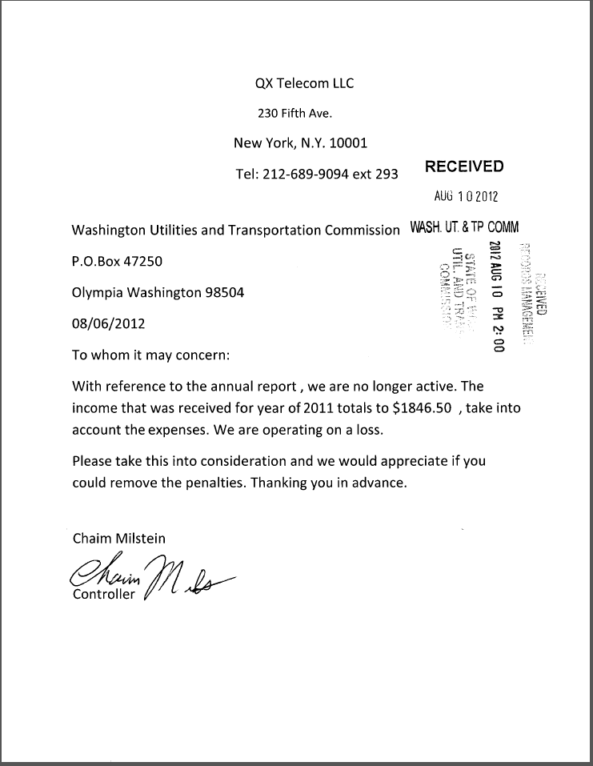

See attachment A for a copy of QX Telecom, LLC’s Mitigation Request.

