Discounting the bull
Sell-side share analysis is wrong
But in reassuringly predictable ways

Print edition | Finance and economics
Dec 1st 2016
“SELL-SIDE” analysts, whose firms make money from trading and investment banking, are notoriously bullish. As one joke goes, stock analysts rated Enron as a “can’t miss” until it got into trouble, at which point it was lowered to a “sure thing”. Only when the company filed for bankruptcy did a few bold analysts dare to downgrade it to a “hot buy”.
Economic research shows that there is some truth to the ribbing. The latest figures from FactSet, a financial-data provider, show that 49% of firms in the S&P 500 index of leading companies are currently rated as “buy”, 45% are rated as “hold”, and just 6% are rated as “sell”. In the past year, 30% of S&P 500 companies yielded negative returns.
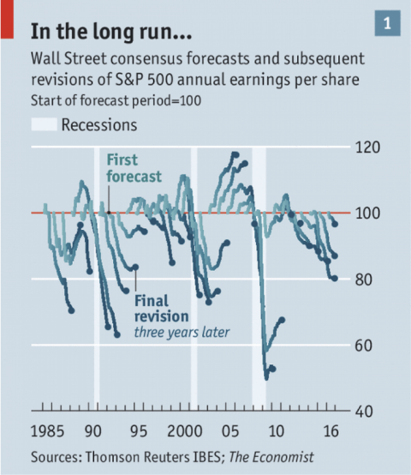
Profits forecasts made more than a few months ahead have a dismal record of inaccuracy. According to Morgan Stanley, a bank, forecasts for American firms’ total annual earnings per share made in the first half of the year had to be revised down in 34 of the past 40 years. Studying their forecasts over time reveals a predictable pattern (see chart 1).
In theory, a diligent share analyst should do his own analysis—that is, by projecting a firm’s future revenue and expenses, and discounting them to the present. Such models, however, are extremely sensitive to different assumptions of growth rates. Since no one can know the future, analysts cheat.
Three statistical sins are common. Analysts can look at comparable companies to glean reasonable profits estimates, and then work backwards from their conclusions. Or they can simply echo what their peers are saying, and follow the herd. Or, most important, they can simply ask the companies they are following what their actual earnings numbers are.
Surveys conducted by Lawrence Brown of Temple University found that two-thirds of sell-side analysts found private calls with company managements to be “very useful” in making their estimates. Analysts’ need to maintain relationships with the companies they cover must colour their projections. They are judged primarily on the accuracy of their short-term forecasts, so there is little risk in issuing flattering, if unrealistic, long-term projections. In the short run, however, they have an incentive to issue ever-so-slightly pessimistic forecasts, so companies can “beat” expectations. Since the financial crisis, company profits have exceeded short-term analyst forecasts around 70% of the time.
So are forecasts are useless? Simply taking the market’s earnings figures from the previous year and multiplying by 1.07 (corresponding with the stockmarket’s long-run growth rate) can be expected to yield a more accurate forecast of profits more than a year in the future.
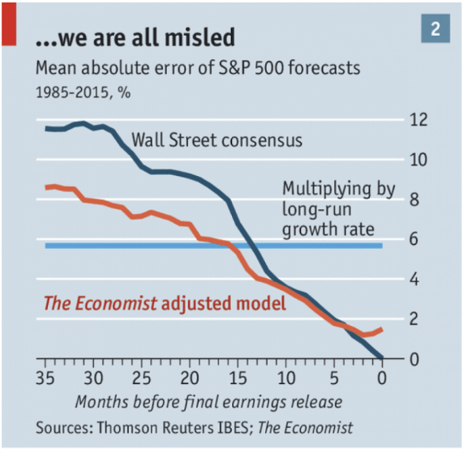
Yet the very predictability of the errors in analysts’ forecasts suggests they could be informative, if they are properly interpreted. Taking forecasts of S&P 500 earnings from 1985-2015, The Economist has built a simple statistical model to try to take out the bias that taints Wall Street’s prognostications. After controlling for the forecasts’ lead time and whether or not they were made during a recession, we find that even our relatively crude model can improve upon the Wall Street consensus for forecasts made more than a quarter in advance (see chart 2).

Adjusting for bias in short-term forecasts is harder. It is tempting simply to accept the errors—after all, they tend to be off by just a little. Data from Bloomberg show that the 320 S&P 500 companies that beat earnings expectations in 2015 did so only by a median of 1.4%. An alternative is to look at crowdsourcing websites such as Estimize. There punters—some amateur, and some professional—are shown Wall Street consensus estimates and asked to make their own forecasts. Estimize users beat Wall Street estimates two-thirds of time.
To some extent, judging Wall Street by its ability to make accurate predictions is silly. Harrison Hong, an economist at Columbia University, reckons that stock analysts should be viewed “more like media”. The latest forecasts aggregated by Thomson Reuters suggest that the S&P 500 will yield earnings per share of $130.83 in 2017 and $146.33 in 2018. According to our model, that would imply that they believe the actual numbers will be closer to $127.85 and $134.30. Share analysts want to tell the truth. They just like making it difficult.
This article appeared in the Finance and economics section of the print edition under the headline "Discounting the bull"

