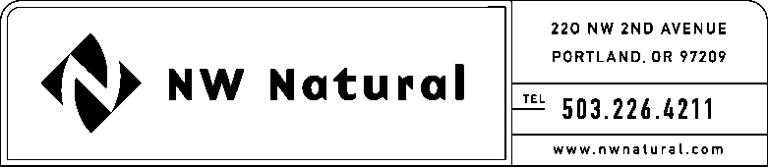

JENNIFER GROSS
Tariff and Regulatory Compliance
Tel: 503.226.4211 ext. 3590
Fax: 503.721.2516
email: jgg@nwnatural.com

September 8, 2014

VIA ELECTRONIC FILING

Steven King, Secretary and Executive Director
WASHINGTON UTILITIES &
TRANSPORTATION COMMISSION
1300 S Evergreen Park Drive, SW
Post Office Box 47250
Olympia, Washington 98504-7250

Re: UG-121207, NW Natural Presentation for September 11, 2014, workshop

Northwest Natural Gas Company, dba NW Natural (NW Natural or Company), files the attached presentation as requested in the Washington Utilities and Transportation Commission’s (“Commission’s”) Notice of Recessed Open Meeting, issued August 28, 2014. The attached presentation provides an update on the Company’s work to comply with the Commission’s policy statement issued in the UG-121207, as well as an update on the Company’s work with Northwest Energy Efficiency Alliance (“NEEA”).

Please call me if you have any questions.

Sincerely,

/s/ Jennifer Gross

Jennifer Gross
NW Natural

enclosures

