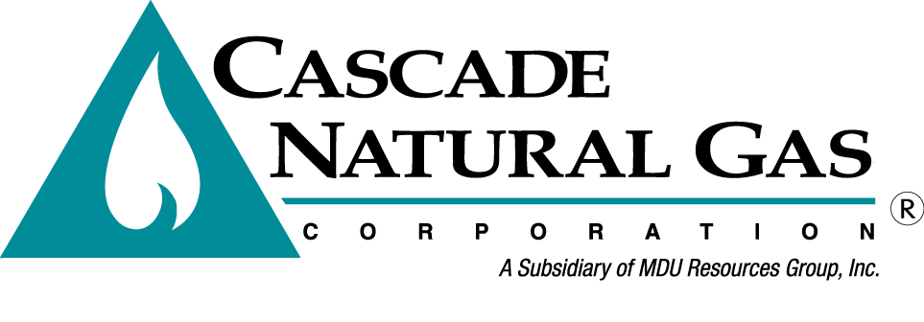
8113 W. GRANDRIDGE BLVD., KENNEWICK, WASHINGTON 99336-7166
TELEPHONE 509-734-4500 FACSIMILE 509-737-9803
www.cngc.com

December 18, 2018

Washington Utilities & Transportation Commission
Mr. Mark Johnson, Executive Director & Secretary
P.O. Box 47250
Olympia, WA 98504-7250

RE: Cascade Natural Gas Corporation’s Presentation of 2018 Annual Hedging Plan to the WUTC Commissioners (Docket UG-180825)

Dear Mr. Johnson:

Pursuant to the Commission’s request at the December 14, 2018 Recessed Open Meeting, please find attached a native version of the Company’s 2018 Annual Hedge Plan presentation to the WUTC Commissioners.

If there are any questions regarding this matter, please contact Chris Robbins (509) 734-4588 or myself at (509) 734-4589. Alternatively, we may be reached at chris.robbins@cngc.com or mark.sellers-vaughn@cngc.com.

Sincerely,
CASCADE NATURAL GAS CORPORATION
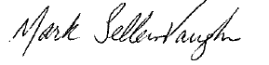
Mark Sellers-Vaughn
Manager, Supply Resource Planning

Attachments:

180825-CNG-2018-Annual-Hedge-Plan-Presentation-12-18-18.pptx

