December 5, 2016
Wenatchee Valley
SHUTTLE

Mr. David W. Danner
Washington Utilities and Transportat ion Commission 1300 S Evergreen Park DR SW
PO Box 47259
Olympia, WA 98504-7250

RE: General Fare Increase for BML Investments LLC dba Wenatchee Valley Shuttle, Certificate Number C-64605 .

Dear Mr. Danner:

The company requests Commission approval to withdraw Docket #TC-161235. This will allow us the opportunity to make some necessary corrections before resubmission.

If you have any questions about this filing, please contact me at 509-264-4981 or via email at jason@wenatcheevalleyshuttle.com .

Sincerely,

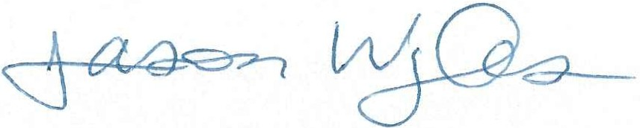
Jason Wyles
Wenatchee Valley Shuttle
P.O. Box 1725 Wenatchee, WA 98807 509-293-5773 office 509-264-4981 cell
509-293-5773 fax

