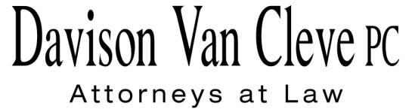
TEL (503) 241-7242 ● FAX (503) 241-8160 ● tcp@dvclaw.com
Suite 400
333 S.W. Taylor
Portland, OR 97204

March 2, 2016

Via Electronic Filing

Mr. Steven V. King
Executive Director
Washington Utilities & Transportation Commission
1300 S. Evergreen Pk. Dr. S.W.
P. O. Box 47250
Olympia, WA 98504-7250

Re: In the Matter of Puget Sound Energy Advice No. 2016-04
Docket No. UE-160199

Dear Mr. King:

On February 11, 2016, Puget Sound Energy (“PSE” or the “Company”) filed in the above-referenced docket revisions to its Schedule 448 and Schedule 449 tariffs in order to align those tariffs with the changes it is concurrently proposing to its open access transmission tariff (“OATT”) at the Federal Energy Regulatory Commission (“FERC”). The revisions to its OATT will enable the Company to participate in the California-ISO’s (“CAISO”) Energy Imbalance Market (“EIM”). The Industrial Customers of Northwest Utilities (“ICNU”) represents a number of PSE customers taking service on Schedule 449 (there are no Schedule 448 customers), which allows these customers to purchase their energy supply from a third party and obtain retail wheeling service from the Company.

ICNU negotiated the revisions to the Schedule 448 and 449 tariffs with the Company and is writing to confirm for the Washington Utilities and Transportation Commission (“Commission”) that, as the Company indicated,/ ICNU does not oppose the filed revisions to these tariffs./ Additionally, as these tariffs are the product of a stipulation entered into in 2001 between the Schedule 449 customers and the Company that remains binding on the parties (“Stipulation”),/ ICNU agrees with the Company’s request that the Commission issue an order that modifies the Stipulation as necessary to reflect the Company’s proposed revisions to Schedules 448 and 449 in this Docket.

If you have any questions, please do not hesitate to contact me.

Sincerely,

/s/ Tyler C. Pepple
Tyler C. Pepple

/ PSE Advice No. 2016-04, Cover Letter at 2 (Feb. 11, 2016).
/ In comments to FERC, however, ICNU has opposed one change PSE is proposing to make to its OATT related to the financial settlement of real power losses on the Company’s transmission system. FERC Docket No. ER16-923, ICNU Protest (March 2, 2016). ICNU’s comments at FERC do not impact resolution of the Company’s filing in this Docket.
/ Docket Nos. UE-001952/UE-001959, 11th Supp. Order, Appen. 1 (Apr. 5, 2001).

